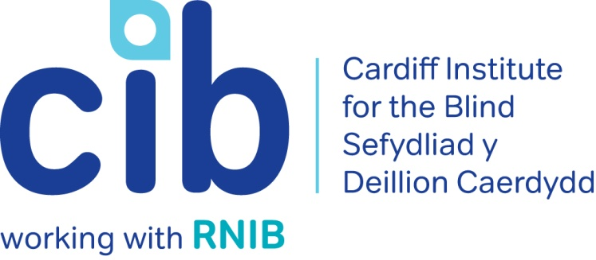

CIB Newsletter

December 2017

We wish all our members, volunteers, colleagues and friends a very merry Christmas and a happy and healthy 2018.

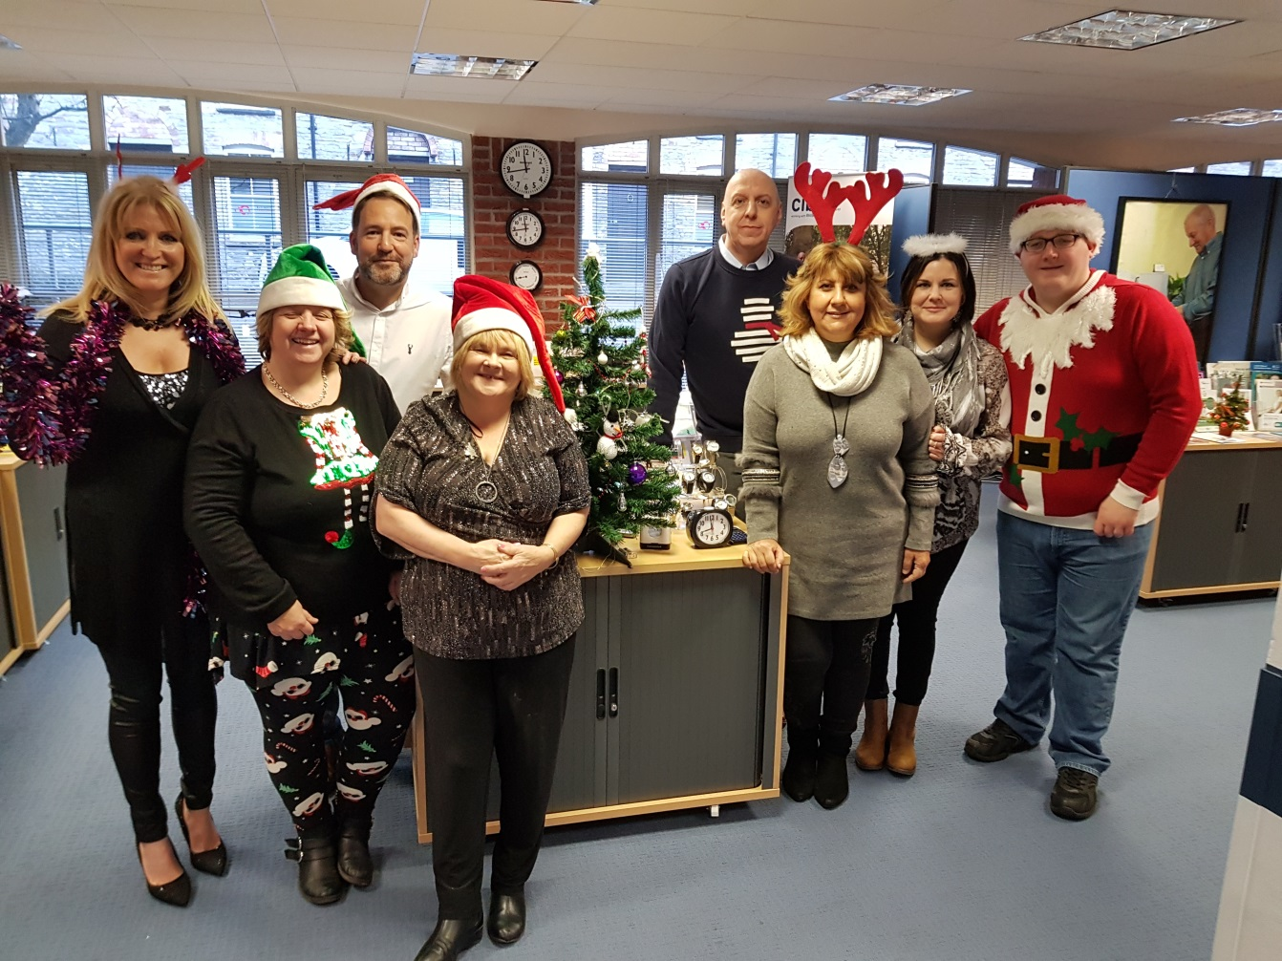
Picture: CIB Staff

Wendy’s story shows you how CIB can help with regaining some independence and our final newsletter of 2017 also tells you about the forthcoming independent living sessions and technology open day. In this edition we also focus on Retinitis Pigmentosa. Please contact Michelle or Teresa for any queries or to book an event on 02920 398900.
Also keep up-to-date via our website at www.cibi.co.uk, Facebook page www.facebook.com/CardiffInstitutefortheBlind and Twitter @CardiffBlind

In this edition:

Page 2: Real life: Wendy Karran

Page 3: Independent living sessions

Page 4: Focus on eye conditions: Retinitis Pigmentosa

Page 7: Club of the month: Ramblers

Page 8: Product of the month: Sonic USB Player
Page 8: Active Community
Page 10: Sherman 5

Page 11: Orcam MyEye

Page 12: Care and Repair: Managing Better:
Page 12: Volunteering

Page 13: Customer feedback

Real Life: Wendy Karran

Wendy was first seen by Ruth Rhydderch our Eye Clinic Liasion Officer (ECLO) at the University Hospital of Wales following deterioration in her vision. She started receiving treatment for wet Macular Degeneration. She was very anxious about her sight loss and Ruth encouraged her to visit our Resource Centre for further help and advice.

Although Wendy was coping well with the support of her husband John, she was in need of reassurance and ongoing emotional support. Teresa visited Wendy at home and gave Wendy details of all help and services available to her. She signed her up for RNIB Talking Books, referred her to RNIB Rights and Advice Service and encouraged Wendy to attend our independent living sessions.

Wendy attended our independent living sessions with her husband John. She found the sessions extremely interesting and learned a lot of new skills. Being able to talk to others with sight loss who understood your frustrations was very helpful. Wendy then joined our Macular and Conversation groups, attending with her husband John.

Wendy’s confidence has increased since joining CIB and she is now a member of our Women’s, Theatre and most recently our Exercise group. She now attends these groups alone, coming to Jones Court on the bus.

Wendy said ‘I really enjoy coming to the groups. It’s great because I am meeting new people with the same eye condition as me. It has boosted my confidence to come out and do new things. I think it's amazing that CIB run a service like this, it enriches people's lives who would otherwise feel restricted and lonely.”

Independent living one day sessions

Held at Jones Court, our sessions give members and their families the opportunity to introduce themselves to other blind and partially sighted people. All modules are interactive and have a practical element. They are facilitated so that people can share their questions, experiences and knowledge and we let people know where to go for further information, advice and support.

Forthcoming sessions:

Monday 12 February 2018 – Making the most of your sight
Brief outline of the day:

- Looking after your sight.
- Low vision assessments and aids.
- Products that can help.
- Further support

Monday 12 March 2018 – Connect to your community

Brief outline of the day:
- About RNIB Connect
- Local VI services available
- Peer support available through Time to Talk, social and support groups, etc.
- Local non-VI services e.g. community transport, other third sector organisations etc.
- Introduction to leisure section of 'Leisure, health & wellbeing module'.

Places for this session are limited so if you and your partner/carer would like to attend please contact us on 02920 398900.

Focus on: Eye conditions

Retinitis Pigmentosa

Retinitis Pigmentosa (RP) is the name given to a group of inherited eye conditions that affect the retina at the back of your eye. RP causes permanent changes to your vision, but how much and how quickly can really vary from person to person. These retinal changes can affect your side vision, which makes it harder for you to see in dim light or the dark, and central vision, which causes difficulty with detailed activities such as reading or watching television.

If you have RP, sight loss is gradual and usually progresses over a period of many years. Some people with RP might become blind but most people with RP keep some useful vision well into old age. New research is constantly changing our understanding of RP.

Causes of Retinitis Pigmentosa

Almost all types of RP are inherited, caused by a fault in the genetic information passed down to you from a parent.

The faulty genes cause your retinal cells to stop working and eventually die. This affects your eye’s ability to process the light that enters it.

Because there are many genes that can cause the retinal cells to stop working, there are many different types of RP.

You can read a more detailed breakdown of the genetic causes of RP in the RNIB Understanding Retinitis Pigmentosa guide.

Symptoms

For most people with RP, the early symptoms include:

- Difficulty seeing in poor light such as outdoors at dusk or in a dimly lit room. It’s normal for eyes to take up to 20 minutes to adapt to dim light but if you have RP it will take much longer or won’t happen at all. This is often called ‘night blindness’

- Loss of peripheral vision if you look straight ahead you’ll be less able to see things to the side, above or below. This can lead to ‘tunnel vision’

Less commonly, in some cases of RP, people can experience:

- Loss of central vision you might find it difficult reading print or carrying out detailed work

If you notice any of these symptoms for the first time, it’s important to have your eyes examined by an Optometrist (optician).

Diagnosis

An optometrist can examine your retina to detect RP.

If you have a family history of RP or have noticed any of the symptoms associated with the condition you need to make this clear to the person testing your eyes. This will help them carry out the best set of tests.

If the optometrist detects any changes in your retina which may be RP, they will refer you to an ophthalmologist (hospital eye doctor) for more detailed testing. This may involve genetic testing and discussing any family history of RP.

Treatment

Although there’s currently no known cure or treatment for RP, you’ll still be monitored regularly at the hospital eye clinic.

Many of the genes causing RP and related conditions are being discovered (or mapped) and it’s this understanding of where the faults occur in the genetic information that might lead to treatment in the future.

For more information on Retinitis Pigmentosa contact the RNIB Helpline on 0303 123 9999 or go to http://www.rnib.org.uk/eye-health/eye-conditions/retinitis-pigmentosa#understanding

Technology Open Day

Our next Technology Open Day will be held at Jones Court on Wednesday 07 February 2018 from 10.30am until 3pm. We will be joined by Enhanced Vision, Dolphin Technology, Macular Society and Blind Veterans UK. Drop in to sample the latest aids in the world of technology.

Club of the month: Ramblers

Walking through some beautiful parts of South Wales our Ramblers group gives you the opportunity to experience the great outdoors with the help of our willing and able volunteers, should you need an arm. The walks vary in distance from month to month to accommodate all abilities. A packed lunch, suitable clothing and a sense of adventure are a must!

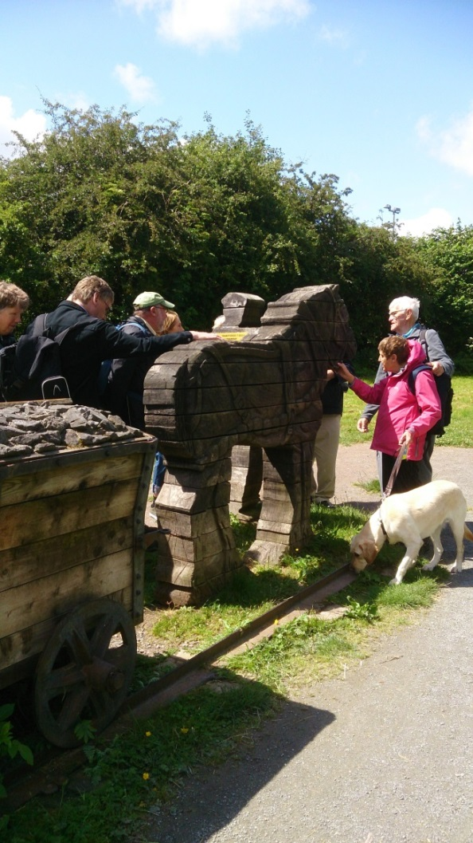

Picture: Ramblers on a walk

If you are interested in attending please call us on 02920 398900.

Product of the month:

Sonic portable USB player

Product code: DH444

£34.95 (ex VAT)

Offering superb sound quality from its two built-in speakers, this easy-to-use, portable MP3 player will play content such as audio books, music and talking newspapers directly from a USB stick.

It has four large yellow control buttons and an extra large volume control.

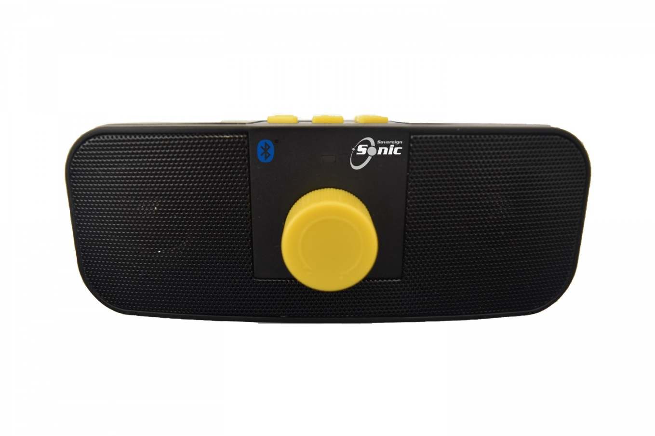

Picture: Sonic portable USB player

Active community

Visually Impaired Tennis
Tennis balls with bells have been blazing across the net this autumn at David Lloyd Cardiff Tennis Club!
The visually impaired version of the game is played on a smaller court than usual, with a lower net. Depending on your sight, you’re allowed up to three bounces before returning.is
VI tennis is fun to play and has a huge social aspect. Maggie Rees said this about her first go at the sport “I thoroughly enjoyed it and loved every minute. It was really, really good, better than I expected actually.”
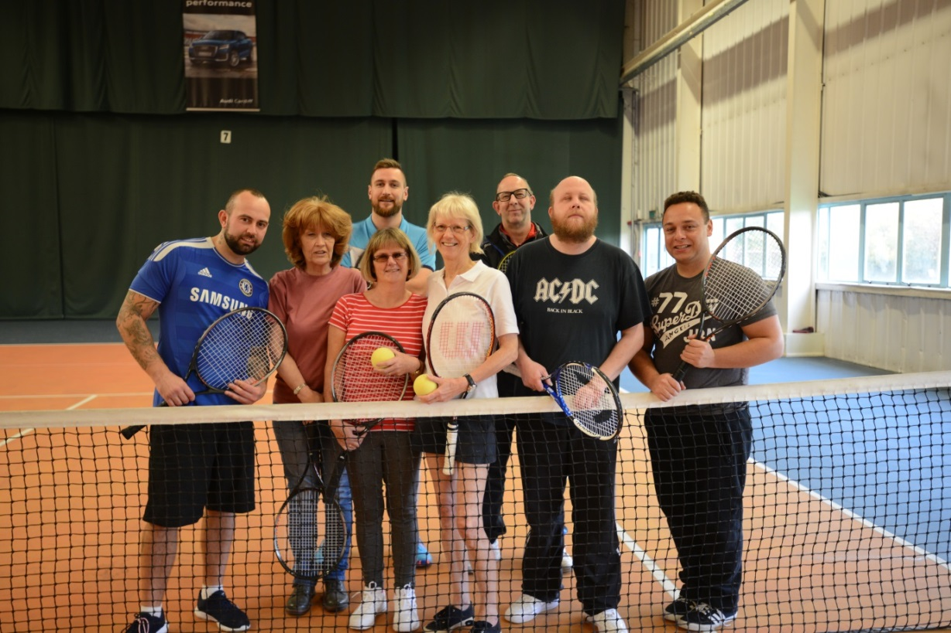

Picture: CIB members and David Lloyd staff on tennis court

Pottery

Members have also been busy testing their pottery skills at Llanover Hall. Wendy and Maggie sculpted some delicate and beautiful roses.

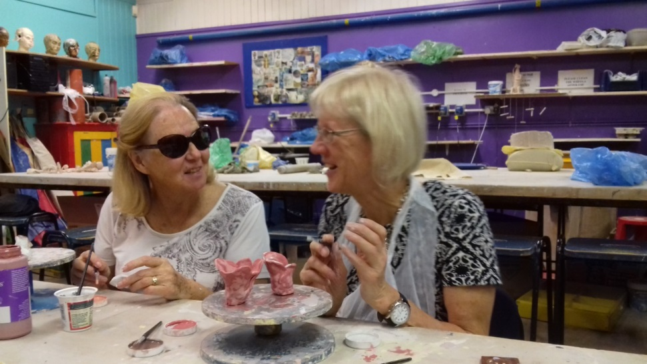

Picture: Wendy and Maggie with their roses

Sherman 5

From tennis to pottery to theatre! Some of our members enjoyed a visit to the Sherman Theatre to watch The Cherry Orchard and enjoyed the opportunity of a pre-show touch tour.

The theatre runs a scheme called Sherman 5 which offers free membership and is designed to give people who have never attended a performance at Sherman Theatre the chance to do so.

The Sherman 5 coordinator can arrange a taxi, free of charge, to bring you to and from Sherman Theatre if required.

For more information, please feel free to get in touch with Alastair 02920 828574.

OrCam MyEye

Designed for blind and partially sighted people, OrCam MyEye is a portable device, combining a smart camera mounted onto the wearer’s eyeglass frame, which is connected to a smartphone-sized computer/battery base unit.

Requiring no internet or power connections, the camera is controlled using easy to use gestures, to provide through a discreet earpiece, text-to-speech of printed text from any surface; including newspapers, books, computer and smartphone screens etc.

In addition to this the MyEye provides facial recognition for up to 100 of your friends and family, and identification of up to 150 products of your choice, including money, credit cards and much more.

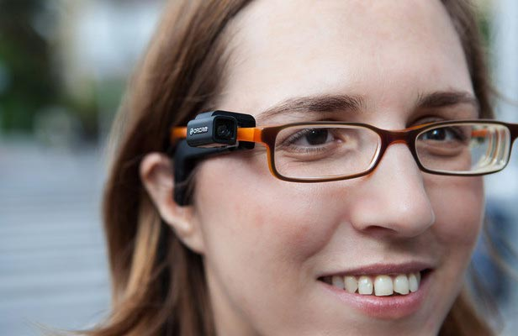

Picture: Orcam MyEye

For a demonstration or for more information contact our office on 02920 398900.

Care and Repair; Managing Better

Aimed at people aged over 50 with a sensory impairment
Care & Repair; Managing Better has specialist caseworkers that are able to make home calls to assess and improve older peoples' living environments. For example, repairs and maintenance, safety, security, heating, lighting, improvements and adaptations to help keep them safe, warm and independent at home and prevent unplanned admissions to care.

If you would like to find out more about the service please contact 0300 111 3333.

The benefits of volunteering

Julie Powiesnik

Julie has been a volunteer with Cardiff Institute for the Blind for the past 10 years. Her first role saw her helping in out Thursday Club when it was held in the Bowchier Hall at Shand House.

Julie also sat on reception and helped with administrative tasks as well as welcoming visitors to CIB and showing customers around the Resource Centre and demonstrating products and gadgets.

Since our move to Jones Court, Julie volunteers every Monday and Friday. She is responsible for updating spreadsheets that record all home visits. You might have received a telephone call from Julie as she also calls members for their feedback on the services we provide.
Julie is very flexible and will help out as and when she is needed whether in one of our clubs, a trip out or with mail-outs.

Julie said “It’s a real pleasure to come and work as a volunteer at CIB. The staff are so dedicated and work very hard so it is very rewarding to be part of the team that does so much for blind and partially sighted people.”
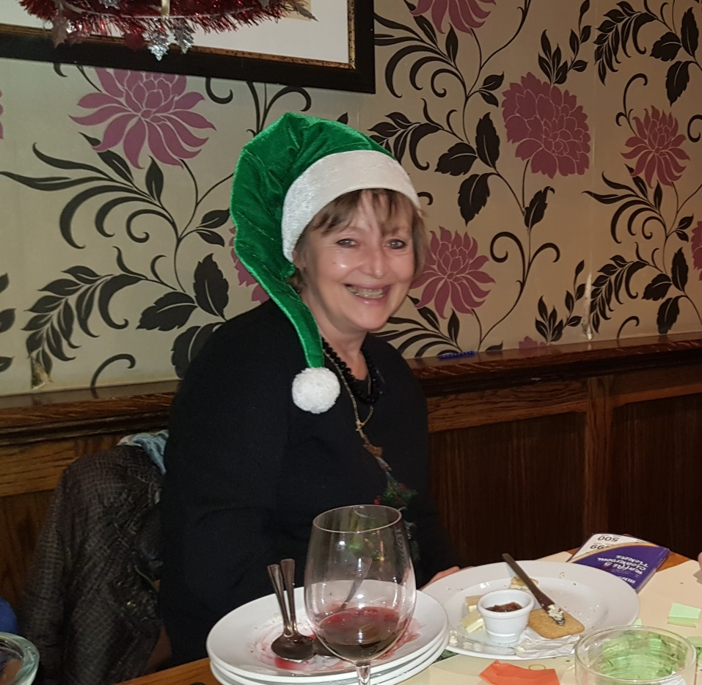

Picture: Julie Powiesnik at our Gardening Club Christmas Lunch

Feedback from our service users

As mentioned above, our lovely volunteer Julie regularly telephones people we support to ask for feedback on the services they have received to help us improve the work that we do. Here is a sample of what people said:

“Teresa visited me twice recently. I really can't fault her service to me. She arranged for me to have a Low Vision Assessment and as a result I am getting new glasses and a magnifier with a light which will be very helpful. She also phoned my Insurance Company on my behalf as I was too nervous to do it myself, that was so helpful. She ordered Talking Books for me and will bring a machine for me to play them on when she next visits. Thank you very much.”

“Michelle has given me excellent service, she has been really helpful! She arranged for me to have Talking Books which I really enjoy and I have a talking watch too. She has also phoned the Council and helped me apply for a reduction in Council Tax, that has just been approved I am so pleased. I can't say enough about how grateful I am for her service; it has made a huge difference in my everyday life.”

“I can say without doubt that the Institute has been a great help to me! Craig has been wonderful. He brought out to my home a CCTV Scanner for me to trial. It is an excellent assistance to me. I can now read letters, documents, bank statements etc. which I couldn't do before. He also sorted out things on my phone and laptop to make them more user friendly for me. I came to the Macular group for the first time and met a few really interesting people, I will try it again in the New Year. Thanks Michelle and Craig for helping me I really appreciate it.”

“I am chuffed to bits with all the help from Teresa. She brought me out a British Wireless for the Blind (BWB) CD player which I have been enjoying enormously I use it every day. She also arranged Talking Books for me, I listen to them using my BWB it is very good quality sound. I also had a Low Vision Assessment and have a magnifier with a light which is very helpful. Thanks so much.”

“CIB is my lifeline. I really enjoy going to the clubs and meeting new people with sight problems like mine. It’s definitely made me more independent, they’ve given me confidence to do things for myself”

Did you know…?

Cardiff is a city of parks and has more green space per person than any other UK core city.

Useful telephone numbers:

CIB | 029 2039 8900
RNIB Helpline | 0303 123 9999
Smell Gas? Wales & West Utilities | 0800 111 999
Power cut? Western Power Distribution | 0800 6783 105
Care & Repair, Managing Better | 0300 111 3333

Please let us know if you no longer wish to receive certain types of communication or any communication from Cardiff Institute for the Blind and if you have signed up to the Fundraising Preference Service.

Cardiff Institute for the Blind

Jones Court

Womanby Street

Cardiff

CF10 1BR

Telephone: 029 2039 8900

Email: CIBPostmaster@cibi.co.uk
Website: www.cibi.co.uk
Twitter: https://twitter.com/CardiffBlind
Facebook: www.facebook.com/CardiffInstitutefortheBlind

