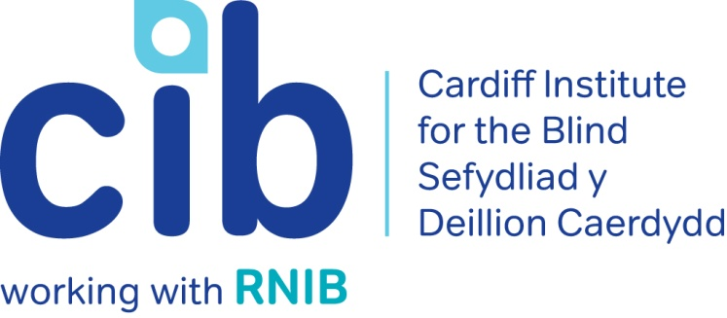

CIB Newsletter

01 March 2017

Welcome to our first newsletter of 2017. We have a wide range of services and events on offer over the next few months, some of which are detailed below. Please contact Michelle or Teresa for any queries or to book an event on 029 2039 8900. Or you can keep up-to-date via our website at www.cibi.co.uk, Facebook page www.facebook.com/CardiffInstitutefortheBlind and Twitter @CardiffBlind

In this edition:

Page 2: Real life: a members journey after losing her sight

Page 3: Independent living sessions

Page 4: Focus on eye conditions: Glaucoma

Page 6: Club of the month: Exercise group

Page 7: Product of the month: RNIB In your pocket
Page 8: Cinema discount card
Page 8: Focus on volunteer: Susan Evans

Page 10: Other news

Page 11: Customer feedback

Real Life: Connie

Connie is registered blind and has been a member of CIB for 2 years. She lost her sight suddenly. Teresa visited Connie at home and explained about the help and support that was available from CIB, RNIB and other local services.

Connie was quite upset and tearful as what she missed most was the theatre. Teresa mentioned our forthcoming Theatre trip and encouraged her to come. She collected Connie on the night and paired her with our volunteer Jean who stayed with her throughout the evening. She attended the pre-show ‘Touch Tour’ where members are taken back stage to ‘touch and feel’ some items such as clothing and props that are used on the set. Using the headsets for the audio description of the performance also enhanced the experience for Connie. She felt comfortable knowing that Jean was with her for the duration and she really enjoyed meeting and chatting to the other members of the group.

Connie then attended one of our independent living sessions where she was given useful information and tips to help make everyday tasks such as getting out and about, shopping and technology easier.

Connie came along to see a few musicals and plays. She had always loved the Theatre but when she lost her sight thought she would never enjoy it again. After coming with the group she realised that she could still enjoy the shows, regardless of how little she could see.

Connie also received support from RNIB Online today team who helped her to use her iPad and has signed up for the RNIB Talking Book Service.

Since her initial visit Connie’s confidence has improved greatly. She is more independent and socially active. She is now a member of the Conversation and Women’s groups and really enjoys the peer support. We also signed her up for a ‘Hynt’ card (which offers a free ticket for a personal assistant or carer at participating theatres and arts centres) and she now attends the theatre regularly with her friend.

Independent living sessions

We are running a range of independent living sessions over the next few months, whichwill offer practical skills, hints and tips and cover topics such as money matters, transport, technology, shopping and health & wellbeing. Guest speakers will be invited to talk at each session and you will be able to ask questions and get individual advice.

Next sessions:

Friday 31 March 2017 – Money matters and shopping
Brief outline of the day:
- Benefits and tax allowance
- Getting the most out of banking
- Products; coin holders, signature guides etc
- Utilities and other services
- Tips on making shopping easier

Monday 24 April 2017– Getting out and about
Brief outline of the day:
- Mobility; aids and navigation devices, support to learn routes, Guide Dogs and guiding.
- Transport; Public transport, taxis, community transport, Transcall, CIB’s volunteer driver service
- Concessions; bus and rail passes, Blue Badge etc
- How to minimise falls

Monday 22 May 2017 – Leisure, health and wellbeing
Brief outline of the day:
- Looking after your health
- Good nutrition
- Sport and fitness; what is available
- Leisure activities
- Emotional wellbeing
- Looking good, feeling good
- Your rights

Mrs C attended the ‘Connect to your community’ session in February. She said:

“Thank you so much for inviting me to the independent living session. I found it really interesting and learned so much. The speakers were all good and I will definitely be coming to the next one”.

To find out about attending, please contact Michelle or Teresa on 02920 398900.

Technology open day

Our next Technology Open Day will be held at Jones Court on Tuesday, 25 April 2017 from 10:30am until 2:30pm. Joining us on the day will be RNIB Online Today team, Enhanced Vision, Dolphin Technology and Blind Veterans UK. Drop in to sample the latest aids in the world of technology.

Focus on: Eye conditions

Glaucoma

Glaucoma is the name given to a group of eye conditions that cause permanent sight loss by damaging your optic nerve.
You may not notice any difference in your vision because glaucoma affects your peripheral vision (also known as your side vision) first. As your peripheral vision is not as sensitive as your central vision, it’s difficult to notice any early changes to your vision – but your sight is being damaged.

There is no treatment to restore any sight loss already caused by glaucoma. But once diagnosed the good news is that treatments, such as eye drops and laser surgery, can prevent further sight loss. Glaucoma is a really good example of why it's so important to get your eyes regularly checked by an optician.

Causes of glaucoma

Glaucoma can be caused by raised eye pressure or a weakness in your optic nerve. Your eye needs a certain amount of pressure to keep the eyeball healthy and in the right shape. But if the pressure is too high, it can cause your optic nerve to become damaged at the point where it leaves your eye.

Types of glaucoma

Primary open angle glaucoma (POAG)
Primary open angle glaucoma is the most common type of glaucoma. It’s a chronic condition which means the damage to your optic nerve and changes to your sight happen very slowly over time.

Acute angle closure glaucoma
Acute angle glaucoma happens when your eye pressure rises very suddenly. It’s very painful and can causes permanent damage to your sight if it’s not treated quickly.

Secondary glaucoma
This is when glaucoma occurs as a result of another eye condition, an operation, injury or medication.

Congenital glaucoma
Congenital glaucoma is a very rare condition that affects young babies. It’s usually diagnosed in early years and managed by specialist clinics.

Treatment
All treatment for glaucoma aims to lower your eye pressure to prevent damage to your optic nerve and your sight. Treatment to lower your eye pressure usually starts with eye drops, and for most people with glaucoma, this is all the treatment they will ever need.

Sometimes, laser treatment or surgery may also be needed to help control your eye pressure and prevent sight loss. Your ophthalmologist (hospital eye doctor) will be able to discuss the best treatment for you.

For a more in-depth look at each type of glaucoma, their causes and specific treatments visit the RNIB website: http://www.rnib.org.uk/eye-health-eye-conditions-z-eye-conditions/glaucoma#understanding or telephone the RNIB Helpline 0303 123 9999.

Club of the month: Exercise group

LIFT- Low Impact Functional Training, is a series of activities and games designed to get older people taking part in physical activity in the local community. The sessions are fun and enjoyable and everyone who comes along has a good time. All of the exercises are done using safe seated and standing exercises so you can always work at a level that's comfortable for you. The sessions are also designed specifically for people who are 50+ so it's never too late to get started.

It's a physical activity that can help you improve your own health and wellbeing in a safe and sociable manner. In partnership with Age Cymru, the classes are held in the Activity Room at Jones Court 11.00am until12noon every Wednesday.

One of the group members said after the last session: “I love the exercise group. It’s great to know everyone in the room can’t see very well so you are not the only one making mistakes! But that’s ok, Jack is really good, he tells you exactly what to do and let’s you go at your own pace.”
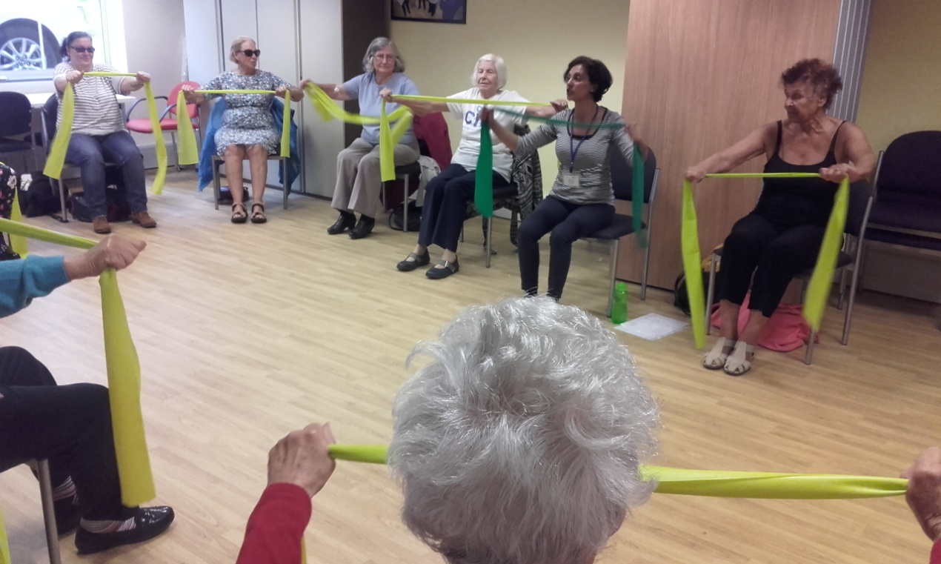

Picture: LIFT group with resistance bands

Product of the week:

RNIB In Your Pocket

Product code: HM61

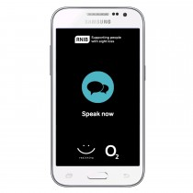

Picture: RNIB In your pocket

In Your Pocket allows you to listen to newspapers, magazines and more than 25,000 books.

For £20 per month, as part of a 24 month contract, you will have a subscription to RNIB Newsagent and Talking Books, a Samsung device and connectivity to O2, with 3GB of mobile data, for on-the-go streaming.

RNIB In Your Pocket was created by RNIB by adapting a Samsung media player to bring you a dedicated reading device. Your monthly payment includes the device, a subscription to the whole of RNIB Newsagent and Talking Books. RNIB Newsagent has almost 200 titles, from daily newspapers to monthly magazines and Talking Books allows you access to over 25,000 books – all of which can be accessed via one voice command.

RNIB In Your Pocket is easy to use straight out of the box, with no need to configure settings.

With In Your Pocket, there’s no waiting for the postman. Just say “Read me The Guardian” and In Your Pocket will oblige.

The device has to be purchased by someone over 18 years of age as they are signing up to a contract and direct debit. The device will contain all library and newsagent content and does not have a parental lock function or capability.

This product must be ordered via the Helpline. For more information please call on 0303 123 9999.

The CEA Card

The national CEA Card scheme makes watching films in the cinema much easier for people with a disability - and often means that a carer can go with you for free. Yes, that's right, two of you can go to the cinema for the price of one.

The scheme was introduced in 2004 and is one of the ways for participating cinemas to ensure they provide a consistent voluntary approach to making reasonable adjustments for disabled guests when they go to the cinema. Around 90 per cent of UK cinemas are supporting the scheme from the large national chains to smaller independent operators.

Under the disability provisions of the Equality Act 2010, cinema operators have obligations to make reasonable adjustments in order to facilitate disabled people going to the cinema. For disabled people, this may mean a carer might be needed to assist them. There is an administration charge of £6.00 for the Card, which lasts for one year.

To apply for the Card, you will need to meet one or both of the following criteria:

- Be in receipt of the disability living allowance, attendance allowance or Personal Independence Payment;
- Be a registered blind person.

The CEA Card is administered and run by The Card Network. For further information on the scheme, including a list of participating cinemas, go to the CEA Card website www.ceacard.co.uk or telephone: 0845 123 1292.

Focus on: Volunteer

Susan Evans

Susan or ‘Little Sue’ as she is affectionately known is registered blind, a mother of 3 and a grandmother of 6 with another on the way. Yet she still finds time to come to CIB to volunteer for at least 2 days every week. You may know ‘Little Sue’ as one of the friendly voices who telephones you on Contact Line or Tele-befriending and she will often call to remind you to come along to the next club meeting. Forever smiling, she is a happy soul with a wicked laugh and a good sense of humour and this comes across in her telephone conversations.

Sue first came into contact with CIB in the early 1990’s when she came to Shand House for ICT training. She became a regular in the computer room and met many like minded people. She joined the Pioneers Group and was a stalwart at every party and social gathering.

In 2000, she became a volunteer befriender providing practical face to face support to other blind and partially sighted members and continued in this role until recently. As well as the Pioneers, Sue is also now a member of our Gardening and Women’s Group and attending these very different groups has given her a very broad understanding of the different needs of blind and partially sighted people and the obstacles they face.

Sue said: "I love it. People are so grateful for that phone call. Sometimes I’m the only person they’ve spoken to that week. Coming here is so important to me and it’s become part of my life. Even though I have quite a large family they have their own lives to live and without CIB I would be very isolated. They’ve given me the confidence to go out. I feel motivated and I don’t feel embarrassed if I have to use my magnifier to read anything.

Ein Llais, Ein Storm -- young people's voice

Ein Llais, Ein Storm, Our Voice Our Storm is Wales Council for the Blind’s (WCB) new young adult project where young adults who are visually impaired have the opportunity to get together to discuss all things sight loss! They want to know what you care about and what you think about services across Wales. If you are interested in getting involved or would like further information contact WCB.
Facebook: www.facebook.com/StormWCB Twitter:@StormWCB
E-mail: mared@wcb-ccd.org.uk or megan@wcb-ccd.org.uk
Telephone: 029 2047 3954

South Wales Talking Magazine Association (SWTMA)

The South Wales Talking Magazine and Cardiff Talking Newspaper have been updating their list of listeners who receive their CD publications. They realise that after many years they may been sending CDs to some people who no longer wish to hear them. To update the list they recently sent everyone a postcard in both the weekly Newspaper and monthly Magazine asking them to
post the card back to confirm they wished to continue receiving the CDs.

For future editions of both publications they will only be sending to those who have replied. If for any reason you didn't respond then your next edition of the Newspaper or Magazine will not arrive. However you can easily be put back on the mailing list by contacting them either by writing to SWTMA c/o Cardiff Institute for the Blind, Jones Court, Womanby St, Cardiff CF10 1BR or by leaving a message with us on 029 2039 8900 You could
also email: info@swtma.com

Guide Dogs launch 'Access All Areas' petition

Although guide dog users are entitled to enter most vehicles, services and premises with their dog, research by the Guide Dogs organisation has shown that the majority of them have experienced some access refusals, despite the Equality Act. One of the most frequent problem areas has been taxis/minicabs. Now Guide Dogs has set up a petition calling on the UK Government to make disability equality training a requirement for all taxi and minicab drivers to help them understand the rights and needs of disabled people.

To find out more and sign the petition, visit the Guide Dogs website http://e-activist.com//ea-action/action?ea.client.id=113&ea.campaign.id=61279&ea.tracking.id=website

RNIB Cymru's Online Today team win WCVA award

Congratulations to RNIB Cymru's Online Today team, who were successful in the Wales Council for Voluntary Action (WCVA)'s annual awards. The team were joint winners in the 'digital inclusion' category.

The team help people with sensory loss discover the benefits of technology in their daily lives. To find out more about their work contact Rachel on 029 2082 8518.

Feedback from CIB members

Our lovely volunteer Julie regularly telephones members to ask for feedback on the services they have received to help us improve the work that we do. Here is a sample of what people said:

“I have been partially sighted for many years, I first joined the Computer Group several years ago. Now I use the computer skills that I learned at the class to do admin work as a volunteer. I also organise trips for some of the Groups. My quality of life has immeasurably increased through joining Cardiff Institute for the Blind. Thank you so much I am so grateful.”

“She has been extremely helpful. She demonstrated and set up a talking book player for me in my home which I find very valuable. It has become part of my routine to listen to it every day. She has also arranged for the RNIB Talking Books and South Wales Talking Magazine to send me discs, which I find very interesting and informative.”

“I can’t get out, so she brought a liquid level indicator to my house. It is very useful for making cups of tea and coffee safely without me burning myself. That’s definitely improved my independence and confidence and it’s just a little gadget. It’s amazing!”

“He brought me out my talking watch that he got repaired for me, he is such a nice man and always gives excellent service, he’s marvellous! Having a link with him and knowing he is there to help definitely gives me confidence that I have help when I need it. I don’t know what I would do without CIB."

“I belong to several clubs. Women’s Group, Listening Club and Pioneers. It gets me out and about and boosts my confidence to go out and interact with other people who have similar problems to my own. Thanks for being there for me CIB.”

"The help I had from CIB was life changing. I had no idea that there was so much help for partially sighted people by CIB available. I am coming into the Computer class to learn how to use my tablet, which I thought I would never be able to use. Thank you so much.’

Did you know?
Laughing 100 times is equivalent to 15 minutes of exercise on a stationary bicycle…

