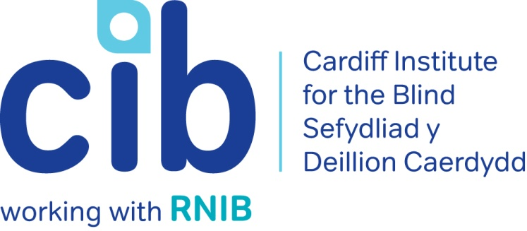
–

CIB Newsletter

Summer 2018

Jane’s story shows you how valuable our Contact Line service is. Without that initial call, Jane might not be as independent as she is today. We also talk about ways that you can get involved in community activities and have also included an article on some of the best apps available for blind and partially sighted people and how the Apple Store helped one of our members.

Please contact Michelle or Teresa for any queries or to book an event on 02920 398900. Also keep up-to-date via our website at www.cibi.co.uk, Facebook page www.facebook.com/CardiffInstitutefortheBlind and Twitter @CardiffBlind

In this edition:

Page 2: Real life: Jane

Page 3: Meals on Wheels

Page 3: Independent living sessions

Page 3: Focus on eye conditions: Cataracts

Page 5: Technology Open Day

Page 6: Product of the month: Eye-shields
Page 6: Apps we can’t live without
Page 8: Active Community
Page 16: How Apple can help
Page 17: Customer feedback

Real Life: Jane

Jane was telephoned via our Contact Line service, which is where a volunteer calls everyone on our database that has agreed to find out how they are, whether they need any help and advice or just want a chat. During this call Susan (our volunteer on Contact Line) felt that she might benefit from more frequent calls and suggested adding her to our tele-befriending list where we phone for a more regular chat.

She agreed and was contacted by our volunteer Jeff, who established that she was quite isolated and could benefit from a home visit to asses her needs.

One of our staff members called Teresa visited Jane at home and made referrals to Care and Repair; to install more suitable lighting and handrails; and to RNIB Advice Service as she was not receiving any benefits. Jane purchased a Sonic USB memory stick player so that she could listen to the South Wales Talking Magazine and Newspaper and RNIB Talking Books. Teresa also encouraged Jane to come into our Cardiff Centre to look at the range of products that might help with everyday living tasks.

Teresa also arranged for Jane to have a domiciliary low vision assessment and she has now received magnifiers and a lamp, which are provided free of charge on permanent loan from the Wales Eye Care Service. Jane is delighted that she is now able to read print again.

Jane said:” I am overjoyed with all the support I am getting from CIB. It's overwhelming the amount of care shown to me by the staff and volunteers. Teresa organised for the optician to come to my home for a low vision assessment and I can now read my mail. It’s amazing. I now have RNIB Talking Books and the South Wales Talking Magazine and echo which keep me occupied. Since I have been with CIB, my life has changed so much. I didn’t know there was so much help available. I now have attendance allowance now so I can pay for taxis to go out. I have a bit of independence back. Thanks so much.”

Meals on Wheels

Cardiff Councils fantastic Meals on Wheels service is now available 7 days a week. Customers across Cardiff are able to enjoy hot, nutritious meals that cater to a variety of dietary requirements and cultural choices, delivered free to their homes for only £3.90 per day.

Customers can refer themselves to the service or be referred by family, friends, neighbours and health/social care professionals.

For more information on the service or if you would like literature posted, please contact Jessica Pritchard on 029 20537080 or email: JePritchard@cardiff.gov.uk.

Independent living one-day sessions

Held at our Jones Court centre in Cardiff, our independent living sessions give blind and partially sighted people and their families the opportunity to introduce themselves to other blind and partially sighted people and get advice on things like managing your money, getting out and about and health and wellbeing. All modules are interactive and have a practical element. They are facilitated so that people can share their questions, experiences and knowledge and we let people know where to go for further information, advice and support.

Places for these sessions are limited, so if you and your partner/carer would like to attend please contact us on 02920 398900.

Focus on eye conditions: Cataracts

Cataracts

A cataract is a clouding of the lens in your eye.

Your lens sits just behind your iris, the coloured part of your eye. Normally your lens is clear and helps to focus the light entering your eye. Developing cataracts will cause your sight to become cloudy and misty.

Cataracts can affect one or both eyes. Cataracts are treated by surgery, during which the cloudy lens is removed and replaced by an artificial lens.

Causes of Cataracts

Developing cataracts is a normal part of growing older. Most people start to develop cataracts after the age of 65, but some people in their forties and fifties can also develop cataracts.
Certain things make it more likely that cataracts will develop:

- Diabetes – people who have diabetes often develop cataracts earlier.
- Trauma – having an eye injury can cause the injured eye to develop a cataract.
- Medications – some prescription drugs can cause cataracts, for example steroids.
- Eye surgery – surgery for a retinal problem will likely lead to cataracts in the affected eye at some point in the future.
- Eye conditions – other eye conditions, such as retinitis pigmentosa, glaucoma or uveitis, may also cause cataracts.
- Having high myopia - (being very short sighted) may cause cataracts.

Cataract Symptoms

Cataracts normally develop very slowly. At first, the changes to your sight may be slight, but as your cataracts get worse you’ll start to notice symptoms such as:
- You feel like your glasses are dirty and need cleaning, even when they don’t.
- Your sight is misty and cloudy.
- You’re more sensitive to light and in particular glare.
- Everything looks a little more washed out than it should be.

Eventually, almost all people with cataracts will find that their sight has turned misty or cloudy and things have become difficult to see.

Cataract Surgery

Cataracts can be removed by surgery. Cataract surgery removes your cloudy lens and replaces it with an artificial prescription lens. This lens is known as an intra ocular lens – often shortened to IOL. The artificial lens is made of plastic or silicone, and will not need to be changed for the rest of your life.

There isn’t any medicine or drops that can remove cataracts – surgery is the only way to treat them.

If you would like more information about Cataracts please contact us or you can access the RNIB website here:
http://www.rnib.org.uk/eye-health-eye-conditions-z-eye-conditions/cataracts

Technology Open Day

Our next Technology Open Day will be held at Jones Court on Tuesday 11 September 2018 between 10.30am and 3pm. We will be joined by Enhanced Vision, Dolphin Technology, Macular Society and Blind Veterans UK. Drop in to sample the latest aids in the world of technology.

Featured product: Eyeshields
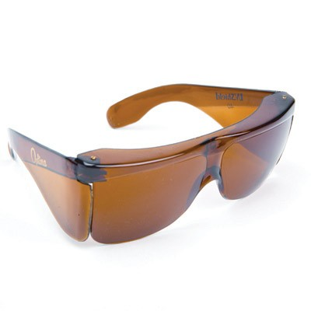

Picture: Amber fit-over eyeshields

Protect your eyes from harmful light with eyeshields. Similar to sunglasses, eyeshields are designed to exclude harmful ultra violet (UV) and blue light which can damage the retina, while the different filter tints can help increase contrast and definition. They're light and easy to wear, in and outdoors and some can even be worn over your existing prescription glasses - just choose the right colour tint for your eye condition and needs.

Call into our Cardiff Centre to have a look at the range of eye-shields available, prices start from £7.15 per pair.

Apps we can’t live without

A Smartphone or Tablet is nothing without apps. There are hundreds of them available and no matter what your interests are, there is one for you. Here is a free one that can support people with sensory loss:

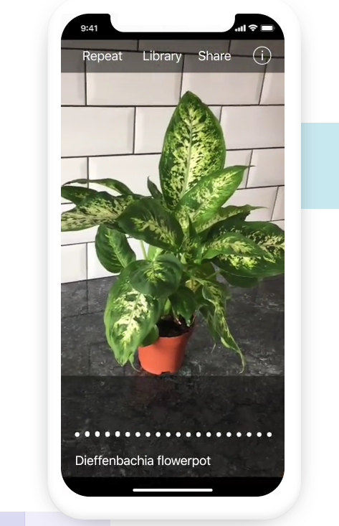
TapTapSee

TapTapSee uses the camera on your Tablet or Smartphone to identify objects in photos. Simply take a picture by double tapping the screen and the app will give you a description of the items in the picture. If you have the phone’s screen reader turned on, it will read the description aloud.

The app logo should look like this:

Seeing AI

Designed for the blind and partially sighted community, the app harnesses the power of artificial intelligence (AI) to open up the visual world and describe nearby people, text and objects.

The app, currently only available on iOS, uses the device’s camera to perform a number of useful functions including:

- Reading documents – with spoken hints to make sure the user captures the full page. It then recognises the structure of the document such as headings, paragraphs and lists, allowing the user to rapidly skip through the document using VoiceOver.
- Identifying a product based on its barcode – simply move the phone’s camera over the product; beeps indicate how close the barcode is (the faster the beeps, the closer it is) until the full barcode is detected. It then snaps a photo and reads the name of the product.
- Recognising people based on their face – and providing a description of their visual appearance such as their gender, facial expression and other identifying characteristics.
- Recognising images within other apps – just tap Share and Recognise with Seeing AI.

The Microsoft Seeing AI app is available free from the UK App Store.
The app logo should look like this:

Active community

Thanks and farewell to Alastair, hello to Jane.

Many of you know Alastair Sill, who worked hard last year as the Community Coordinator for our Big Lottery project to give people more opportunities to try or keep doing sport and leisure activities in Cardiff. He captured our hearts and became very much part of the Cardiff team. He built up a wonderful network of contacts across Cardiff, in theatres, leisure centres and museums, including Llanishen Leisure Centre, the Star Hub, Western Leisure Centre, the National Museum of Wales, St Fagan’s, Sherman Theatre, New Theatre and many more.

His work raised awareness of the barriers often faced by people with visual impairments participating in sport and leisure activities in the community. This paved the way for a warm welcome for visually impaired users in these venues and a general eagerness among service providers to remove or overcome many of the barriers faced by blind and partially sighted people. One of our service-users, Mavis, commented after a visit to the Sherman Theatre: “Once they found out I was partially sighted, they couldn’t do enough for me”.

Alastair enabled and inspired many people to do things they had not done for years or had not thought of doing at all and we’d like to say a huge thanks and best wishes to him for the future.

Whilst we were very sorry to say goodbye to Alastair, we were also very excited to say hello and welcome to Jane McCann, who took over Alastair’s role in April. Jane has kindly written the next article to say hello to you and explain what she hoped to achieve.

Hello from Jane McCann

I have been the Community Coordinator for Cardiff since Alastair left at the end of April, encouraging and supporting people to start new activities or go back to things they used to do but have perhaps stopped due to developing sight loss.

I know as a person with sight loss myself that starting a new activity can be daunting. My job is to ease that process. If anybody would like to try something new, but would like a bit of support or advice, or perhaps have a go first with other blind and partially sighted people, please get in touch with me. It would be lovely to hear what you are interested in trying out.

In the autumn, I will be arranging open days and taster sessions at more of the leisure centres. Leisure centres are now welcoming to all people of all ages and abilities. Gone are the days when leisure centres were full of elite athletes in all their fancy gear.

I will also be arranging visits to the local libraries to find out everything that is going on there. All the libraries are now “well- being hubs” and do much more than provide books. All sorts of social groups meet in the hubs, so please get in touch if you would like to be involved.

Below are some of the activities that people have taken up over the past couple of months.

Bowling

Gary and Dav have both taken up bowling this summer. Gary attends an indoor group in Sophia Gardens and I must say looks very professional.

Dav attends a new VI group in Whitchurch, where he enjoys both the bowling and the social side of the club on the weekend.
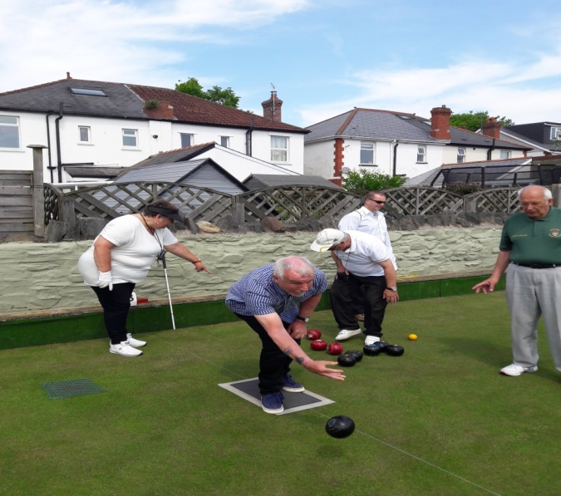
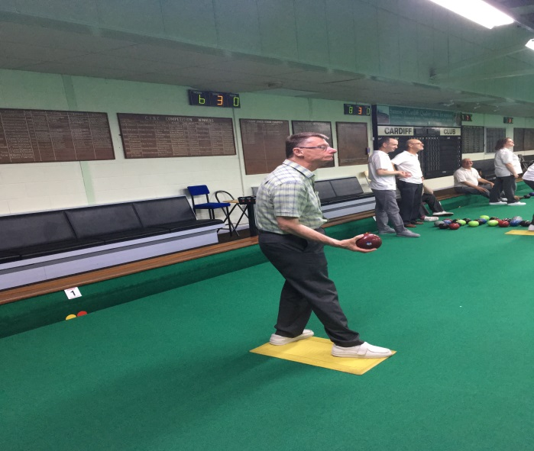
Picture: Gary bowling Picture: Dav bowling

There is also a club which meets in the bowling pavilion on Llandaff Fields on a Sunday afternoon for a bit of bowling, a pot of tea and a bit of banter. Harry and Sandra have been running the club for years and it is a lovely way to spend a Sunday afternoon.
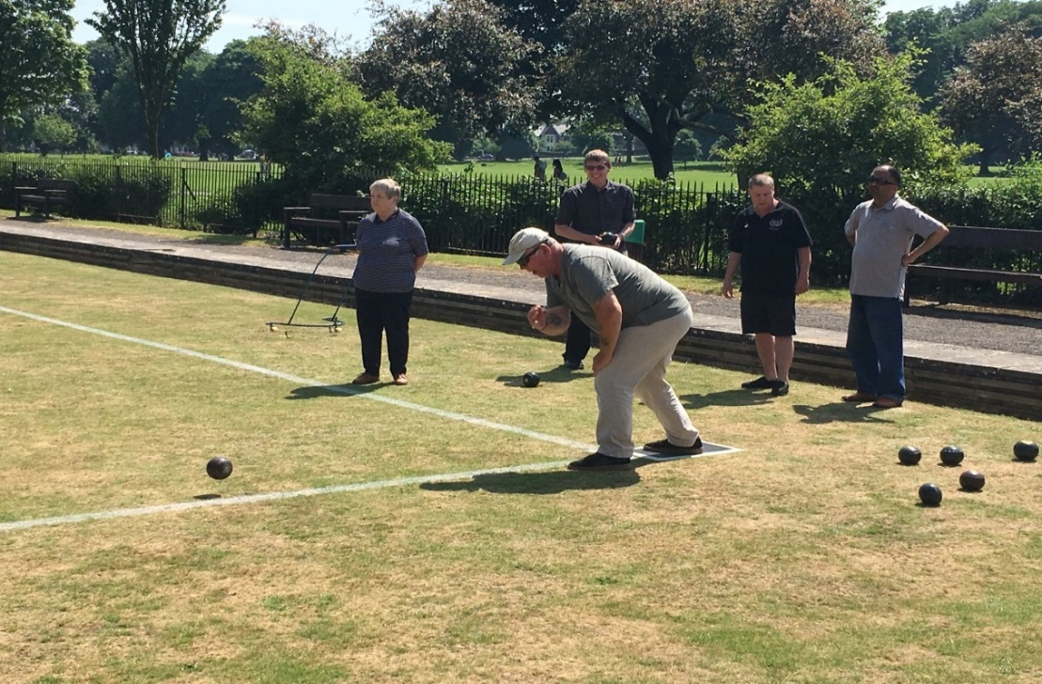

Picture: bowling at Llandaff Fields

Cycling

We have had great fun cycling up the Taff Trail on tandems from Pedal Power in Sophia Gardens.

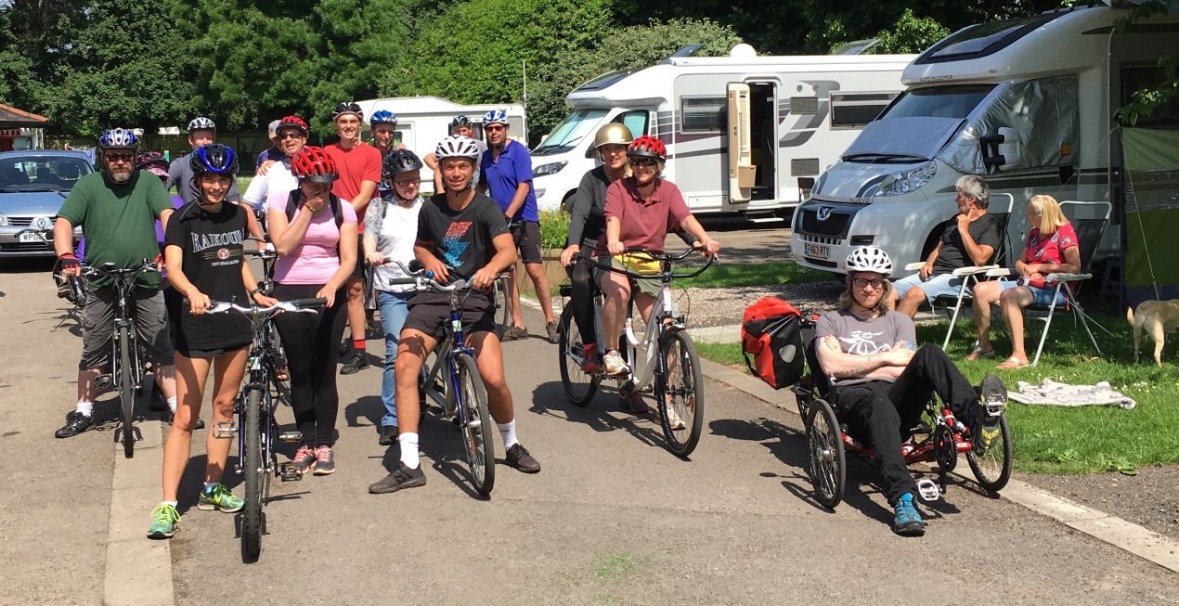
Picture: Group of our riders and pilots.
This will be a regular event from 11am -1pm on the first Sunday of every month – next meet 5 August. Get in touch if you would like to join in but spaces are very limited, so pre-booking is essential. We will also be organising a couple more sessions during the week before the end of the summer for those who can’t make the week ends.

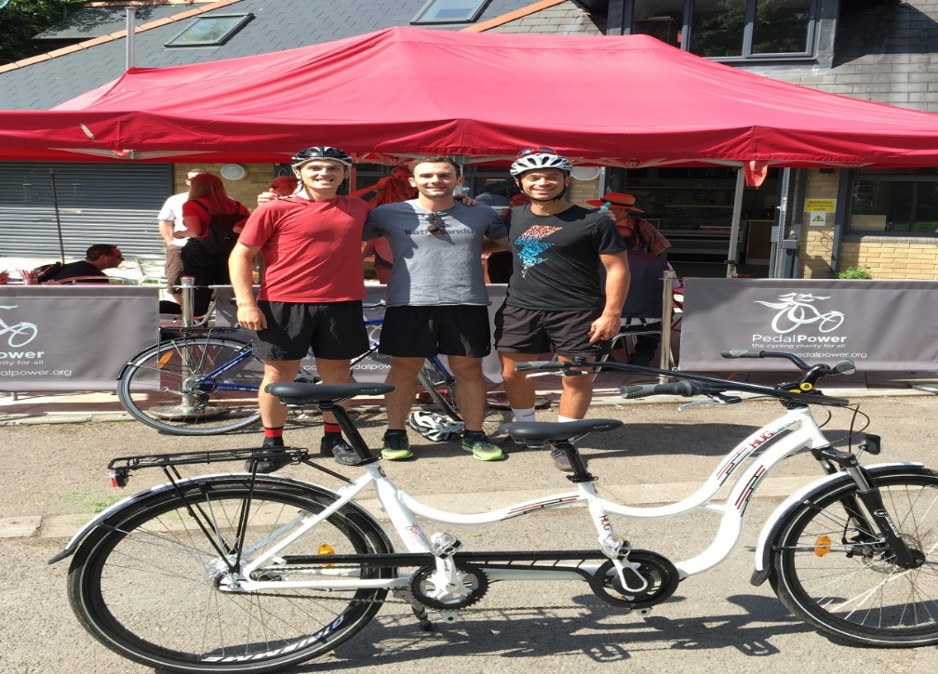

Tandems and side by side bikes are available for anyone to hire from Pedal Power, any day of the week if you have a sighted friend to steer, though it is wise to book.

Audio Book Clubs

A new book club will be starting in the autumn in Central Library,. Also, the books discussed in the book clubs in all the local libraries should be available in audio format.

Anyone interested in attending a book club should contact Michelle, Teresa or Jane in the office.

Dancing

Some of the ladies (and one dog) also tried their hand at circle folk dancing. Another session will be held in CIB on September 18th if anyone would like to join in.

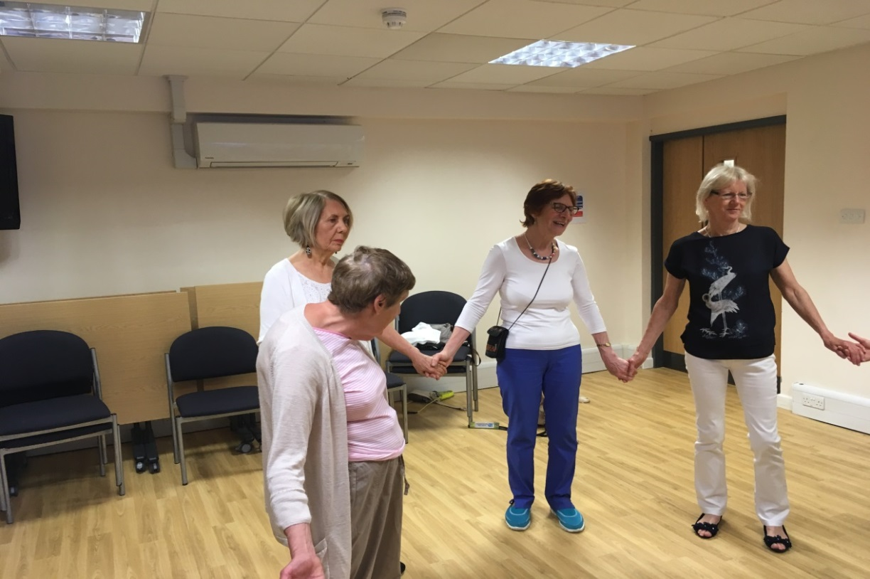

There is a U3A group that does circle dancing every other Tuesday morning in The Tabernacle in the Hayes. They are very welcoming to partially sighted people if you would like to go along, or contact Jane at CIB if you would like further details.

Ukulele

Nicki spent the day learning to play the ukulele with an adult education workshop (£20 for the day).

The tutor made sure that Nicki fully participated in the sessions and she thoroughly enjoyed her day.

The ukulele has become a very popular instrument. It is one of the easier ones to pick up and there are now many groups across the city that meet up on a weekly basis just for a social strum.
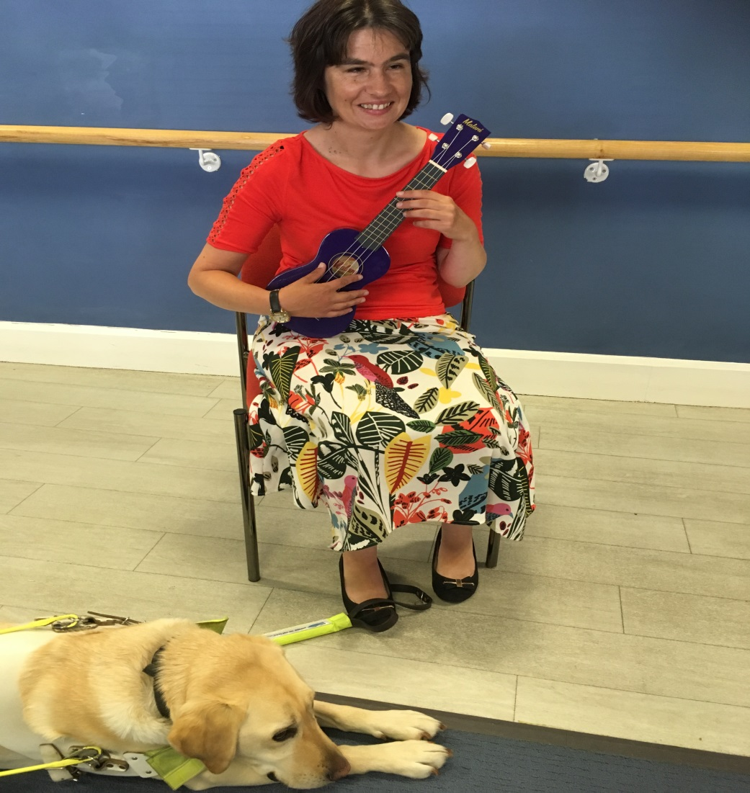

Picture: Nicki with a ukulele

If you are interested in finding out more or learning to play yourself, get in touch with Jane.

Dates for the Diary

Ceri Dupree Touch Tour – 01 September 2018 – New Theatre Cardiff.
There are many other touch tours and audio described performances across the city in the autumn.

Disability Sports Have a Go Day Cardiff – 07 & 08 September – Cardiff Met, Cyncoed.
Opportunity to try out all sorts of sports made accessible for people with disabilities.

Ceramic tactile art exhibition – 13 & 15 September – The Arcade, Queens Arcade, Cardiff.
A tactile exhibition displaying the various stages of producing ceramic art.

Circle Dance Taster – 18 September – CIB.
Opportunity to try some traditional folk dances from around the world.

British Blind Sport Have a Go Day – 29 September – Leckwith House of Sport.
Opportunity to try various sports, including shooting, goalball, archery, football, cricket (exact sports to be confirmed).

Other dates will be announced shortly for visits to the leisure centres, the exercise groups and the libraries. Please contact Jane so that she can let you know the details.

There are various Touch Tours and Audio Described performances lined up in the theatres across Cardiff and Newport. If anybody would like details, please get in touch.

How Apple Can Help

Georgia has total sight loss and had lost her confidence in using her iPhone. Constant updates had changed the way it worked and she was struggling to use it. She mentioned to CIB that she needed help with her phone but that she could not get in touch with the Apple shop, and that, even if she could, she would not be able to find her way up to the shop.

RNIB’s Digital Inclusion officer had been in discussion with Apple for some time and when CIB approached, the store, they could not have been more helpful. We passed Georgia’s details to Grant at the Apple Shop and he phoned her to arrange an appointment. He arranged to meet her from the taxi at 9.25 on Monday morning and was there waiting for her (even though all the trains from Newport had been cancelled due to the electrification work and he had had a nightmare journey in). He went up in the lift with Georgia, spent an hour going through the things she was struggling with and then guided her back down to the taxi. He also arranged to phone her for an appointment the following week to carry on from where they left off.

As a result, Georgia is much more confident in using her phone and is inspired to start using it in new and different ways.

If anybody has an iPhone or iPad they need help with, the Apple Shop in Cardiff are very happy to phone you to arrange a suitable appointment. All you need to do is call us at CIB and we will get in touch to ask them to give you a call or you can call direct on 0800 107 6285. We are now supporting another member to try out the new system.

When booking your appointment, let them know if you need someone to meet you by the entrance to the shopping Centre. Tell them which entrance it will be and what time you will be there. The easiest entrance is the Admiral House entrance by Zizzi’s.

There are many options for your appointment in store:
- You could book a short 10 minute technical support appointment at the Genius Bar.

- You can book an individual one to one training appointment which can last up to an hour. Your member of staff will go through anything you want to look at, including how to use voiceover or other accessibility features in relation to apps. You can also use the time to sort out any technical issues like your password or thumbprint.

- If a few of you would like to go together, you can ask for a small group session, again for up to an hour. This may be a good way of exploring new apps that are useful for people with sight loss for example Seeing AI, Be my Eyes or Soundscape. If enough people get in touch to let us know they are interested, we could perhaps arrange for regular sessions of this type.

The best time to book an appointment is first thing in the morning as the store is at its quietest. It will be easier to hear and the staff will be more available for meeting and greeting.

If anybody does book an appointment in this way, please let us know how you get on so that we can feed back to Apple.

Feedback from our service users
We’ve had some great feedback from you. Thank you for taking the time to talk to our volunteer Julie about your experience. We really do appreciate it, as it demonstrates to others the impact our services have.

Here are some of our favourite quotes:

- When I was diagnosed as partially sighted I was totally scared and desperate. I was sent to CIB and I never looked back after that. Spiro was brilliant. He introduced me to members who had similar problems to me. I had awful fears and they helped take them away because they inspired me to learn ways to cope and embrace life. It totally transformed my attitude to being positive and grateful for the little sight I had. He also taught me to touch type which has been totally invaluable. That was 10 years ago and I’m still living life to the full thanks to CIB.
- Michelle came to see me, she is wonderful. She really listened and has done a lot for me. I used to be an avid reader and got a lot of pleasure from it. Michelle introduced me to Talking Books which are amazing and have made a huge difference to my quality of life since losing my sight. I thoroughly enjoy murder mysteries, often listen to them twice, they enrich my life. Thank you so much.
- Craig is an amazing technical expert and is a total asset to CIB. He has majorly supported me by introducing me to the Synaptic smart phone and the Visum, a specially adapted tablet on a stand which helps me read letters and do crosswords etc. He took the time to expertly coach me in using both. It has made me so independent despite my sight loss. Thank you.
- Michelle came to visit me at home. She knew exactly what I needed so she got Care and Repair to come and put new lighting in my kitchen including lighting at counter level. It's a fantastic transformation it has changed my life. I can see so much clearer in my kitchen now, even the microwave looks bigger. It's a pleasure to come out and use the kitchen so I'm more independent and can cook more nutritional meals. Thanks Michelle and Care and Repair.
- Thank you Teresa, we really enjoyed coming along. I must say the atmosphere you have created in that group was so wonderful. I have been volunteering for years and never been to such a nice group, testament to you I think. You are such a positive lady.

The importance of safeguarding

CIB takes the safety and safeguarding of our service-users, volunteers and staff very seriously and we do everything we can to ensure people at risk are not harmed in any way whilst accessing our services. Any behaviour that is deemed to put people at risk of harm will not be tolerated and action will be taken immediately, with referral if necessary to the appropriate statutory agencies.

Part of our role on safeguarding is to ensure people know what safeguarding is and what to do if they see or are involved in an incident, suspect something or just have a question.

Section 126(1) of the Social Services and Well-being (Wales) Act 2014 defines an adult at risk as an adult who:-

(a) is experiencing or is at risk of abuse or neglect;
(b) has needs for care and support (whether or not the authority is meeting any of those needs); and
(c) as a result of those needs is unable to protect himself or herself against the abuse or neglect or the risk of it.”

Section 197(1) of the Act provides definitions of “abuse” and “neglect”:
“abuse” means physical, sexual, psychological, emotional or financial abuse (and includes abuse taking place in any setting, whether in a private dwelling, an institution or any other place), and “financial abuse” includes:-

- having money or other property stolen;
- being defrauded;
- being put under pressure in relation to money or other property;

If you have a safeguarding concern or question, please contact your local authority adult safeguarding team on the following numbers:
Cardiff 029 2233 0888. (If outside office hours, contact the emergency duty officer on 029 2078 8570)

Vale of Glamorgan 01446 700111 (If outside office hours, contact the emergency duty officer on 029 2078 8570)

You can also contact one of our managers or the CIB Director Kieran Harris on 029 2039 8000. We also gain support and advice from RNIB and you can also contact them via safeguarding@rnib.org.uk or 0207 391 3283.

Data protection and contact from CIB
Many of you will be aware of the new regulations on data protection, called the General Data Protection Regulations, which came into force this May. This gives people more control over their data and how it is used. CIB has always taken its responsibility of taking and using personal data very seriously.
We have usually taken verbal consent to store and use information but we now have to be able to evidence that we have consent, particularly for email and text communication.
So that we can stay in touch to share relevant news and information, provide services and let you know how you can help support the work we do, we would be very grateful if you can return this form to us at Cardiff Institute for the Blind, Jones Court, Womanby Street, Cardiff CF10 1BR; or call 029 2039 8900, or email you preferences to cibpostmaster@cibi.co.uk
Please indicate below what you'd like to hear from us about by putting a cross in the relevant boxes, or just put a cross in the box titled ‘All’ if you want to receive information, advice and news on everything we do:

□ Services and products
□ General news
□ Campaigning and Volunteering
□ Fundraising
□ All

Please indicate below if you want to hear from us by email or text:
□ Yes, I want to hear from you by email
□ Yes, I want to hear from you by text

Please indicate below if you don’t want to hear from us by post or phone:
□ No, I don’t want to hear from you by post
□ No, I don’t want to hear from you by phone

Useful telephone numbers:

CIB | 029 2039 8900
RNIB Helpline | 0303 123 9999
Smell Gas? Wales & West Utilities | 0800 111 999
Power cut? Western Power Distribution | 0800 6783 105
Care & Repair, Managing Better | 0300 111 3333

Cardiff Institute for the Blind

Jones Court

Womanby Street

Cardiff

CF10 1BR

Telephone: 029 2039 8900

Email: CIBPostmaster@cibi.co.uk
Website: www.cibi.co.uk
Twitter: https://twitter.com/CardiffBlind
Facebook: www.facebook.com/CardiffInstitutefortheBlind

