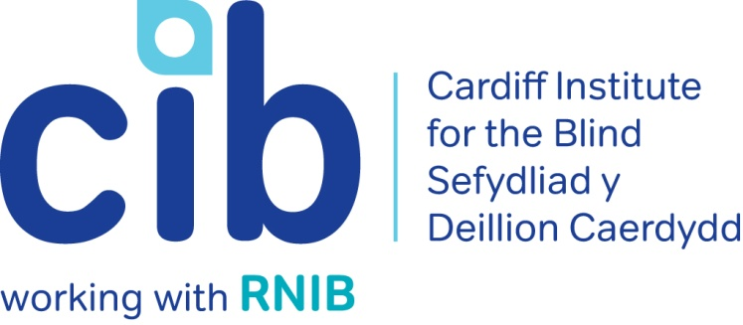
–

CIB Newsletter

Winter 2018

May we start by wishing everyone a very merry Christmas and a happy and healthy new year.

In this edition, we want your help in deciding whether to change our name. You can read more about this important decision on page two. We have also included some information on accessible televisions and more of our favourite apps. Jane gives an update on her project and ways that you can get involved in community activities.

Please contact Michelle or Teresa for any queries or to book an event on 02920 398900. Also keep up-to-date via our website at www.cibi.co.uk, Facebook page www.facebook.com/CardiffInstitutefortheBlind and Twitter @CardiffBlind

In this edition:

Page 2: CIB Name change consultation

Page 3: Welcome Natalie

Page 3: Real life: Andy’s story

Page 4: Technology for Life

Page 5: Independent living sessions

Page 6: Focus on eye conditions: Glaucoma

Page 7: Product of the month: 2019 Pocket diary
Page 8: Apps we can’t live without
Page 10: Accessible TV’s
Page 12: Active Community
Page 18: Customer feedback

CIB name change consultation

Cardiff Institute for the Blind has been working across South Wales for nearly 10 years. Over this time we have used a couple of different names when delivering services outside of Cardiff as we weren’t sure people would engage with a charity that just had Cardiff in the name.

Lately we have been using the RNIB name in some areas as we are an associate charity of RNIB and work very closely with them to ensure people get a wide range of support. This has understandably caused confusion and created difficulties with things such as data protection and fundraising.

More and more people we speak to are initially saying they don’t want our support or don’t feel eligible for our support because they think we just help people with no sight. We also sometimes have to work hard to assure those who are partially sighted that we can make a difference to their life. For information, it is thought around 93% of people registered as sight impaired or severely sight impaired have some level of sight.

People are also put off by the ‘Institute’ part of our name, having preconceptions that we employ blind and partially sighted people to make things like wicker baskets or that we are a residential home for blind and partially sighted people.

So, we have decided to consult on changing our name to one that:

• Communicates that we work across South Wales

• Is more relevant to what we do

• Allows us to work with more people

We can assure you that the cost of changing our name if we do will be small and we believe any additional cost will be more than made up by the additional income we believe a name change will bring.

We know that changing our name is a big decision and we will only change it if we are sure it is the right thing to do for the people we want to make a difference for. We exist to support blind and partially sighted people enjoy independent and fulfilled lives, so your views are essential.

With that in mind, we want your help in deciding whether to change our name and what name might give us the greatest impact in delivering our future work.

You can give us your thoughts by telephone on 02920 398900, by asking for a large print version of a questionnaire or by completing an online questionnaire. Please also telephone us if you want to complete the survey in Welsh. For more information and a link to our online questionnaire, please visit our webpage

https://www.cibi.co.uk/decideourname/

Welcome Natalie

We are delighted to welcome Natalie Moore to our team. Many of you will already know Natalie as she was the RNIB/CIB Receptionist before joining us as our new Resource Centre assistant at the end of October.

Real Life: Andy

Michelle visited Andy at home following a call regarding a new cane. Andy was struggling with his mobility as his sight had deteriorated and he had lost all confidence. He would not go out alone and using public transport was difficult as Mandy his wife suffers from MS and uses a motorised scooter which often could not access the bus. Andy was becoming increasingly isolated and depressed.

Michelle referred Andy to the Rehabilitation Officer for further mobility training, RNIB to check his benefit entitlement and to Care and Repair for additional lighting and to paint the edges of his steps. She also encouraged Andy to attend our finding your feet session.

Following his first visit to Jones Court with Mandy, Andy joined our conversation group where he was introduced to other members. Following his mobility training Andy was able to travel to CIB on the bus independently. This was a huge confidence boost for Andy and he then became instrumental in setting up our Photography group.

Andy recently attended an exhibition at Llanover Hall and had a discussion with the Manager about setting up his own exhibition along with two other visually impaired members of the photography group.

‘The help Michelle and CIB have given me has been phenomenal. It's up there as a miracle, likened to getting the cataract removed from my eye and being able to see colour again! Before she came to see me at my home, I was lost and confused and Mandy my wife who has MS had to do everything for me. CIB has made a 200% difference to my life. I am doing so much more and even go on a bus on my own. Previously my wife had to guide me everywhere.’

‘I am now enthusiastic to keep creating and learning new skills. My life has totally changed and turned around and I now have a very optimistic outlook due to Michelle's help and hard work. Thank you’

Technology for Life

Do you have a smartphone or tablet that you are struggling to use or no longer use? Would you like to try before you buy or learn a bit more about what devices are available and which best suits your needs?

We support people with sight loss to understand technology, what would be best for them and how it can increase independence.
We can offer:

- Information and advice about devices, apps and accessibility features
- We connect people to the most appropriate support in their community
- Volunteers who can support people at home

For further information please contact out office on 02920 398900 or you can call the RNIB Helpline on: 0303 123 9999 Or email: tfl@rnib.org.uk

Independent living one-day sessions

Held at our Jones Court centre in Cardiff, our independent living sessions give blind and partially sighted people and their families the opportunity to introduce themselves to other blind and partially sighted people and get advice on things like managing your money, getting out and about and health and wellbeing.

All modules are interactive and have a practical element. They are facilitated so that people can share their questions, experiences and knowledge and we let people know where to go for further information, advice and support.

Places for these sessions are limited, so if you and your partner/carer would like to attend please contact us on 02920 398900.

Focus on eye conditions: Glaucoma

Glaucoma is the name given to a group of eye conditions that cause permanent sight loss by damaging your optic nerve.
You may not notice any difference in your vision because glaucoma affects your peripheral vision (also known as your side vision) first. As your peripheral vision is not as sensitive as your central vision, it’s difficult to notice any early changes to your vision – but your sight is being damaged.

There is no treatment to restore any sight loss already caused by glaucoma. But once diagnosed the good news is that treatments, such as eye drops and laser surgery, can prevent further sight loss. Glaucoma is a really good example of why it's so important to get your eyes regularly checked by an optician.

Causes of glaucoma

Glaucoma can be caused by raised eye pressure or a weakness in your optic nerve. Your eye needs a certain amount of pressure to keep the eyeball healthy and in the right shape. But if the pressure is too high, it can cause your optic nerve to become damaged at the point where it leaves your eye.

Types of glaucoma

Primary open angle glaucoma (POAG)
Primary open angle glaucoma is the most common type of glaucoma. It’s a chronic condition which means the damage to your optic nerve and changes to your sight happen very slowly over time.

Acute angle closure glaucoma
Acute angle glaucoma happens when your eye pressure rises very suddenly. It’s very painful and can causes permanent damage to your sight if it’s not treated quickly.

Secondary glaucoma
This is when glaucoma occurs because of another eye condition, an operation, injury or medication.

Congenital glaucoma
Congenital glaucoma is a very rare condition that affects young babies. It’s usually diagnosed in early years and managed by specialist clinics.

Treatment
All treatment for glaucoma aims to lower your eye pressure to prevent damage to your optic nerve and your sight. Treatment to lower your eye pressure usually starts with eye drops, and for most people with glaucoma, this is all the treatment they will ever need.

Sometimes, laser treatment or surgery may also be needed to help control your eye pressure and prevent sight loss. Your ophthalmologist (hospital eye doctor) will be able to discuss the best treatment for you.

For a more in-depth look at each type of glaucoma, their causes and specific treatments visit the RNIB website: http://www.rnib.org.uk/eye-health-eye-conditions-z-eye-conditions/glaucoma#understanding or telephone the RNIB Helpline 0303 123 9999.

Featured product: 2019 Big Print pocket diary

Product code: DS0419
£5.50 (ex VAT)

Great pocket diary for taking with you wherever you go. Big bold print on each page and a week to view.

Wire bound with burnt amber toned, wipe clean covers that look great at home and work. Includes dedicated pages for; personal details, special occasions, forward planning, two pages listing 2019 and 2020 Bank Holidays, conversion tables for measurements, 30 address entries, and notes pages. In the back there is also a small plastic sleeve so you can put in shopping receipts, bus tickets or notes.

Picture: 2019 Pocket diary

Call into our Cardiff Centre to have a look at the range of calendars and diaries available.

Apps we can’t live without

A Smartphone or Tablet is nothing without apps. There are hundreds of them available and no matter what your interests are, there is one for you. Here is a free one that can support people with sensory loss:

Station Alert UK

Knowing where to get off the train is not easy when you have little or no vision – in fact many sighted people often miss their stop. The Station Alert UK app allows you to select your stations and save them as favourites. It will then alert you at whatever distance from the station you have selected, so you can sit back and relax.

Available on: iOS and Android

Cost: Free

Download from the App store

Picture: Station Alert UK App

ATM Finder

This fully accessible app was developed with the Thomas Pocklington Trust (TPT) to enable visually impaired people to locate Link ATMs more easily. Users can filter their search to find ATMs that have audio assistance, are free to use, belong to a specific organisation, such as your bank, and are wheelchair accessible. The app is GPS-enabled and shows you the ATMs that are closest to you on a map and also allows you to search for ATMs in other locations to help you plan ahead.

Available on: iOS and Android
Cost: Free
Website: www.link.co.uk/atm-locator/mobile
Download from the App store

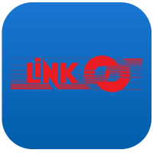

Picture: ATM Finder App

Television

If you're finding it hard to see your television and enjoy your favourite programmes, here is some information that may help.

Audio Description on TV

Audio Description (AD), a free service, describes body language, expressions and movements, making the programme clear through sound.

Most major broadcasters (like the BBC, Channel 4 and Sky) provide AD on 20 per cent of their programmes. AD is also available in Welsh on selected Welsh language programmes.

Accessible TV devices

Panasonic television with Voice Guidance

With advice from RNIB experts, Panasonic launched the world's first range of digital talking televisions in 2012. The built-in Voice Guidance works by announcing on-screen information and the most important menus. As you become more familiar with your TV you can change the level of Voice Guidance from beginner to expert if you want fewer instructions.

Panasonic has sold talking TVs since 2012 which announce on-screen information and the most important menus. The banner information, accessibility menu and volume controls have speech but the Electronic Program Guide currently doesn't.

Samsung Televisions with Voice Guide

Samsung have now built speech into most of their new televisions. The feature is called Voice Guide and is available on all series 7, 8 and 9 models and most series 6 models. All functions of the TV should speak, although there is currently no speech support on third party apps such as iPlayer or Netflix.

Apple TV

Apple TV was launched with a feature called 'Voiceover' which is a screen reading technology and helps people with sight loss to find out what's happening on the screen without having to ask a sighted friend for assistance. Apple TV enables access to video on demand services and TV catch-up apps but does not show standard broadcast TV.

Fire TV

Amazon’s Fire TV in the UK now has speech. Users can browse Amazon’s catalogue, using the voice search function and view content. Third party apps are currently not supported. Fire TV enables access to video on demand services and TV catch-up apps but does not show standard broadcast TV.

Sky+ app

The Sky+ app is Sky's replacement for the Sky Talker. The app enables you to search, browse, select and record all your favourite shows. For more information and to download the app for iOS or Android go to the Sky accessibility pages for the Sky+ app.

Sky have also developed an easy grip remote control with high visibility buttons and can contact customers using alternative formats.

TV listings

Sourcing accessible TV guides and especially those highlighting audio described TV programmes can be difficult. There are web based, large print, audio and Braille TV guides available.

RNIB's Big Print Freeview guide has the full listing of the top ten Freeview channels. The Big Print weekly newspaper contains a TV supplement listing programmes on BBC1, 2, ITV1, Channel 4 and channel 5.

RNIB magazines for UK customers gives details of listings for:

- DAISY audio CD, electronic text by email and braille formats
- radio programmes
- other general leisure titles.

TV License concession

If you watch or record television programmes from your TV, computer, mobile phone, games console, digital box or DVD/VHS recorder, you'll need a TV Licence. However, you can get a 50 per cent reduction on your TV Licence fee if you're registered blind or severely sight impaired. To find out whether you qualify and how to apply for a TV License concession go to the TV Licensing website.

Active community

Big Lottery Community Project update

In April 2017, the Big Lottery granted CIB four years of funding to improve accessibility and inclusion of blind and partially sighted people in sport and leisure activities in Cardiff, Rhondda Cynon Taf and Swansea. Jane, Carys and Charlotte are the Community Co-ordinators managing the projects in each area.

The aim is to raise awareness among service providers of the access needs of visually impaired people, encourage VI people to go along to accessible taster events put on by the service providers as part of their awareness journey, and to enable and support people to take up a new activity or restart an old one in a welcoming environment.

As we are nearly half way through, the head of the Big Lottery Fund for Wales and the Chief Executive of Camelot visited Cardiff in October to get an update. They had a taste of accessing a leisure centre with a visual impairment and met some of our members who, thanks to the project, are now regular players of VI sport or leisure centre goers, receiving tailored and appropriate support from their leisure centre to enable them to access their chosen activity independently.

They were also grateful for our feedback on how they should pitch their advertising campaigns to remind the public that the lottery is not just about winning big prizes, it is also a major source of funding for a wide range of good community causes like this project!

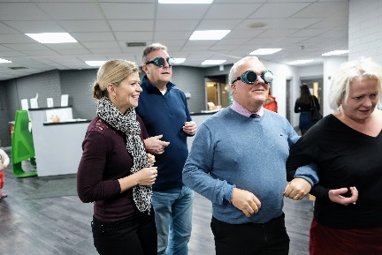
Picture: Big Lottery Fund Wales Director and the Chief Executive of Camelot being guided around leisure centre wearing sim specs.

Since the summer newsletter, we have been busy doing all sorts of sporting activities. In September, a very wide range of accessible sports were on offer to “have a go” at through the Disability Sports Wales Insport Series and the British Blind Sport Have a Go Day.

We tried all sorts of sports and found muscles aching afterwards that we never knew we had! Following these, a new session of VI tennis has been set up in Leckwith House of Sport and we are hopeful that a blind shooting club will be set up in Cardiff soon.

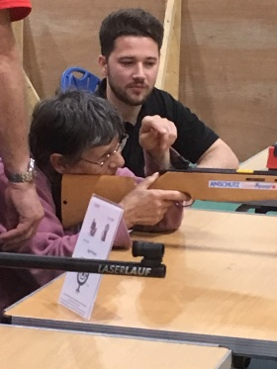

Picture: CIB Member Rosa shooting a rifle

We have also had a taster session In Llanishen Toning Suite, following which Llanishen Leisure Centre has 5 or 6 new very keen members, one of whom is 87, so never say you are too old!

I always used to be able to rely on Rosa, who is not quite 87 yet, to come with me to any event, but I now have to book her well in advance as Llanishen is her “new home”.
She is there several times a week, using the toning suite, the gym and doing aerobics and yoga.

Early in the new year, we will be having a taster session in the newly refurbished Fairwater Leisure Centre where they have an interesting range of more unusual groups such as walking football and balance classes set up by the neurology department in Llandough.

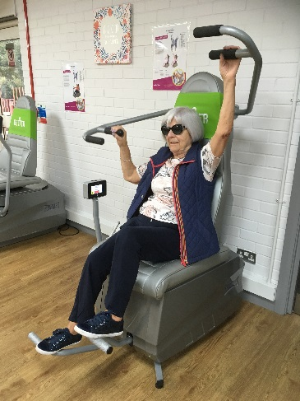

Picture: Connie using a toning machine

Disabled Membership of the Better Leisure Centres is £21 per month, which allows you to access all classes and facilities in all the centres. Also, a VI member is entitled to attend the centre with a sighted companion who can go in for free to act as a guide.

As well as sports, we have had a variety of other sessions, including one on accessible astronomy which was very popular. There is now an exhibition in the museum which we are hoping they will do an audio described (AD) tour of in the near future.
St Fagan’s are working on an AD tour of the mill, the blacksmith and the shop. A taster will be arranged early in the new year.

We have had a couple of art and craft sessions at which we made hand crafted cards, clay Christmas decorations, pompoms, did knitting, weaving and painting. There is now an arts and craft group run by Sian on the last Tuesday morning of every month at CIB in the activity room. Everyone is welcome. There is no charge, just a small contribution for materials.

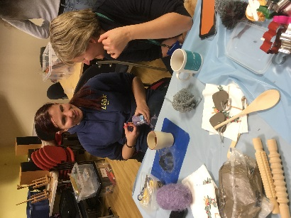

Picture: Andrea with craft materials talking Jane

We visited the Sherman to see “The Lord of the Flies” with fantastic support and a wonderful Touch Tour. Tickets are still available for the audio described and touch tour performances of Alice in Wonderland and Little Red Riding Hood over Christmas.
Tickets are £5 if you are visually impaired. If you have a Hynt card, someone can come with you for free. If you have no-one to go with, but would like to go, they can provide you with a “buddy”.
Also, in Wales Millennium Centre on 21 December there is a fantastic cabaret with a touch tour beforehand you may enjoy. There are also many other AD performances coming up. If you would like to be added to an e-mail list giving details of upcoming AD performances, please get in touch.

Calling all singers – a few members now go along to Goldies in Central Library on the first Tuesday of the month. It is also worth remembering though that most hubs have a Goldies group at least once a month, so you may be able to go to one closer to home.

Any book worms? You are welcome to join any of the book groups held in your local hub. All the book club leaders will be able to help you to source an audio version of the book they are reading. There is also a specific audio book club in Central Library on the third Tuesday of every month if you fancy coming along. Books will be announced on the CIB Facebook page or you can call CIB for
details.

Please get in touch with Jane on 02920 398900 if you would like to get involved or assist with any of the tasters. Attached to this newsletter is a list of the CIB groups, a list of the independently run VI specific groups and a list of venues we have worked with which run VI friendly groups/activities.

What’s on?

Below is a list of venues and groups used regularly by visually impaired people. Taster sessions can be arranged by Jane at CIB for you to "try them out". Contact the venue or the leader for details and to discuss access needs or contact Jane at CIB for further information on 02920 398900.

Adult Education Classes
Put your sight loss details on the enrolment form and provide an outline of the type of adjustments you will need. Ensure that the tutor gets in touch prior to the class beginning to discuss access needs. Some free courses available to disabled people and a discount is available for the rest.

Better Leisure Centres
All are welcome, and we are happy to discuss access needs and how best to support you. Health conditions on top of sight loss can benefit from GP Exercise Referral for free membership for limited time & supervised classes. Disabled membership price is £21 per month. You can also get discounted pay as you go price on most facilities. Free swims for over 65.

Cinemas
Check for times & dates of audio described shows. Ask for headphones when buying your ticket and for assistance to your seat if needed. With a CEA card, a companion/guide can accompany you free of charge. (A £6.00 annual administration fee applies.)

Circle Dancing
Meet alternate Tuesdays, 11:00am-12:30pm at The Tabernacle, The Hayes, Cardiff. For U3A members the cost is £12 per year to join. Contact Pat on Pat Adams adamsp37@aol.com

Cycling for Women
Breeze Network for women and children meet once a month from Pedal Power, Sophia Gardens, Cardiff, various dates and times. A pilot will be found, but you must hire or bring your own tandem.

Book groups
Meet at local Hubs, various times & dates. Hub can help find books on audio to join in.

Friends & Neighbour Groups
Weekly groups that meet at your local library/hub for a chat and a coffee. Contact venue for details.

Friends of ….. Library
Regular events including talks, music groups, films & other activities held at most libraries. Contact hub for list of events and telephone for updates if no access to Facebook/e-mail.

Goldies
Singing for pleasure group held weekly in Rhydypennau library & monthly in the others. Contact venue for details.

Knit & natter sessions
Weekly groups for a bit of knitting & a lot of talking held at your local library/hub. Contact venue for details.

Pedal Power
Open most days in daylight hours. Tandems & side by side bikes available for hire. Annual membership £20. Tandem hire £6 per hour for members.

Quiz at the Sherman
Held mid-monthly at Sherman Theatre, Senghennydd Road, Cathays, Cardiff. Contact Sherman 029 2064 6900 for details and to inform of access needs. Quizmaster will then ensure accessible questions & scribe may be found if needed.

Theatres
Book by phone for the audio described (AD) performance and use your Hynt card for a discount or a free companion. Make sure you have a seat where the audio description will work. If you are unfamiliar with the theatre, check with Box Office. Contact Box Office by phone to let them know you would like AD & Touch tour.

Sherman Theatre
As above, but they can often provide a "buddy" should you not be able to bring anyone with you but would like assistance.

Young-ish persons social group!
The new year will see the start of a new monthly social gathering at Zero Degrees Bar in Westgate Street, Cardiff. These will take place every second Tuesday of the month from 6.30pm until 8.30pm. Everyone is welcome of course, but the group is primarily aimed at those under 50. For more information contact Dan Thomas dant7733@gmail.com or by phone on 07572 877536.

Feedback from our service users

We’ve had some great feedback from you. Thank you for taking the time to talk to our volunteer Julie about your experience. We really do appreciate it, as it demonstrates to others the impact our services have.

Here are some of our favourite quotes:

‘When I first lost my sight 6 years ago I was extremely depressed and suicidal. The staff at CIB helped me to realise that I was not alone with my sight loss. Other visually impaired members inspired me to overcome my difficulties and I came to finding your feet sessions which really boosted my confidence in handling money and shopping. I have my BWB on all the time which keeps me company and I come to Computer class which I really enjoy.’
‘
‘Teresa and Michelle run such a wonderful team at the CIB. I would be really lost without them. I get so much out of being a member, especially going to the groups- I have made some very good friends at the Thursday club over the years, the companionship is invaluable.’

‘I find the atmosphere in CIB is so pleasant and welcoming. Everyone is so helpful and very professional. I come to yoga and macular group which have become 2 of my main social activities because I am meeting such nice people. The yoga is improving both my emotional and mental well-being, I'm so grateful it makes such a difference to my life.’

‘I moved down to Cardiff from North Wales 3 years ago and I can honestly say that since I joined the CIB I really feel like I have been promoted to the Premier League, the service is that excellent. In meeting Michelle, I feel like I am in the best hands possible, she has given me so much help and guidance. In North Wales I used to help run the Macular Group, we had 9 members, there is no comparison to the Cardiff Macular Group, I have learned so much by meeting fellow members. Finding out different ways of coping with our sight loss and just getting a much more optimistic outlook, knowing you are not alone! Attending the Technology open days has also been very beneficial in introducing me to new gadgets and magnifying tools. I am tremendously grateful for all the support and advice I have had and continue to receive, thank you.’

Useful telephone numbers:

CIB | 029 2039 8900
RNIB Helpline | 0303 123 9999
Smell Gas? Wales & West Utilities | 0800 111 999
Power cut? Western Power Distribution | 0800 6783 105
Care & Repair, Managing Better | 0300 111 3333

Cardiff Institute for the Blind

Jones Court

Womanby Street

Cardiff

CF10 1BR

Telephone: 029 2039 8900

Email: CIBPostmaster@cibi.co.uk
Website: www.cibi.co.uk
Twitter: https://twitter.com/CardiffBlind
Facebook: www.facebook.com/CardiffInstitutefortheBlind

Data protection and contact from CIB
Many of you will be aware of the new regulations on data protection, called the General Data Protection Regulations, which came into force this May. This gives people more control over their data and how it is used. CIB has always taken its responsibility of taking and using personal data very seriously.
We have usually taken verbal consent to store and use information but we now have to be able to evidence that we have consent, particularly for email and text communication.
So that we can stay in touch to share relevant news and information, provide services and let you know how you can help support the work we do, we would be very grateful if you can call us on 029 2039 8900, or email cibpostmaster@cibi.co.uk to let us know your preferences.
Please select what you'd like to hear from us about or just select ‘All’ if you want to receive information, advice and news on everything we do:

Services and products Yes/No
General news Yes/No
Campaigning and Volunteering Yes/No
Fundraising Yes/No
All Yes

Please indicate below if you want to hear from us by email or text:
Yes, I want to hear from you by email

Yes, I want to hear from you by text

Please indicate below if you don’t want to hear from us by post or phone:
No, I don’t want to hear from you by post

No, I don’t want to hear from you by phone

