Vision News
The newsletter for people with sight loss in Swansea.
Working in partnership with RNIB, VIWG and CIB.
No. 5, December 2018
Contact us: RNIB in Swansea, Swansea Vale Resource Centre, Ffordd Tregof, Swansea SA7 0AL 01792 776360. Email: Anita.Davies@rnib.org.uk

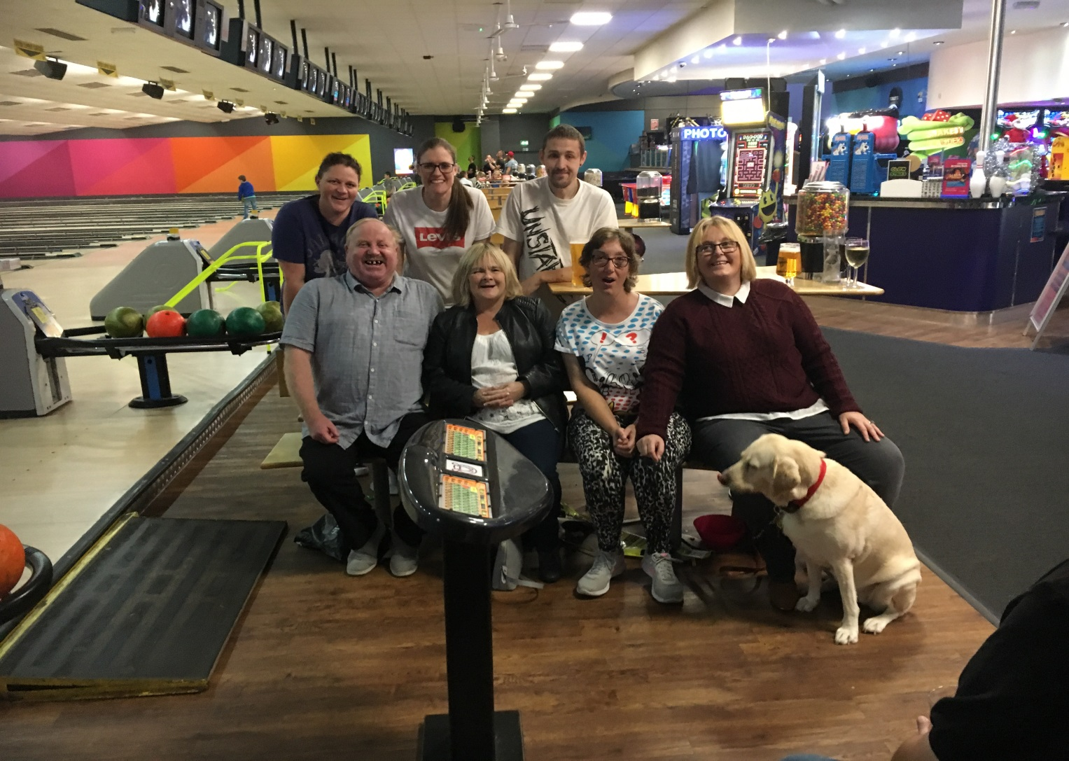

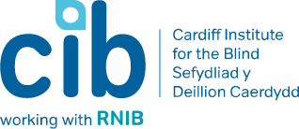
Photograph of members ten pin bowling: Left to Right, Charlotte, Stacey, Craig, Stephen, Judith, Donna, Catherine and Sally

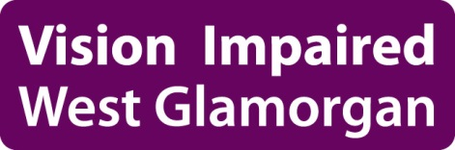
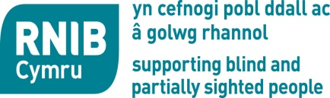

Registered Charity Numbers: RNIB Cymru 226227
CIB 214131 VIWG 504736

Contents

Hello and Welcome 4

A Personal Story – Anthea 5

Volunteering 6

News:
CIB Change of Name 6
Have a Go Day 8
Peer Support Group for Phones and Tablets 9
Swansea and Gower Talking Magazine 9

Events:
Digital Confidence Building 10
Low Vision Group 10
Health and Wellbeing 11

Peer Support Groups:
Social and Support Groups 12
Yoga Classes 13
Musical Memories Choir 13
Darts Night 13
Visually Impaired Sports Activities 14
Hobbies and Interests 14
Arts and Crafts 15
Ten Pin Bowling 15
Theatre Trips and Holidays 16

Ongoing for You:
Sensory Impairment Review 17

Vision Impaired West Glamorgan:
County Steering Group 17

Community Coordinator 18

Useful Telephone Numbers 19

Hello and Welcome
This newsletter is for blind and partially sighted people living in the Swansea area. We hope this will give you some useful information and advice on the services we run.

Under the General Data Protection Regulation we are required to request your consent to contact you.

We send this newsletter out in large print, audio and electronic formats. Please let us know at the office if you would like to change the format you receive our newsletter in.

Although we send out newsletters, we also contact members via the phone or email. This is because for many people it is the most preferred method of informing them of new services. If this is not the case with you, and you would prefer not to have phone calls or emails then please let us know when we contact you.

We would love to receive your articles or any other useful information for future newsletters. Please contact the office. We also welcome any feedback you have on the newsletter.

A Personal Story
My name is Anthea I have had problems with my eye sight since I was 3 years old. I have had a few operations, but now I am registered blind/deaf since 2013. It’s been a great shock and a very hard journey. I have recently had breast cancer, but I am back with the City Centre Group which meets once a month in Tesco’s in Swansea. I find it extremely interesting as they have various speakers and a chance to get together. One of the speakers was from trading standards which I found interesting and valuable. As well as the city centre group I have learnt a great deal from attending the shopping workshop. This was useful to learn how to go around the shops and how to ask for an assistive shopper. The money workshop was fantastic as I learnt how to tell the notes apart and not to rush as I get very frustrated.

I attended the transport workshop, which I found good. I used to get on the wrong bus and ended up in strange places, stranded but I have learnt to ask what number bus it is and to ask the driver to let me know when my stop is. I learnt how to pre-book a taxi, and if I was to use a train to book tickets beforehand and let them know if I would like assistance. I learnt about the different types of tactile paving and how to cross the road by using different types of crossings which I found interesting too. I must admit I have learnt a great deal from them. I also attended a workshop where there was a demonstration on Blind Tennis. I have learnt new skills to get by with everyday living.

I used to drive the buses at one time and was in contact daily with the general public but since losing my sight I have been reluctant to go out on my own. I joined the city centre social group which has built my confidence up to go out and meet people. I am learning new things at the meetings, people are friendly, and we have outings too. I’m glad I’m part of the groups as I really enjoy them.
Volunteering

Have you considered volunteering and the benefits this can bring to your own life as well as to others?

We have a number of different roles and are in need of volunteers across Swansea. If you have an hour to spare or know someone who could give an hour, regardless of your experience, please get in touch. We provide training, expenses, a way of making new friends and a warm welcome.

News
CIB Change of Name
CIB is consulting on changing its name.

Cardiff Institute for the Blind has been working across South Wales for many years. Over this time we have used a couple of different names when delivering services outside of Cardiff as we weren’t sure people would engage with a charity that just had Cardiff in the name.

Lately we have been using the RNIB name in some areas, such as Swansea, as we are an associate charity of RNIB and work very closely with them to ensure people get a wide range of support. This has understandably caused confusion and created difficulties with things such as data protection and fundraising.
More and more people we speak to are initially saying they don’t want our support or don’t feel eligible for our support because they have some level of sight and do not consider themselves blind. We also sometimes have to work hard to assure those who are partially sighted that we can make a difference to their life.

For information, it is thought around 93% of people registered as sight impaired or severely sight impaired have some level of sight.

People are also put off by the ‘Institute’ part of our name, having preconceptions that we employ blind and partially sighted people to make things like wicker baskets or that we provide residential care for blind and partially sighted people.

So we have decided to consult on changing our name to one that:

• Communicates that we work across South Wales
• Is more relevant to what we do
• Allows us to work with more people

We can assure you that the cost of changing our name if we do will be small and we believe any additional cost will be more than made up by the additional income we believe a name change will bring.

We know that changing our name is a big decision and we will only change it if we are sure it is the right thing to do for the people we want to make a difference for. We exist to support blind and partially sighted people enjoy independent and fulfilled lives, so your views are essential
With that in mind, we want your help in deciding whether to change our name and what name might give us the greatest impact in delivering our future work.

You can give us your thoughts in English or Welsh by telephone on 029 2039 8900, by asking for a large print version of a questionnaire or by completing an online questionnaire. Please click the link below to access the online questionnaire.
www.cibi.co.uk/decideourname

Have a Go Day in LC2

This event will be held on Saturday 23rd March 2019 from 10am to 4pm. This is an opportunity to try various leisure and sporting activities.

The morning session will include yoga, Zumba, spin. In the afternoon there will be opportunities to try sports for visually impaired people such as football, cricket, and possibly goalball.

Places are limited so booking is essential. Please ring the office on 01792 776360.

Oakhouse Foods, Llansamlet, Swansea deliver frozen ready meals, and a full range of groceries such as milk, bread, fruit and vegetables. There is a large print order form listing the meals available plus a brochure.

The delivery charge is £1 for orders over £30. For orders under £30 the delivery charge is £3.00. They cover all dietary requirements and are approved by the ABMU health board. Please ring 01792709232 for further information.

Peer Support Group for Phone and Tablets

RNIB in Swansea will be running peer support groups and one to one sessions to help with the use of mobile phones and tablets. The peer support groups will be themed groups such as:

How to use voice over;
Looking at which mobile phones are more suitable for people with sight loss;
The pro and cons of using technology when you have sight loss;
The peer support groups are aimed at sharing information and ideas.

One to one sessions are available for those who need support to learn things such as:

How to turn the phone on and off;
How to make a call;
How to store numbers;
How to use voice over;
How to shop online or listen to audio books.

If you are interested please contact the office on 01792 776360.

The Swansea & Gower Talking Magazine records items of Swansea news from the Evening Post each month, and other information of interest to those with sight loss. Local history books have also been recorded. It is produced on Memory
Sticks and CDs each month and posted free. Please contact Jean Kirkwood on 01792 202679.

Events
Calendar

Digital Inclusion Confidence Building

Do you have difficulties using a mobile phone, IPad or tablet? Do you want to know how these devices can help you feel less isolated and build your confidence? Our workshop will give you the opportunity to learn how you can use these devices to manage money, shop online, getting out and about and keep in touch with family and friends.

White Room, Swansea Grand Theatre
Saturday 23rd February 2019 10.30 - 12.30
Thursday 28th February 2019 10.30 - 12.30

Low Vision Group

The Low Vision Group meets several times a year. It is very friendly, informative and fun. We look at the importance of regular visits to the opticians, the benefits of a low vision test, and what free low vision aids are available.

We have low vision aids for people to try. These include a monocular, lamp, visim (electronic magnifier), hand magnifier and typo scope. You are very welcome to bring the things you find useful and share your experience with us.

We also look at the benefits of using different types of coloured paper and pens, as well as other things that people may find useful. We talk about the importance of good lighting and welcome questions which we will do our best to answer.

Please come along. Who knows - sharing tips and experiences may well make a difference to your life or someone else’s.
See you at the next group session on Wednesday 20th February 2019 10.30am-12.30pm at Singleton Hospital, School of Medicine. Booking is essential.

Please ring Sue Neale Eye, Clinic Liaison Officer, on 01792 200390 to book a place on this workshop.

Health and Wellbeing
Access Bars is a technique that quietens the mind through a gentle touch of the hands on the head?

We are able to offer an introductory two hour workshop which will teach you 5 out of the 32 access bars hands on techniques. You will be introduced to some of the “tools” of Access Consciousness which are designed to empower you to create the life you desire.

Having your bars run is what we call it when you receive a session, touching the bars allows for the electromagnetic charge that holds thoughts feelings and emotions in place to dissipate, allowing you to perceive your life body and relationships with clarity and ease.

The sessions are run by a qualified bars facilitator who is registered with access consciousness to facilitate an introduction to the bars. There are no pre-requisites other than a willingness to receive, during the session - you will have your bars run and you will run the bars for someone else. There will be time for you to ask questions about access conscious and what it could do for you.

The cost for the 2-hour session is £35.00 per person and notes of the class content will be provided. Class size is limited to a maximum number of 10 participants. For further information or to book onto the workshop please contact Clayton Georges on claytong35@gmail.com, or ring the office on 01792776360.

Peer Support Groups
Mumbles, Swansea and Gorseinon Social Support Groups
Join one of our friendly social and support groups. Build your confidence by bringing friends or family. Enjoy a cup of tea or coffee, make new friends and listen to a guest speaker.

Gorseinon Group at Gorseinon Institute
Wednesday, 6th February, 10am -12 noon
Wednesday, 6th March, 10am-12 noon
Wednesday, 3rd April, 10am-12 noon

Mumbles Group at the Methodist Church
Monday, 21st January, 11am-1pm
Monday, 18th February, 11am-1pm
Monday, 18th March, 11am-1pm
Monday, 15th April, 11am-1pm
City Centre Group at Tesco, Oystermouth Road, Swansea
Monday, 14th January, 10 am-12 noon
Monday, 11th February, 10am -12 noon
Monday, 11th March, 10 am-12 noon
Monday, 8th April, 10 am-12n noon

Yoga Classes
Yoga classes will be run from 2pm-3pm every Monday at the YMCA in Swansea. If you are interested please contact Emma 07741254468.

Musical Memories Choir
This choir runs every Tuesday 11am to 1pm, at Christwell Church, Manselton, Swansea. The choir is aimed at all older people in the community and those living with dementia or other conditions. You don’t need to be able to sing just join in and enjoy good company and music, free of charge.

Darts Night
Glantawe Lions have arranged a darts night for members to join them and have a social night out. It is planned for Thursday 28th February 2019 at the Travellers Well Pub on Carmarthen Road Swansea. There is a bus stop directly outside and opposite. Lions members are happy to meet people off the bus and give assistance to and from the bus stop into the pub. If you are interested please call the office.

Visually Impaired Sport Activities

Want to meet new people and have fun?
Come along to one of our groups which support people to continue with interests or to enjoy a new hobby.
Roll and Stroll – Every Thursday from 10-12, meeting at the Annex attached to Victoria Park kiosk.
Swimming – Lane swimming every Tuesday 12pm -1pm at Penlan Leisure Centre.
Bikeability - Tandem Cycling – Every Tuesday 11am -12.30pm, at Dunvant Rugby Club.
Bowls – Tuesday 12 noon-2pm Beaufort Indoor Bowls, Landore. Ring Julie Thomas, Secretary of West Glamorgan VI Bowls club, for details on 07823771471.
Goalball is being developed in the South Wales area. There will be opportunities for practise sessions and coaching in the Swansea area in 2019. If you would like to learn more about Goalball please contact the office 01792 776360.

Hobbies and Interests
Reading Group - Share books and stories
Knitting – Share tips on making knitted items

Knitting Social Group at Grand Theatre Conservatory
Thursday, 10th January, 11am -1pm
Thursday, 14th February, 11am -1pm
Thursday, 14th March, 11am -1pm
Thursday, 11th April, 11am -1pm
Reading Group at Swansea Central Library
Wednesday, 16th January, 11am-12pm
Wednesday, 20th February, 11am-12pm
Wednesday, 20th March, 11am-12pm
Wednesday, 17th April, 11am-12pm

Arts and Crafts
Join the Glynn Vivian’s learning team to explore the exhibitions, try different materials and techniques in this creative monthly workshop, specifically tailored for those with a visual impairment. For further information or to book a place, please contact Charlotte Phillips at Charlotte.Phillips@rnib.org.uk.

Tuesday, 22nd January, 1pm-3pm
Tuesday, 19th February, 1pm-3pm
Tuesday, 19th March, 1pm-3pm

Ten Pin Bowling
We have set up a Ten Pin Bowling Group which takes place on the first Friday of each month 2pm-3pm at Parc Tawe. Side rails are raised, lighting is improved and you don’t need bowling shoes.

Booking is essential. If you are interested please contact the office on 01792 776360.

Friday, 4th January, 2pm-3pm
Friday, 1st February, 2pm-3pm
Friday, 1st March, 2pm-3pm
Friday, 5th April, 2pm-3pm
Theatre Trips and Holidays
Theatre Trips
We run various trips to encourage people to enjoy a day out and to make new friends. To book please ring the office on 01792 776360.

The Band 30th January 2019
Grand Theatre, Swansea 2.30pm
£20 per person.

Bodyguard 25th April 2019
Cardiff Millennium, Cardiff 2.30pm
£45 per person with transport

Doctor Dolittle 8th August 2019
Cardiff Millennium, Cardiff 2.30pm
£37 per person with transport

Annie 29th August 2019
Cardiff Millennium, Cardiff 2.30pm
£36 per person with transport

Slumber Sunday March 10th 2019
Tower Hotel, Swansea
Overnight stay, bed, breakfast and evening meal
25 minute spa treatment
Use of all spa facilities
£95 two people sharing: £125 single occupancy

Ongoing For You

City and County of Swansea will be carrying out a Sensory Impairment Review. It is important that people with sight loss take part in this consultation to express their views on services important to them. Please contact the office so that we can ensure that your views are heard.

County Steering Group Meetings run by Vision Impaired West Glamorgan
at Civic Centre, Swansea

The County Steering Group is made up of people with sight loss who represent the views of blind and partially sighted people in the Swansea area. The group campaigns locally to improve services, whether this is around transport, access to the City Centre and shops or any other barriers people face in day to day life. Group members sit on a variety of forums relating to disability, health and local authority services. The group is friendly and is always looking for new members. Come along and find out more.

Wednesday, 30th January, 11am-1pm
Wednesday, 27th February, 11am-1pm
Wednesday, 27th March, 11am-1pm
Wednesday, 24th April, 11am-1pm
Does it concern you that people are making decisions about your everyday life without asking you first?

Here at RNIB in Swansea and VIWG we want to make sure that your views count when new services are being developed and existing services are being changed.

Community Coordinator

We have received Big Lottery funding to hire a Community Coordinator, Charlotte Phillips. Charlotte’s role is to support our members who want to take part in various sport and leisure activities within their local community.

Another area of Charlotte’s role is to encourage people with sight loss and give information and advice on how to organise their own activities. Having sight loss can sometimes make it more difficult to access services. Similarly, some service providers can be unsure about how to react to someone with sight loss who wants to use their service.

The Community Coordinator is here to help build understanding, and to show ways in which both parties can support one another.

If you live in the Swansea area and want to access some local community, sports or leisure groups but aren’t feeling very confident. Then why not give us a call on 01792 776360 and see what we can do to help?‬‬‬‬‬‬‬

Useful Telephone Numbers

Age Cymru 01792 648866

Care & Repair 01792 798599

Community Transport St Johns Day Service 01792 456593

Deaf Blind UK 0800 132320

Foodshed food delivery (covers Swansea area) 01656 722506

Macular Society Swansea Support Group 01792 401450

Morriston Hospital 01792 702222

Oakhouse, Foods 01792 709232

RNIB Office Swansea 01792 776360

RNIB Helpline 0303 123 9999

Sensory Services Team 01792 315969

Singleton Hospital 01792 205666

Sue Neale ECLO Swansea 01792 200390

Swansea & Gower Talking Magazine 01792 202679

Swansea Civic Centre 01792 636000

Swansea Council for Voluntary Services 01792 544000

We provide other services to support individuals such as:

Braille
These workshops are to assist people who would like to learn Braille. Booking is essential. Please ring the office 01792 776360.

Telebefriending – a regular weekly, fortnightly or monthly call from one of our volunteers.

Annual Welfare Call (Contact Line) – a volunteer will ring each member at least once a year.

Confidence Building – A service to support people to get out and about: for example shopping, gym and leisure activities, as well as using services available within their Community.

This newsletter has been printed by Wales Council of the Blind.

If you would like to change the format you receive our newsletter in please let us know at the office. We provide large print, audio, email, braille.

I look forward to hearing from you.
Anita Davies, Locality Development Manager, RNIB
Registered Charity Numbers: RNIB Cymru 226227
CIB 214131 VIWG 504736

