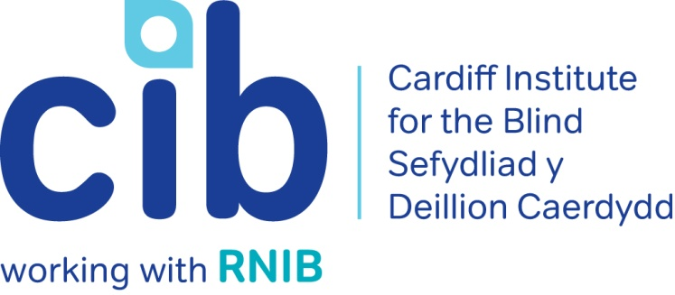

CIB Newsletter

September 2017

Vivien’s story shows you how CIB can help with regaining some independence and our third newsletter of 2017 also tells you about the Wales Low Vision Service , NatWest accessible services, the new £10 note, audio described museum tours, and our own independent living sessions. We explain diabetic retinopathy and how to connect with others affected by sight loss. Please contact Michelle or Teresa for any queries or to book an event on 02920 398900. Also keep up-to-date via our website at www.cibi.co.uk, Facebook page www.facebook.com/CardiffInstitutefortheBlind and Twitter @CardiffBlind

In this edition:

Page 2: Real life: Vivien Potger

Page 3: Independent living sessions

Page 4: Focus on eye conditions: Diabetic Retinopathy

Page 6: Club of the month: Conversation Club

Page 7: Product of the month: Talking induction hob
Page 8: Active Community
Page 9: Audio described tours

Page 9: Low Vision Service Wales

Page 10: Accessible services at NatWest Bank

Page 12: The new £10 note

Page 12: South Wales Talking Magazine & Newspaper
Page 13: Volunteering

Page 15: Customer feedback

Real Life: Vivien Potger

Vivien is an 89 year old lady living in Cardiff. She has recently been diagnosed with Macular Degeneration. Her family all live away and her niece had contacted us for advice as Vivien was becoming increasingly more isolated. We visited Vivien to discuss her requirements and advise her of the help and services available.

Having previously been turned down for Attendance Allowance, Vivien was slowly losing her independence as she couldn’t afford to pay for taxis and the bus stop was too far away. For many years Vivien would travel to her regular hair salon in Penarth but now no longer able to drive due to her failing eyesight and there being no direct public transport, she was unable to go. This left Vivienne feeling very low as this was one of the few social outings she undertook and really looked forward to.

We referred Vivien to the RNIB Rights Advice and Information Service and we were present when the Department for Work and Pensions (DWP) attended to complete the necessary forms. Vivien is now in receipt of the higher rate of Attendance Allowance which will enable her to get out and about more and go to her favourite salon.

Vivien purchased a Sonic USB player for use with talking books and we signed her up for the RNIB Talking Book Service. She is now enjoying listening to the books and also music that her niece copies onto memory sticks for her to play on her USB player.

We advised Vivien to have a Low Vision Assessment and sourced her local Optician and we also contacted Care & Repair for an assessment of handrails and a stair lift in her home.

Vivian is extremely grateful for our help and support she is looking forward to attending our Living with Sight Loss sessions and the Macular Group.

Independent living sessions

Monday 20 November 2017 – Carers, partners and family

Our next independent living session will focus on carers and will include guest speakers and the chance to ask questions and get individual advice.

During the session we will cover:

- Understanding sight loss and the different eye conditions
- The challenges faced by blind and partially sighted people and for those people supporting them
- The support available
- Supporting you partner to be independent rather than dependent
- Handy hints and tips

Places for this session are limited so if you and your partner/carer would like to attend please contact us on 02920 398900.

Focus on: Eye conditions

Diabetic retinopathy

The most serious eye condition associated with Diabetes is diabetic retinopathy. It occurs when the tiny blood vessels at the back of your eye become blocked and leak.

There are different types of diabetic retinopathy –

- Background diabetic retinopathy: Background retinopathy does not usually affect your sight, but your eyes will need to be monitored carefully to make sure your retinopathy doesn’t become worse.

- Proliferative diabetic retinopathy: If background retinopathy gets worse, many of the retinal blood vessels become damaged or blocked. When these changes affect a large area of your retina, blood supply to the retina is reduced. The body tries to fix this by growing new blood vessels on the retinal surface or into the vitreous gel. Unfortunately, these new vessels are weak and they bleed very easily, which may affect your vision.

- Diabetic maculopathy: When your macula (the central part of your retina) is affected by your retinopathy, you are said to have diabetic maculopathy. This means that your central vision, which is required for seeing fine detail and colour, will be blurred.

Reducing risk

You can reduce your risk of developing retinopathy, or help to stop it from getting worse, by:
- Controlling your blood glucose level (also known as blood sugar level).
- Tightly controlling your blood pressure.
- Controlling your cholesterol levels.
- Keeping fit and maintaining a healthy weight.
- Giving up smoking. Nerve damage, kidney and cardiovascular disease are more likely in smokers with Diabetes. Smoking increases your blood pressure and raises your blood sugar level, which makes it harder to control your Diabetes.
- Getting regular retinal screening. The most effective thing you can do to prevent sight loss due to diabetic retinopathy is to go to your retinal screening appointments.

Early detection and treatment can stop you from losing sight. If you’re pregnant and have gestational diabetes, you will have retinal screenings more often during your pregnancy and after your baby is born.

Treatment for diabetic retinopathy

If your sight is at risk from retinopathy and it has been picked up early enough, you will be given laser treatment. The aim of laser treatment is to prevent bleeding or to prevent the growth of new blood vessels for people with diabetic retinopathy.

If you develop diabetic macula oedema you may be offered treatment with an injection into the eye. Whether you need treatment for macula oedema will depend on how much swelling you have in your macula.
For more in depth information about Diabetic Retinopathy please call the RNIB Helpline on 0303 123 9999 or go online at https://www.rnib.org.uk/eye-health-eye-conditions-z-eye-conditions/understanding-eye-conditions-related-diabetes

Club of the month: Conversation club

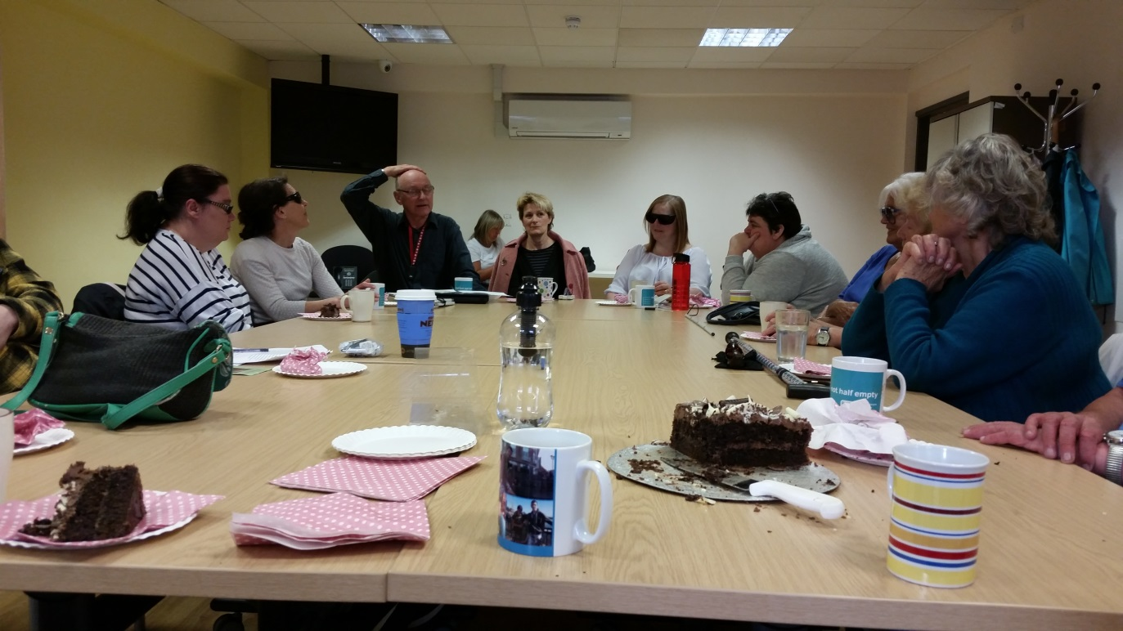

Picture: Conversation club

Our Conversation club is held on the second Monday of every month from 10.30am until 12.30pm. Facilitated by David Taylor who is employed by Cardiff Council Library Services, the group chooses a different topic for discussion each month. Recent topics have included ‘entertainment’ and ‘holidays’. Everyone has their chance to speak or if you would prefer to be a quiet observer that’s ok too! Tea and biscuits or cake are always on offer and it is a great way to meet new people.

If you are interested in attending please call us on 02920 398900.

Product of the month:

Single talking induction hob
Product code: DK182
£75.00 (ex VAT)

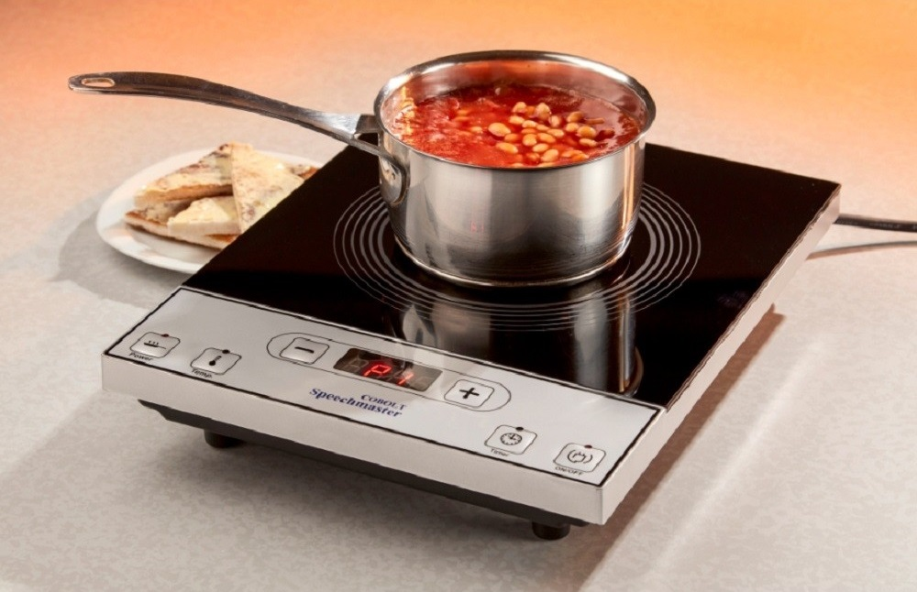

Picture: Single talking induction hob

This single induction surface hob is specifically designed to enable blind and partially sighted users to cook with confidence. With settings and functions fully vocalised, this hob makes induction cooking accessible. All functions are spoken in a clear, English voice. The controls have a good tactile feel and the hob has a smooth wipe clean surface. For your safety, the hob turns off immediately when a pan is removed.
Safe, fast, easy to clean and compact, the simple operation allows cooking to be done by selecting either power level or temperature. A timer is also included to enable the hob to turn off after a preset period.

Active community

Our newest member of staff Alastair Sill has been working hard to ensure blind and partially sighted people can start participating more in activities, sports and leisure interests in their local communities. So far, there have been taster sessions for goalball, tennis, tandem cycling and even ballet!

We are currently seeking volunteers to be ‘gym buddies’ to support blind and partially sighted people by going to the gym or sporting activities in their local area.

If you would like to try something new, need help accessing a venue or ar interested in volunteering please call Alastair on 02920 398900.

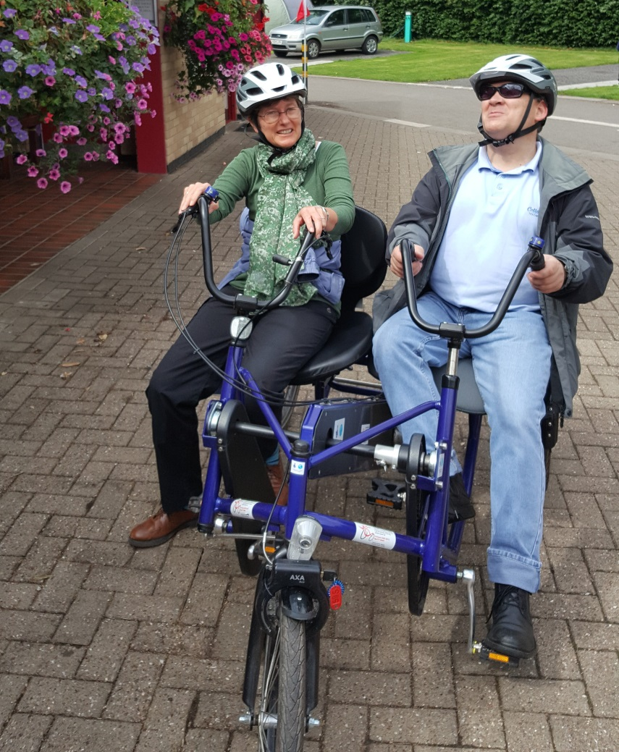

Picture: Pedal Power

Audio Description Tours

National Museum Cardiff

National Museum Wales are continuing to run their audio described tours of their collections. The tours will cover a different theme each time and most will include touch elements.

Blind and partially sighted people are welcome to bring their family or sighted companions along. We also offer a limited amount of guided assistance - please let us know if you require this.

The next tour:

Thursday 12 October 2017 - Victorian Art Gallery
11.00am until 1.00pm

The tours last approximately 90 minutes. We recommend visitors arrive 10 minutes before the start time. The tours are Free, but booking is essential. To book, please contact (029) 2057 3240, leave a message and your contact details and they will return your call.

Low Vision Service Wales

Low vision simply means not being able to see as well as most other people even when you’re wearing glasses or contact lenses. For example, you would probably have low vision if you have age related macular degeneration (AMD).

If you already have a vision impairment or low vision, or are registered as either sight impaired or severely sight impaired a specially trained and accredited Low vision optician/optometrist can help you make the best use of the sight you have.

Once you have contacted your local Low vision practice they should offer you a free hour long appointment to discuss your eyesight condition and the difficulties this may present in your day to day life. The practitioner may then get you to try out a number of different low vision aids such as handheld or stand magnifiers and task lights specific to your requirements.

Between you, you will decide which (if any) low vision aids may best help you and how to use them to best effect. These will then be ordered free of charge for you to take home on loan for as long as you may need them.

Depending on your particular condition, your eyesight and the tasks that you wish to carry out in day to day life may change over time. Therefore Welsh Government provide funding for each low vision patient to have one full free assessment every year.

For further information about the Wales Low Vision Service contact Michelle or Teresa on 02920 398900.

NatWest Bank accessible services

NatWest has been working to become more accessible with the Royal National Institute of Blind People (RNIB).

They have produced an accessible debit card which has been specially designed to be easier to use if you're blind or partially sighted.

The card has several features:
- A series of raised dots so you'll know whether the card is a debit or savings card.
- A carved out notch on the side of the card, so you can work out which way to insert your card into a cash machine or card reader
- On the back of the card, telephone numbers have been increased in size by 50%.

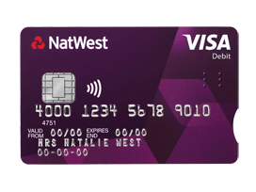
Picture: NatWest debit card

For customers with visual impairments they also provide the following services free of charge:
- Statements and general correspondence produced in Braille, large print or audio
- Brochures produced in Braille, large print or audio
- PIN numbers provided in Braille

In addition, all cash machines have audible tone prompts after each key depression. The keyboards on new cash machines also have the following features:

- Raised dot on the number 5
- Coloured keys for 'entry' and 'error'
- A depression in the middle of the keys making the keys easier to press

And finally they will soon be installing talking cash machines.

For further information please contact NatWest on 03457 888 444.

New ten pound note

The new £10 note is now in circulation but, don’t panic as you have until Spring 2018 to spend the old ones!

On the front of the £10 polymer note (the side with raised print), there are two clusters of raised dots in the top left hand corner. This tactile feature helps blind and partially sighted people identify the value of the note.

The polymer £20 will also have a tactile feature, but with a different pattern. The polymer £5 will be identifiable as the only polymer note without a tactile feature.

Additionally, the new polymer notes will have the same features as the paper notes: the notes retain tiered sizing and include bold numerals and similar colour palettes to the current notes.

South Wales Talking Magazine and Newspaper

The weekly Cardiff Talking Newspaper and monthly South Wales Talking Magazine are about to launch both of their free publications on memory sticks following requests from many listeners.

This will bring them into line with both RNIB and Calibre talking books who already issue their books in this format. The cost of producing the talking newspaper and magazine on CD is becoming prohibitively expensive so the use of re-useable memory sticks is the way forward.

The plan is to ask listeners to agree to start receiving their Talking Newspaper and Talking Magazine on memory sticks so that CDs can be slowly phased out over the coming months.

If you don’t already have a suitable player for memory sticks then maybe now would be a good opportunity to start dropping hints about a birthday or Christmas present as they are reasonably priced and easy to use. Contact us here at the CIB resource centre for help and advice on choosing a player.

The South Wales Talking Magazine Association would like to hear from you when you are ready to start receiving memory sticks instead of CDs. Your name will be added to the list and as soon as they are launched there will be a seamless change over. You’ll be kept up to date with progress in forthcoming editions of the Newspaper and Magazine.

Contact us here at the CIB on 02920 398900 and we will pass on your request or email info@swtma.com

The benefits of volunteering

Graham and Susan Wood

Our husband and wife double act Graham and Sue have been volunteering for CIB since 2014. Sue, who worked as a medical secretary at University Hospital of Wales until she retired, chose CIB as we were so helpful to her step father before he died.

Sue started as an administration volunteer in Jones Court in February 2014. She also provides support to Marilyn, one of our Contact line volunteers, taking notes and making referrals for her following calls to members.

Graham started in November2014 following his retirement as a Building Surveyor for Cardiff Council. As well as administration work, Graham also took on the Transcall role, driving blind and partially sighted members to various locations. Graham now updates our Resource Centre stock every week.

Graham and Sue are an active couple, they play bowls weekly, enjoy cricket and Sue is a keen artist specialising in acrylic and pastel paintings. They have since joined the CIB Ramblers and help to guide blind members across interesting locations throughout South Wales every month. Sue is also a volunteer with our monthly Women’s Group and she came along with them to a gallery to see some of her own paintings on display on one occasion!

Sue and Graham continue to enjoy their volunteering roles at CIB, possibly with the exception of the dreaded ‘mailshot’ time when they are roped in to help label, stamp and fill envelopes for this newsletter!

They say “It’s lovely knowing we are helping people, what we do is worthwhile and makes a difference to blind and partially sighted people.”

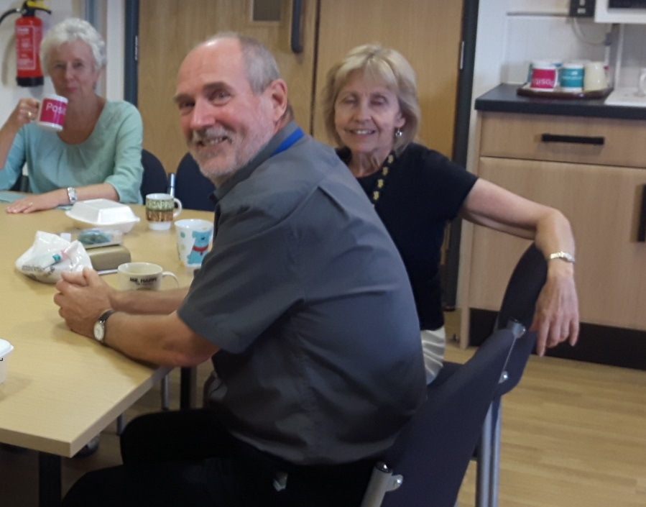

Picture: Graham and Sue Wood

Feedback from our service users

Our lovely volunteer Julie regularly telephones people we support to ask for feedback on the services they have received to help us improve the work that we do. Here is a sample of what people said:

“I am absolutely delighted with the service I had from Teresa. She helped me to apply for Attendance Allowance which I wouldn't have been able to do on my own and my application as a result was successful. She also introduced me to a white symbol cane I find it very helpful when shopping and going around town. I also have bump-ons on my microwave which means I can use it on my own. All these things add up to a much easier, more independent life, Teresa has been wonderful.”

“I have been coming regularly to the new exercise class. We do chair exercises with resistance bands, I always feel really good afterwards, and it’s just enough exertion for me. I have also been coming to the independent living workshops and I find the speakers really useful especially the Fire Officer who gave us fire safety tips for around the house, I learned a lot. Thank you very much.

“I do really enjoy the tele befriending calls I get from Jeff. He calls me once a fortnight and we have a long chat about all sorts of things such as travelling and books we have read. We seem to have such a lot in common and I definitely look forward to our chats as he brightens up my life!”

“I do really enjoy going to the Thursday Club. It's a much better venue now that we come to the Activity Room at Jones Court. It's nice and modern, the food for lunch is good and I do enjoy the company. I have also started using Talking Books. I used to be an avid reader so this is a replacement I'm getting used to. Thanks CIB for all your help.”

“It was great to be able to spend time with other people with vision loss, just playing a sport. I was mainstreamed in education so didn't really do any sports as they were not very inclusive in the 80s and 90s when I was in school. So being able to take part in a sport was awesome. I really enjoyed it and am very eager to do the next session!”

Did you know…?

When the Capitol Theatre opened on Queen Street in 1921 it was the largest purpose-built cinema in Europe.

Useful telephone numbers:

CIB | 029 2039 8900
RNIB Helpline | 0303 123 9999
Smell Gas? Wales & West Utilities | 0800 111 999
Power cut? Western Power Distribution | 0800 6783 105
Care & Repair, Managing Better | 0300 111 3333

Please let us know if you no longer wish to receive certain types of communication or any communication from Cardiff Institute for the Blind and if you have signed up to the Fundraising Preference Service.

Cardiff Institute for the Blind

Jones Court

Womanby Street

Cardiff

CF10 1BR

Telephone: 029 2039 8900

Email: CIBPostmaster@cibi.co.uk
Website: www.cibi.co.uk
Twitter: https://twitter.com/CardiffBlind
Facebook: www.facebook.com/CardiffInstitutefortheBlind

