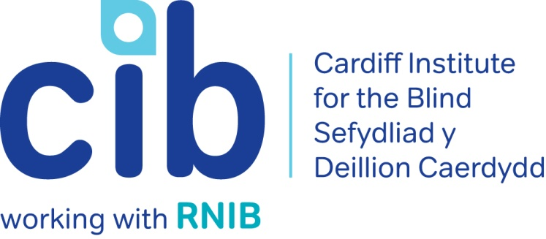

CIB Newsletter

June 2017

Richard’s story (page 2) shows how CIB can help with reading and finance if you’re facing sight loss. Our second newsletter of 2017 also tells you about audio described museum tours, a workshop for visually impaired musicians and our own independent living sessions. We explain cataracts and how to connect with others affected by sight loss. Please contact Michelle or Teresa for any queries or to book an event on 02920 398900. Also keep up-to-date via our website at www.cibi.co.uk, Facebook page www.facebook.com/CardiffInstitutefortheBlind and Twitter @CardiffBlind

In this edition:

Page 2: Real life: Richard’s journey after losing his sight

Page 3: Independent living sessions

Page 4: Focus on eye conditions: Cataracts

Page 6: Club of the month: Thursday Club

Page 7: Product of the month: Non-spill mug
Page 8: New Community Co-ordinator: Alastair Sill
Page 8: The benefits of volunteering

Page 10: Other news

Page 11: Customer feedback

Real Life: Richard

Richard’s eyesight was deteriorating quite quickly. He had to stop driving and playing golf due to Macular Degeneration.

Richard was struggling with everyday tasks. He could no longer read books, the newspaper or complete crosswords which he had loved to do. His other passion was walking and Richard found that he was often tripping and missing pavement kerbs. Richard was becoming more dependent on his wife in and around the home, and relied on her for driving him to all of his appointments.

Michelle first visited Richard at home and explained about the help and support that was available from CIB, RNIB and other local statutory and voluntary services. She advised Richard to have a Low Vision Assessment at his local opticians as they could possibly prescribe him magnifiers and other items that could help Richard to read. If eligible, these items can be loaned free of charge.

We referred Richard to RNIB Rights, Advice and Information Service (RAISE) to help with claiming attendance allowance and also to Cardiff Council Independent Living Team for training with a Rehabilitation Officer to help Richard get out and about alone using a mobility cane. We encouraged Richard to pop into our Resource Centre to see the range of products that may help him live more independently. We helped him complete a Blue Badge form and a Council tax reduction application form.

As Richard was no longer able to read printed books we signed him up to the RNIB Talking Book Service and South Wales Talking Magazine Association (SWTMA) and he now enjoys talking books, weekly local news and a monthly magazine on CD.

Richard said, ”Michelle has been marvellous to me. She put me in touch for a Low Vision Assessment and now I will be getting magnifiers and TV glasses which will allow me to do some reading and watch TV. She has also arranged for Welfare Rights to visit us as I am not on benefits yet. I came in to get advice from Craig on my computer which I found very helpful and in the future I will be joining some social and support groups run by CIB. I am so grateful to know you are there for me, thank you Michelle and CIB for everything!”

Independent living sessions

Monday 31 July 2017 - Technology

Our next independent living session will focus on technology and will include guest speakers and the chance to ask questions and get individual advice.

During the session we will cover:

- Home and leisure
- Health and mobility
- Magnification, reading and learning
- Electronics, telephone and mobiles
- Overview of technology training and support services

Following our recent technology open day Carl said

“The Orcam glasses were amazing, I would be able to go shopping on my own for the first time in years, I’m going to start saving for a pair. Thank you all for a really interesting day.’

To find out about attending, please contact Michelle or Teresa on 02920 398900.

Focus on: Eye conditions

Cataracts

Causes of Cataracts

Developing cataracts is a normal part of growing older. Most people start to develop cataracts after the age of 65, but some people in their forties and fifties can also develop cataracts.

Certain things make it more likely that cataracts would:

- Diabetes – people who have diabetes often develop cataracts earlier.
- Trauma – having an eye injury can cause the injured eye to develop a cataract.
- Medications – some prescription drugs can cause cataracts, for example steroids.
- Eye surgery – surgery for a retinal problem will likely lead to cataracts in the affected eye at some point in the future.
- Eye conditions – other eye conditions, such as retinitis pigmentosa, glaucoma or uveitis, may also cause cataracts.
- Having high myopia - (being very short sighted) may cause cataracts.

Cataract Symptoms

Cataracts normally develop very slowly. At first, the changes to your sight may be slight, but as your cataracts get worse you’ll start to notice symptoms such as:
- You feel like your glasses are dirty and need cleaning, even when they don’t.
- Your sight is misty and cloudy.
- You’re more sensitive to light and in particular glare.
- Everything looks a little more washed out than it should be.
Eventually, almost all people with cataracts will find that their sight has turned misty or cloudy and things have become difficult to see.

Cataract Surgery

Cataracts can be removed by surgery. Cataract surgery removes your cloudy lens and replaces it with an artificial prescription lens. This lens is known as an intra ocular lens – often shortened to IOL. The artificial lens is made of plastic or silicone, and will not need to be changed for the rest of your life.

There isn’t any medicine or drops that can remove cataracts – surgery is the only way to treat them.

If you would like more information about Cataracts please contact us or you can access the RNIB website here:
http://www.rnib.org.uk/eye-health-eye-conditions-z-eye-conditions/cataracts

Club of the month: Thursday Club

Running for nearly 40 years, Thursday Club is the oldest of CIB’s clubs and groups. It was originally a craft club and was held in the Bowchier Hall in Shand House, Newport Road. The 40 plus members would weave small baskets, enjoy a hot lunch and the occasional outing.

The Club was re-located temporarily a couple of times, most recently to St Andrew’s Church Hall in Roath but it is now held in the Activity Room in Jones Court. The members enjoy activities such as quizzes, bingo and a light lunch. During the year various trips are organised.

Transport is very limited and we are grateful to VEST (Voluntary Emergency Service Transport) for transporting our club members every week but there is currently a waiting list for this service.

Club member Carol says “It’s a lovely group, a lifeline for many and often their only trip or social activity in the week”

If you are interested in attending please contact us on 02920 398900.

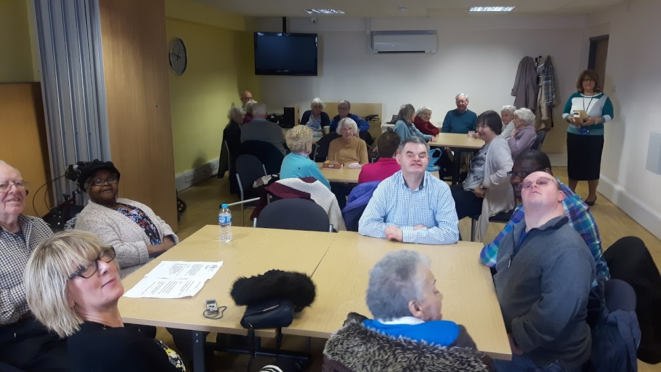

Product of the month:

Non-Spill Mug - Turquoise
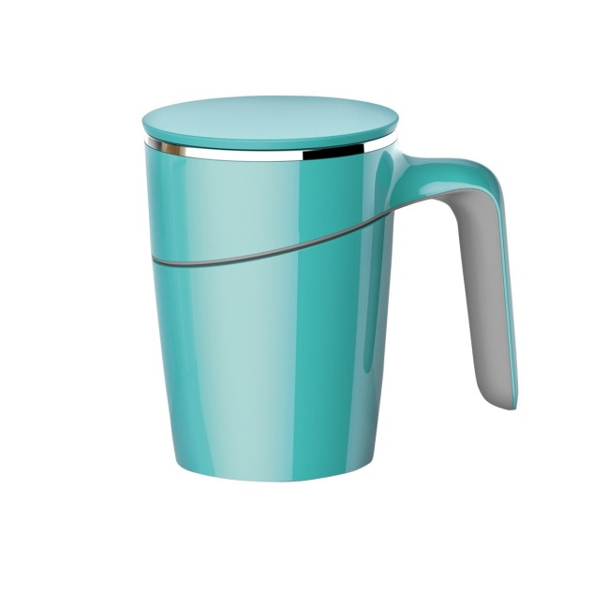

Picture: Non-Spill Mug - Turquoise

Product code: DK144Q

£14.95

This non-spill, twin wall insulated mug has a suction base, providing security in busy environments and around the home to help reduce spillages.

Available in coral, turquoise and white the mug has a suction base, making it difficult to tip over if knocked by accident. In order to lift the mug, ensure that you lift straight up. If you try to lift at an angle the mug may jerk away causing the contents to spill.

The product comes with a lid which is removable for drinking. The lid is fitted with a silicone seal to further reduce risk of spillage when on the move and for security on surfaces.

Active community

We are delighted to welcome our newest member of staff Alastair Sill. Alastair, who is based in Jones Court, will help to deliver a Big Lottery Fund People & Places project that aims to ensure blind and partially sighted people are able to participate more in activities, sports and leisure interests in their local communities.

In just a few weeks Alastair has met with many of our members who have expressed an interest in various activities. He has also had meetings with various sports and community groups as a result of this including:

- Visually Impaired Tennis
- Cardiff International White Water
- Disability Sports Wales
- Llanover Hall Community Arts Centre (Pottery and patchwork)
- Cardiff Blind Bowls
- Pedal Power (tandem bicycles)

If you would like to get involved in a local activity or are interested in any of the above please contact Alastair on 02920 398900.

Audio Description Tours

National Museum Cardiff

National Museum Wales are continuing to run their audio described tours of their collections. The tours will cover a different theme each time and most will include touch elements.

Blind and partially people are welcome to bring their family or sighted companions along. We also offer a limited amount of guided assistance - please let us know if you require this.

The next tours:

Thursday 22 June 2017 - Sculpture
2.00pm until 4.00pm

A guided tour of sculpture collections, including masterpieces by Rodin.

Thursday 10 August 2017 - Behind the scenes Herbarium

Visit the Museum’s herbarium and handle original plant specimens.

The tours last approximately 90 minutes. We recommend visitors arrive 10 minutes before the start time. The tours are FREE, but booking is essential. To book, please contact (029) 2057 3240, leave a message and your contact details and they will return your call.

Workshop for visually impaired musicians at Royal Welsh College of Music & Drama

Once again, the Royal Welsh College of Music and Drama (RWCMD) will be running a workshop for visually impaired musicians as part of its Summer School programme.

The course will be held from 1st to 3rd August and will include sessions on improvisation, music technology (with assistive software), and Braille music. It is open to people of all ages with a visual impairment who would like to develop their musical skills. Previous musical experience is not required. The course director is Jackie Clifton, founder of 'Musicians in Focus'.

For more information and to book a place, visit the RWCMD website, or telephone 02920 391430.

RNIB Connect Project

RNIB Connect is a growing community of blind and partially sighted people and their families, friends, carers and supporters. It is where people can connect with others for peer support and social interaction and find the information and inspiration they need to get on with their lives.

It aims to encourage people who are blind or partially sighted to take part in local activities whether it’s face to face, online or on the telephone.

If you would like to know more about getting involved please contact Eleanor Rothwell on 02920 828500 or email: eleanor.rothwell@rnib.org.uk

RNIB Sight Loss Counselling

If you have lost or are losing your sight, you may be worried about how you will cope. Or you may feel depressed about the changes you are facing. Perhaps you are experiencing feelings of sadness, anger or anxiety and this is affecting you on a day-to-day basis. Or maybe it’s causing you to worry about the future.

During these times, many people find it helpful to talk through their feelings with someone outside their usual circle of family and friends. If you are supporting a person with sight loss, you may also experience these feelings and need someone to talk to.

RNIB’s Sight Loss Counselling Team offers confidential telephone and online counselling to help you get through these times. They support people of all ages, including children and young people from the age of eleven and their counsellors have extensive experience in supporting people impacted by sight loss.

They can offer you:
- time to talk about your situation and how you’re feeling
- one-to-one telephone and online counselling, as well as telephone support groups facilitated by a counsellor

For further information please contact us on 029 2039 8900 or RNIB Helpline on 0303 123 9999.

The benefits of volunteering

Jeff Goodwin

Jeff became a volunteer with RNIB in October 2012. In his first volunteer role Jeff telephoned service users to see how they were getting on following their successful benefit award and to ask if they needed further help. Jeff then moved on to help the Technology Support Squad. He visited people in their homes and tried to solve IT issues such as broadband or printer problems. Jeff has had 40 years’ experience in IT designing networks and broadband services so he is somewhat of an expert in this field!

Jeff continues to help the Technology Support Squad and also carries out home assessments for CIB. He visits newly diagnosed people at home to explain about the help and support that is available from CIB, RNIB and other voluntary and statutory organisations. Jeff also has a list of service users he calls on a regular basis from our tele-befriending service.

Jeff is married with 2 daughters and granddaughters who occupy a great deal of his time but he still finds one day a week, sometimes more, to help us. Jeff loves the variety of his volunteer roles. He really enjoys meeting and chatting to people and is always eager to help resolve problems.

One service user said,
“I find that Jeff calling me on Tele-befriending is a real lifeline. I am on my own and don't have children or relatives who come and visit or call regularly. Jeff calls me every week. He's a firm contact that I look forward to a chat with. I really enjoy speaking to him as he is so interested in what I have to say. Thank you very much.”

Feedback from CIB members

Our lovely volunteer Julie regularly telephones people we support to ask for feedback on the services they have received to help us improve the work that we do. Here is a sample of what people said:

“I really appreciate my regular tele-befriending call, it gives me so much confidence to know that someone will be in touch as sometimes I don't see or hear from anyone for days. I've been chatting about my time and experiences during the war and all sorts of other good memories that really cheer me up! He's a good friend to me and brightens up my life, thank you very much.”

“The help that I got from Michelle when I came into CIB’s Resource Centre was fabulous. She was so caring and patient with me. I had come in for a walking stick and she happened to have one which had been donated that was exactly the right size. I've used it a lot already and I gave a donation for it. I also bought a Talking Book machine and she helped me fill in the application for RNIB talking books and I bought a key ring clock too. Very helpful indeed, thank you so much.”

“I really enjoyed coming to the Living with Sight Loss session. It was very interesting, especially about the Care and Repair Service. I had no idea it existed. I was happy to meet with people who have the same condition as me which is macular degeneration. It was good to discuss similar problems that we all come across. I know I am not alone now! I look forward to being a regular member of the macular support group and I will definitely come to the next Living with Sight Loss session.”

“I have had a brilliant service from Teresa. She put me in touch with Ruth the Eye Clinic Liaison Officer who is now helping to get me registered blind and also to get my eye drops sorted out. She is a fantastic help. I have already joined 3 clubs. The Conversation Club which was really interesting and in the Women's group we went to do assisted shopping at Debenhams. I'm really looking forward to joining the Gardening Club. It feels like I have a new life!”

And finally, we at CIB love what we do, trying to make every day better for blind and partially sighted people. We don’t expect thanks but this bouquet and note from a service user was so beautiful. Thank you.

"For Teresa with much gratitude for all your care and support, very grateful thanks Vivien and Denise"

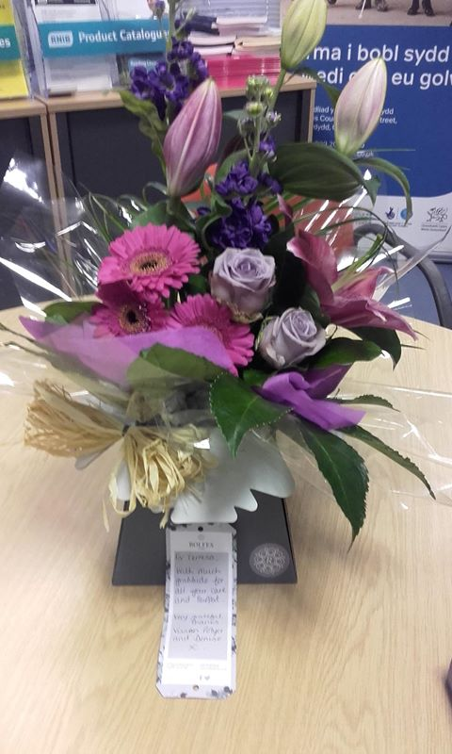

Picture: Bouquet of pink, purple and blue flowers

Did you know…?

Cardiff is one of the flattest cities in Britain.

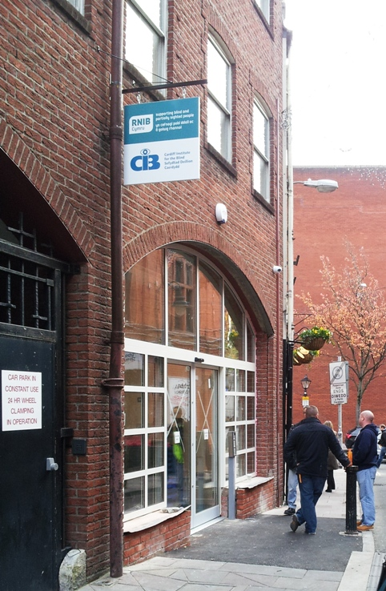

Picture: Front of CIB/RNIB Building on Womanby Street.

Cardiff Institute for the Blind

Jones Court

Womanby Street

Cardiff

CF10 1BR

Telephone: 029 2039 8900

Email: CIBPostmaster@cibi.co.uk
Website: www.cibi.co.uk
Twitter: https://twitter.com/CardiffBlind
Facebook: www.facebook.com/CardiffInstitutefortheBlind

