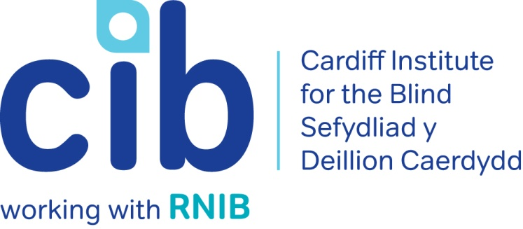
–

CIB Newsletter

Summer 2019

Welcome to the Summer edition of our newsletter. Please contact the office on 02920 398900 with any queries and don’t forget to keep up-to-date via our Facebook page www.facebook.com/CardiffInstitutefortheBlind and Twitter @CardiffBlind or website www.cibi.co.uk.

In this edition:

Page 2: Real life: Julie

Page 3: New name for CIB

Page 4: Technology for Life – drop in sessions

Page 5: Focus on eye conditions: Charles Bonnet syndrome

Page 7: Driving with Macular Disease

Page 8: Product of the month: Sonic USB player
Page 9: Apps we can’t live without
Page 10: New Skype group
Page 11: Changes to preferred format
Page 11: Active Community
Page 15: Service user feedback

Real Life: Julie

Jane, our Community Coordinator, met Julie after she had been in post for a few months. Julie used to volunteer with CIB and come in for various groups. She had however been suffering health problems, her confidence was very low, and she was not going out except to hospital appointments. She mentioned to Jane that she used to swim and would love to swim again but that she was scared to go back to her local leisure centre as she had suffered an awful experience where the changing room had been left in a bad state, which she had not seen.

Jane invited Julie to a group visit to the newly refurbished Fairwater Leisure Centre in which the group met all the staff, had a chat about what support people with a sight impairment might need and what the staff could do to help. They had a tour of the facilities and a taster session in the gym. The staff were very friendly and happy to help in whatever way they could.

Jane also contacted Julie’s local leisure centre to discuss the problems Julie had faced in the past. The leisure centre could not have been more supportive, and Jane passed on their responses, letting her know a plan of action that they suggested to better meet Julie’s needs.

Julie now swims twice a week. She said that the staff at the pool could not be more friendly and helpful. They accompany her to the changing room to check all is well before Julie goes in. Julie started trying to use the steps but found it a bit much, so now they have the hoist ready for her. She gets a taxi there and back as it is not too far away and she has got to know all the others swimming at that time. They go out for a monthly meal and celebrate birthdays. If someone is not there, the others are asking about them. It is a real community and Julie is thrilled to be back in that environment. She says “I love it and I can’t thank Jane and CIB enough for all their support. I feel I want to give something back and that is why I love volunteering for CIB.”

New name for CIB

As many of you will know, Cardiff Institute for the Blind (CIB) has been consulting on whether to change its name and what name to change it to.

As some background, the organisation was founded as the Association for Improving the Social and Working Conditions of the Blind in 1865 and the name changed at an unknown date to Cardiff Institute for the Blind. After signing an association agreement with RNIB in 2009, the organisation introduced a trading name of Cardiff, Vales and Valleys as it expanded across South Wales.

This name was not working and to coincide with the organisation’s 150th anniversary in 2015, we decided to go back to Cardiff Institute for the Blind but began using the RNIB Cymru name outside of Cardiff – mainly to retain contracts with Swansea Council and Rhondda Cynon Taf Council, who did not feel the Cardiff Institute for the Blind name was appropriate.

Feedback from staff, service-users, partners and funders since then has been that our name and dual branding (using the RNIB Cymru name) was confusing and hampering our ability to support people recently diagnosed with sight loss and our ability to fundraise.

An increasing number of new service-users where we make the initial contact were saying things like: “Why are you contacting me when I’m not blind?” and “I don’t think the services you provide can help me”, as many people think of us as being the institute where you go to make wicker products.

Using the RNIB name outside of Cardiff became more complicated with the introduction of the General Data Protection Regulations (GDPR), where you have to be clear who is holding personal data and why, and people who wanted to donate or fundraise also weren’t clear who the money was going to.

There is no doubt that the Cardiff Institute for the Blind name is quite well known in Cardiff but many people just refer to us as ‘CIB’, ‘the Institute’ or ‘the Blind’ – none of which are ideal when you want to attract a wide range of people.

Income from fundraising has been slowly reducing and we believe
a change of name will give us an opportunity to have a conversation with our service-users and supporters about the financial challenges facing all charities, the need to be relevant and continually evolve, and how essential donations and legacies are to an organisation such as ours.

The CIB Board agreed for us to consult on changing the name and we did this in two stages. In stage one, we asked people whether we should change our name and what might be the response if we did. As people unanimously agreed a name change was needed in the first consultation, the second stage was to find our what thoughts people had on a name, strapline and logo.

In total, we have done four focus groups with around 60 people, randomised telephone calls to service-users across our areas and nearly 300 people completed an online survey.

When we asked service-users “Would you object to Cardiff Institute for the Blind changing its name?”, only one person said yes but they said they would continue using our services if we did.

We asked people to provide comments about Cardiff Institute for the Blind’s name and identity and the following is a pretty good summary of the response:

• The name was a barrier to me and I just wish I'd come earlier.
• I didn't want to go to CIB because the name put me off but a friend said I should and I wish I'd gone earlier.
• I only came to you out of desperation because I didn't originally think you were for me. How wrong I was!
• I’m not blind and so it’s not right for me and other partially sighted people.
• I agree 100% it needs updating. It's old fashioned. I hate the Institute part of it.
• Think it needs to better represent where you work.
• Doesn't seem like it fits who you are any more.
• You need something catchy, so people remember it.

A report on the focus groups produced by RNIB, who delivered the sessions, summarised the views of people as being:

“There was a consensus that services users placed great value on their relationship with Cardiff Institute for the Blind (CIB) and regarded the staff and peers as ‘a family’. However, most were surprised this would be the case when first approaching CIB due to the name and image.

“People hugely value the service and some felt regret that they had taken so long to approach CIB due to their misconceptions about if and how CIB could help them. People were keen that others new to sight loss did not make the same mistake.

“There was a universal acknowledgement that CIB’s current name no longer reflected the breadth of its services and locations and the logo did not illustrate the charity as it is today.

“The recommendation to the change CIB’s name was overwhelmingly welcomed across all focus groups. Only one participant felt the name should stay the same because of the historical connections.

“Participants had a variety of reasons to explain why they thought the CIB name is no longer right for the organisation. These included ‘Cardiff’ not covering the geographical areas we operate in and so was misleading, ‘Institute’ being dated, unfriendly and off-putting and ‘Blind’ not representing those who are partially sighted.”

So that is the background to how we got here today, which is ready to launch a new name. So come on, tell us, what is the name I hear you say!

The name Sight Life was chosen as the most liked name in the consultation we did, with people saying it was positive, catchy and reflected the fact we support people to enjoy an independent, active, social and fulfilling life.

In addition to a new name, we’ve developed a bilingual strapline of Local sight loss support / Cymorth colli golwg lleol, as people were keen we stress that we provide local support and that sight loss is the subject we specialise in.

We’ve also created a logo in consultation with a wide range of people with sight loss and those who may develop sight loss in the future and we have been told the final version is accessible, distinctive and is good at giving people a flavour of what they can expect from us an as organisation.

The new logo is at the end of this article and we will be updating our website, social media pages and email addresses to reflect the new name.

We’d love to have your feedback and for you to share as widely as possible. We want everyone with sight loss in our area to enjoy an independent, active, social and fulfilling life and to do that, people need to know about us and know how to get in touch with us.

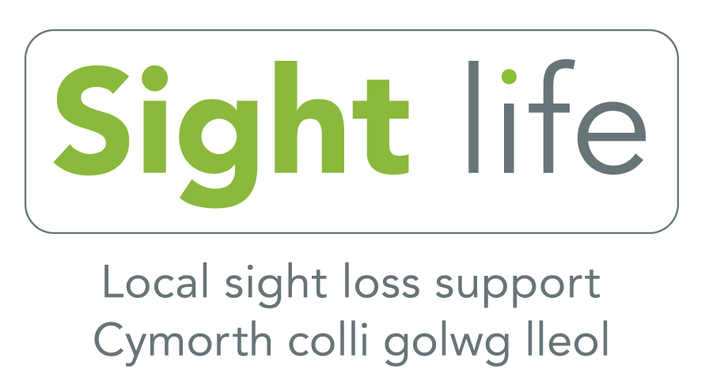

Technology for Life drop in sessions

Do you have a Smartphone or Tablet that you are struggling to use or no longer use? Would you like to try before you buy or learn a bit more about what devices are available and which best suits your needs?

In partnership with O2, we are running fortnightly drop-in sessions held in our Centre in Jones Court, Womanby Street, Cardiff. A member of staff from the Cardiff O2 store will be available to help with any accessibility issues for any device on any network. It is not restricted to O2 customers or contracts. The ‘Gurus’ as they are called, can support people with sight loss to understand technology, what would be best for them and how it can increase independence.

The fortnightly sessions are held on a Monday from 11am until 1pm. If you would like to book a slot, please contact us on 02920 398900.

Focus on eye conditions: Charles Bonnet Syndrome

What is Charles Bonnet syndrome?
Charles Bonnet syndrome (CBS) causes people who have lost a significant amount of sight to see things that aren’t there, medically known as hallucinations. CBS hallucinations are only caused by sight loss and aren’t a sign that you have a mental health problem. People see different kinds of things ranging from simple shapes or patterns to faces, and objects. CBS can be frightening, but the hallucinations usually get less frequent with time.

CBS hallucinations do not involve hearing things or feeling things that aren’t there, and people are usually aware that what they are seeing isn’t real.

Who develops CBS?
CBS occurs in people who have lost a lot of their vision from an eye condition, for example, age-related macular degeneration, cataracts, glaucoma or diabetic eye disease. As these conditions are more common in older people, many people who have CBS also tend to be older. However, anyone of any age, including children, may develop CBS following sight loss.

Origins of the name CBS
Charles Bonnet syndrome is named after a Swiss philosopher and writer who lived about 250 years ago. Charles Bonnet wrote about the experiences of his grandfather, who lost his sight following cataract surgery. His grandfather began having “visions”; seeing patterns, people, birds and buildings, which were not really there.

What causes CBS?
CBS is caused by loss of vision and the way your brain reacts to this loss. Exactly how sight loss leads to hallucinations isn’t really known, but research is slowly revealing more about how the eye and the brain work together.

When your sight is good and you are seeing real things around you, the information received from your eyes stops the brain from creating its own pictures. When you lose your sight, however, your brain isn’t receiving as much information from your eyes as it used to. Your brain can sometimes fill in these gaps by creating new fantasy pictures, patterns or pictures. When this happens, you experience these pictures as hallucinations. CBS tends to start in the weeks and months following a big deterioration in your sight.

How will I know if I have CBS?
It’s natural to be worried, confused or frightened when you see things that are not really there. Until you know what’s happening, you may be concerned that seeing things is a sign of a mental health problem, or you might think that you have dementia. However, CBS is caused by sight loss and the hallucinations aren’t a sign of any other health problem.

If you suddenly find that you’re seeing a pattern, person, building or a landscape that you know is not really there, then don’t be afraid to tell your GP or optician, who should be familiar with CBS.

Is there any treatment for CBS?
Currently there is no medical cure for CBS. Sometimes just knowing that the condition is not a mental health problem, or a symptom of another disease can help a lot. Knowing that CBS usually improves with time (even if it doesn’t go away completely) and having information on CBS as well as sharing your experiences with friends or family can also help.

For further information contact RNIB Helpline on 0303 123 9999 or call CIB on 02920 398900.

Driving with macular

Being able to drive is very important to many people as it helps maintain independence, especially in areas with less reliable public transport. However, many people with macular are not able to continue driving.

What are the rules?
If you can meet the minimum sight requirements for driving (possibly using corrective glasses or contact lenses), then you can continue to drive. Many people with macular may still be able to drive safely and legally. However, there is a legal requirement for you to report your condition to your licensing authority if you have been diagnosed with the condition in both eyes.

Additionally, if you are over the age of 70, and whether you have macular or not, you will need to renew your driving license.

If you have been diagnosed with macular, seek advice from an optician or ophthalmologist to determine whether your sight passes the required driving requirements.

Personal Independence Payment (PIP)

Any people who were receiving Disability Living Allowance (DLA) and were aged over 16 and under 65 on 8 April 2013 are being invited by the Department of Work and Pensions (DWP) to claim Personal Independence Payments (PIP). If you are in the relevant age group and have not yet had an invitation to claim PIP, you will eventually get a letter from DWP which will explain what you need to do to begin your claim.

When the DWP invite you to make a claim for PIP, it is vital that you contact them to start your claim within four weeks. If you do not start your claim within four weeks, the DWP will suspend your benefits. You can still make a claim for PIP after this and if you do it within a further four weeks the DWP will reinstate your DLA whilst you are making your claim for PIP.

Getting help with PIP

RNIB has produced a factsheet on PIP that contains lots of useful information and more details about how to make an effective claim for it. If you would like some advice or help with completing the claim form please contact RNIB Helpline on 0303 123 9999, open Monday to Friday 8am to 8pm and Saturday 9am to 1pm, or email helpline@rnib.org.uk. They will be able to put you in touch with their specialist advice services and form filling service.

PIP appeals

If your claim for PIP is unsuccessful or you are unhappy with the rates you have been awarded you have the right to appeal. RNIB can advise and support you with this also.

Featured product: Sonic 2 USB player
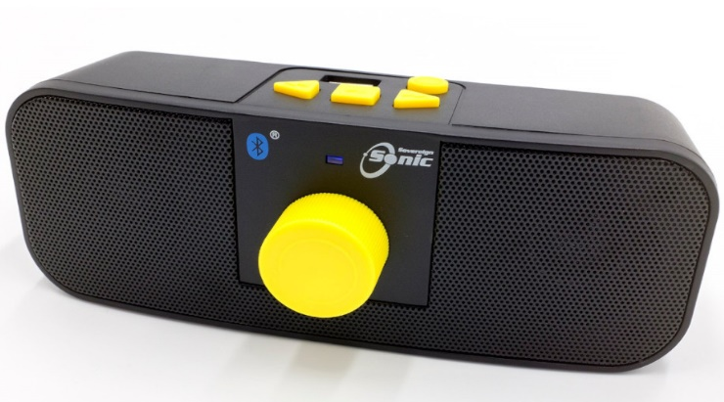

Product code: DH422
£49.95 (ex VAT)

The Sonic 2 will book-mark your place when you switch it off or remove a memory stick and will play from there when that stick is next used. You can navigate easily to a new book, skip chapters or review paragraphs.

The Sonic 2 has fabulous sound quality even when using earphones. It also has a new USB C power supply designed specifically for blind and partially sighted users. The charger has a unique tactile feel, 3D raised logo, high contrast colours and a strengthened braided nylon cable.

You can listen to books, podcasts and music on your mobile phone or tablet using Bluetooth to connect to the Sonic 2.

Apps we can’t live without

Cardiff Bus app

Picture: Cardiff Bus app

The Cardiff Bus app allows you to plan your journey from start to end, from getting to the stop and checking timetables to watching the live times feed for your bus and buying your ticket.

The app is free to download and is available in both iTunes store
and Google Play store. Just search for Cardiff Bus.

This is a new app, not an update to the iffapp, and you must create a new user account when you download it. The main map in live times shows all the bus stops in their network. You can click on the stop you want to get a few options on how to proceed. You can also add your stop or stops to the favourite menu to find it more easily next time. You can also use the search bar to find your stop or a location that you want to get to. Once you have selected a stop, using 'departures' will show you a live departure board telling you when the next buses are due.

For more information email mtickets@cardiffbus.com or call their Customer Service centre on 029 2066 6444.

Telephone and Skype groups
RNIB Cymru are setting up some telephone and Skype groups to support blind and partially sighted people in Wales who would like to talk to others with similar experiences.
Telephone groups are a great way to meet people when you have a busy schedule or find it difficult to travel for a face to face meeting. A telephone call can really lift spirits and brighten your day as well as being an opportunity to learn something new or share your knowledge and experiences.
They have trained volunteer facilitators with sight loss who are interested in running the following sorts of groups:
- Students in higher education
- People in work
- Parents and carers of people with sight loss
- Parents with sight loss
- Welsh language social group
If you are interested in chatting with others over the phone or Skype for an hour once a month, they would love to hear from you. Also, if there is a group that you would find useful that’s not listed here, please contact Eleanor.
Contact Eleanor Rothwell on 077 0282 1915 / 02920 828 565 or eleanor.rothwell@rnib.org.uk

Changes to preferred formats

Some of you will have received a telephone call lately asking if you would like to receive the newsletter on a USB stick instead of CD (which are being phased out) or in another format. Our newsletter is currently sent out to over 1500 service users in and around Cardiff in their preferred format of either large print, braille, email or audio CD.

Email enables us to contact people more efficiently and at short notice so if you have an email address that we are not aware of, please contact us so that we can update our system.

Active community - National Lottery Community Fund project update

Where there’s a will, there’s a way!

Starting something new when you are an adult can be daunting, especially if there are additional barriers to overcome such as having sight loss. However, the sense of achievement from overcoming those barriers and doing the activity in question, as well as the other benefits of being part of a community, make the effort all worthwhile.

Two inspirational ladies have taken up swimming again after a long break and are reaping the rewards, not just because they are fitter, but because it has brought much more to their lives than just the swimming.

When Jane first came in to post in April 2018, Sian was one of the first people she supported. Sian said she would like to swim again but was feeling anxious about the whole process of starting an activity she had not done for ages, certainly not since she had a guide dog. Jane went with Sian a few times to give her confidence navigating round the changing rooms, find her way to the poolside, meet the staff and generally get a bit of a routine going. At this time, Sian was doing about 12 lengths each visit.

In spite of being very busy volunteering for Guide Dogs and CIB, Sian started going regularly, sometimes on her own, using her lovely guide dog Uri to get there, sometimes going with her sister or friend as a guide – the advantage of whom was that they could come into the changing rooms and the pool too. The more she went, the better she knew and was known by the staff until they would rope off a lane for Sian without being asked.

Being the determined lady she is though, after swimming for a few months, Sian decided to set herself a challenge. Sian and her husband signed up for the tandem triathlon in Bishops Castle in Shropshire. Sian was committed to swim a kilometre (50 lengths) and then cycle 21 miles on the back of the tandem. It was just as much of a commitment for her husband, Dave, who obviously had to do the cycle ride and then had to do a 10k run. At the time of signing up, Dave had not done any running.

Last weekend, they did the triathlon and nailed it. When Sian’s lengths counter told her she only had 2 left to swim, she was convinced they were wrong – she could have kept going well beyond 50. In spite of being very hilly terrain, they did the cycle ride in style. Dave was shocked when he discovered that not only was he expected to run 10k but it was up a mountain! The event was both physically and mentally demanding, but Sian loved it and is determined to go again next year. She met some lovely people and enjoyed being part of an unusual event. Dave isn’t quite so sure – he is more tempted by the National Stone Skimming Championships and the Beer Festival that take place there the following weekend!

They should both be very proud of their achievement and of their fundraising efforts for Guide Dogs.

Remember, swimming is free in the local pool for over 60s. Adult swimming lessons are available if anyone has not yet learned to swim but would like to give it a go. Most lessons are in the evening, but the Cardiff Bay pool do adult beginner lessons on a Tuesday and Thursday morning and the Star Hub do them on Sunday mornings. One of our other members is due to start lessons next week and we will keep you posted.

If you would like to try cycling, Pedal Power organise a monthly tandem ride on the first Friday of the month at 3:30-5:00pm and they plan to organise gentler side by side rides round the park over the summer. Get in touch if you would like to try this and we will organise a group visit.

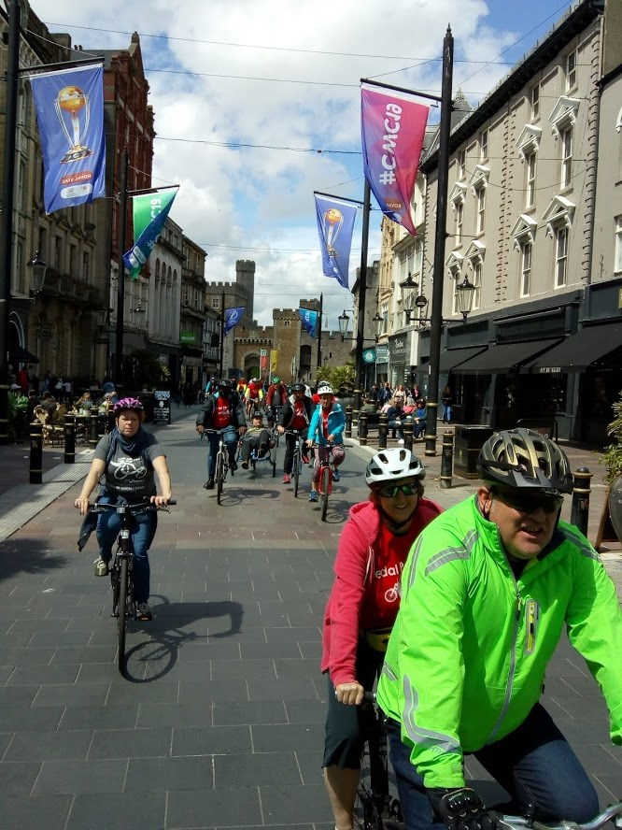
Picture: Tandem cyclists in Cardiff

Feedback from our service users

We’ve had some great feedback from you. Thank you for taking the time to talk to our volunteer Julie about your experience. We really do appreciate it, as it demonstrates to others the impact our services have.

Here are some of our favourite quotes:

“Teresa and Jeff have been a brilliant help. I really didn't realise they could do so much. The visor that Teresa got us is a simple but really good help to shielding the bright light. She referred us to Independent Living Service which has given us a reduction on our water bill, which is great. Also, Jeff installed the voice over function on my mobile phone, which is a tremendous help. Thank you both for your ongoing care”.

“I found Teresa was very kind and helpful, she explained things really well and the most important thing was that I really thought she understood how I felt in coping with my sight loss. She introduced me to Talking Books, which is like having a companion and I really enjoy them. She also referred me to Care and Repair and they have put a hand rail in my drive making it much safer for me to walk up it to the front door and a platform in front of the front door step, making it much less steep and so much safer and guarding me from falls. I'm so pleased and grateful for all the help”.

“I have been receiving services from CIB for several years now and I am extremely happy with the help. One of the things I was originally helped with was special lighting throughout my house, which is a simple thing but was a huge help to me when my eyes started to really deteriorate. I have Talking Books plus radios in several rooms of my house, all set up on different channels and they all keep me company. Teresa recently got me a huge large print calendar and black felt pens which I find extremely helpful to keep track of my appointments. It's helped a lot. Overall CIB have been great at supporting me. Thank you”.

“I retired from work at the end of last year and was then diagnosed with Macular. I was really feeling down and feeling the need to fill a void in my life of not working. I was referred for a home visit from CIB, which has totally transformed my outlook on life. Teresa came and she is marvellous and put me at ease right away. I was able to talk and open up to her really easily. I've already joined the Macular Group and am looking forward to coming to the Macular Seminar in 10 days’ time. I've also joined the coffee morning and already made some new friends and am looking forward to starting the Chair Yoga classes. All in all, with all these new events going on, I have discovered a whole new world to be part of. Thank you so much.

Cardiff Institute for the Blind

Jones Court

Womanby Street

Cardiff

CF10 1BR

Telephone: 029 2039 8900

Data protection and contact from CIB
Many of you will be aware of the regulations on data protection, called the General Data Protection Regulations, giving people more control over their data and how it is used. CIB has always taken its responsibility of taking and using personal data very seriously. We have usually taken verbal consent to store and use information, but we now have to be able to evidence that we have consent, particularly for email and text communication.
So that we can stay in touch can you call us on 029 2039 8900, or email cibpostmaster@cibi.co.uk or return this form to let us know your preferences.

Please select what you'd like to hear from us about or just select ‘All’ if you want to receive information, advice and news on everything we do:

Services and products Yes/No
General news Yes/No
Campaigning and Volunteering Yes/No
Fundraising Yes/No
All Yes

Please indicate below if you want to hear from us by email or text:
Yes, I want to hear from you by email

Yes, I want to hear from you by text

Please indicate below if you don’t want to hear from us by post or phone:
No, I don’t want to hear from you by post

No, I don’t want to hear from you by phone

Name: ______________________________________________

Postcode: ________________ Telephone: __________________

