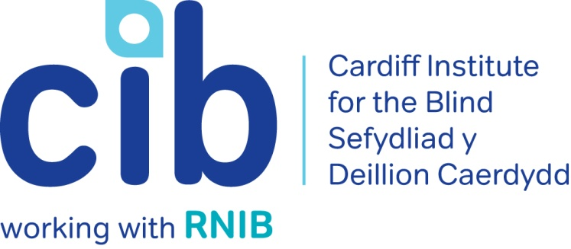
–

CIB Newsletter

Spring 2019

Welcome to the Spring edition of our newsletter. Now that the colder weather is hopefully behind us, we hope you can get out and enjoy some of the many activities on offer. Please contact the office on 02920 398900 with any queries and don’t forget to keep up-to-date via our Facebook page www.facebook.com/CardiffInstitutefortheBlind and Twitter @CardiffBlind or website www.cibi.co.uk.

In this edition:

Page 2: New name for CIB

Page 3: Real life: Laurence’s Story

Page 4: Technology for Life – drop in sessions

Page 5: Focus on eye conditions: Diabetic Retinopathy

Page 7: Carer’s Project

Page 8: Product of the month
Page 9: Apps we can’t live without
Page 10: JobSense
Page 11: Independent Age
Page 11: Active Community
Page 14: Adult Education
Page 15: Service user feedback

New name for CIB

We have been consulting on the need to change our Cardiff Institute for the Blind name as we had been told that it stopped or delayed many people from asking for or accepting our support and that it no longer reflected what we do and the fact we work across South Wales. We believe it has also been affecting our ability to generate much needed income, as the name has become outdated and does not reflect the difference we make to people’s lives.

The response was that people overwhelmingly recommended changing our name and we are now asking people about what name, strapline and visual identity will best help us reach and support the thousands of blind and partially sighted people living across South Wales.

Our service-users and partners have recommended a name and identity that is modern, informal and helps communicate the life changing support we can provide to people - particularly those who have recently developed a condition affecting their sight. The two names and descriptive straplines we are testing have been taken from the first stage consultation, but we are very open to changing or adapting these following feedback from this consultation.

We would love you to have a say in this important decision and you can do that by either clicking a link to an online survey from our website; the address is www.cibi.co.uk/decideourname; by calling us on 029 2039 8900 or by visiting us on Womanby Street.

Real Life: Laurence

Laurence started noticing that something was going wrong with his sight towards the end of 2011. He was not working at the time as he had suffered a serious accident in work. He visited the hospital and treatment was tried briefly, but in early 2014, he was told that there was little that could be done, and he was registered severely sight impaired.

This affected his wellbeing and confidence. He received some rehabilitation from social services to help with his mobility, but he was not in a good place, relied heavily on help from his Dad and stopped going out and doing the things he used to enjoy, like going the gym and swimming.

Our Locality Manager Teresa visited Laurence in February of this year following a referral from his optician and Laurence said that "It has snowballed from there". He was not seeing many people, not going out on his own and had not been to town since before his accident at work.

Teresa chatted to Laurence about his sight loss and how it was affecting him. She arranged for him to have a British Wireless for the Blind radio on free loan; signed him up for Talking Books from RNIB; told him how to get a bus pass from the local library and signed him up to a Hynt card to allow him to take a companion for free to theatres and art centres. The Hynt card and Talking Books arrived quickly and Laurence went to the library with his Dad and now has a bus pass.

She also referred him to Guide Dogs for the Blind, who have explained that he would not be able to go on the waiting list unless he was able to walk three different routes of about 40 minutes independently.

Our Community Coordinator Jane has also supported Laurence to go to Pentwyn Leisure Centre, where the manager showed him around and offered him a free guest pass for a week so that he would have a chance to have an induction with one of the fitness instructors and have a few goes before deciding whether he would like to carry on going. He loved being back in the gym and even went swimming with his Dad too. Laurence decided to join and is now going regularly. All the staff are very friendly and greet Laurence by name, making him feel very at home.

Laurence then came to our public centre on Womanby Street and met Michelle and Craig, who told him about some apps that might be helpful on his iPhone. He came again on the bus with his Dad the following week for a coffee and a chat and then attended our technology open day on his own. Laurence said ‘Since coming to CIB I feel more confident and I now use public transport on my own. I have also started back at the gym and I am hoping to join in with other activities that I never thought I would.”

Technology for Life drop in sessions

Do you have a Smartphone or Tablet that you are struggling to use or no longer use? Would you like to try before you buy or learn a bit more about what devices are available and which best suits your needs?

In partnership with O2 we are starting fortnightly drop-in sessions to be held in our Centre in Jones Court, Womanby Street, Cardiff. Two members of staff from the Cardiff O2 store will be available to help with any accessibility issues for any device on any network. It is not restricted to O2 customers or contracts. The ‘Gurus’ as they are called, can support people with sight loss to understand technology, what would be best for them and how it can increase independence.

The first session will be held on Monday, 13 May 2019 from 11am until 1pm. If you would like to book a slot, please contact us on 02920 398900.

Focus on eye conditions: Diabetic retinopathy

The most serious eye condition associated with Diabetes is Diabetic Retinopathy. It occurs when the tiny blood vessels at the back of your eye become blocked and leak.

There are different types of diabetic retinopathy –

- Background diabetic retinopathy: Background retinopathy does not usually affect your sight, but your eyes will need to be monitored carefully to make sure your retinopathy doesn’t become worse.

- Proliferative diabetic retinopathy: If background retinopathy gets worse, many of the retinal blood vessels become damaged or blocked. When these changes affect a large area of your retina, blood supply to the retina is reduced. The body tries to fix this by growing new blood vessels on the retinal surface or into the vitreous gel. Unfortunately, these new vessels are weak and they bleed very easily, which may affect your vision.

- Diabetic maculopathy: When your macula (the central part of your retina) is affected by your retinopathy, you are said to have diabetic maculopathy. This means that your central vision, which is required for seeing fine detail and colour, will be blurred.

Reducing risk

You can reduce your risk of developing retinopathy, or help to stop it from getting worse, by:
- Controlling your blood glucose level (also known as blood sugar level).
- Tightly controlling your blood pressure.
- Controlling your cholesterol levels.
- Keeping fit and maintaining a healthy weight.
- Giving up smoking. Nerve damage, kidney and cardiovascular disease are more likely in smokers with Diabetes. Smoking increases your blood pressure and raises your blood sugar level, which makes it harder to control your Diabetes.
- Getting regular retinal screening. The most effective thing you can do to prevent sight loss due to diabetic retinopathy is to go to your retinal screening appointments.

Early detection and treatment can stop you from losing sight. If you’re pregnant and have gestational diabetes, you will have retinal screenings more often during your pregnancy and after your baby is born.

Treatment for diabetic retinopathy

If your sight is at risk from retinopathy and it has been picked up early enough, you will be given laser treatment. The aim of laser treatment is to prevent bleeding or to prevent the growth of new blood vessels for people with diabetic retinopathy.

If you develop diabetic macula oedema you may be offered treatment with an injection into the eye. Whether you need treatment for macula oedema will depend on how much swelling you have in your macula.

For more in depth information about Diabetic Retinopathy please call the RNIB Helpline on 0303 123 9999 or go online at https://www.rnib.org.uk/eye-health-eye-conditions-z-eye-conditions/understanding-eye-conditions-related-diabetes

The Carer’s Project

Breathe is offering several free therapies and treatments to support carers.

Breathe is a counselling and wellbeing space in Cardiff set up by Gofal, the charity thinking differently about mental health. They have received a grant from the Welsh Assembly to offer therapies free to adults who have caring responsibilities. Their therapies include counselling, group support, mindfulness, reflexology and shiatsu.

If you need someone to care for your loved one, they can also supply respite care by a member of the Gofal team - whilst you are taking part in The Carer’s Project.

Group Support
This is a chance for carers to get together to share, support each other and to learn about what support is available from outside organisations.

Counselling
They offer different types of counselling and talking therapies. You could be experiencing difficulties at home, in relationships, at work or with your family. They offer up to 8 sessions with a qualified, British Association for Counselling and Psychotherapy (BACP) counsellor.

Mindfulness
Mindfulness is a very simple form of meditation and helps us to become more aware of the present moment. It helps us to calm our minds and to enjoy the world around us.

Reflexology
Reflexology is a complementary health therapy which uses gentle massage techniques directly on the feet with pressure points corresponding with different areas of the body.

Shiatsu
Shiatsu is a wonderfully supportive, healing treatment based on traditional Japanese massage therapy which uses stretches, pressure points, meridian massage and hands-on techniques.

If you would like to discuss this project or require more information you can contact them on 02920 440191 hello@breathespaces.com.

Featured product: Cooking for VIPs (large print edition)

Product code: TC21366 £12.95

This book provides a selection of more than 100 recipes that are simple to prepare with inexpensive ingredients. Also included are several recipes that can be cooked or prepared a day or two in advance as well as tips for cooking with limited sight. Each recipe is graded according to the level of difficulty based on the author's experiences. Also available in braille and DAISY audio.

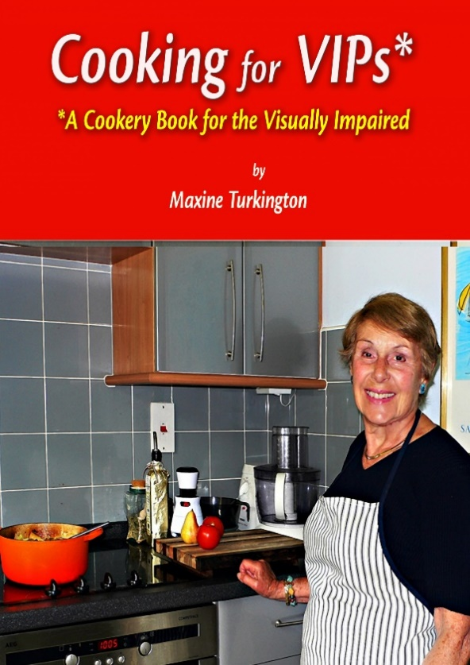

Picture: Cooking for VIP’s book

Apps we can’t live without

A Smartphone or Tablet is nothing without apps. There are hundreds of them available and no matter what your interests are, there is one for you. Here is a free one that can support people with sensory loss:

Dolphin EasyReader

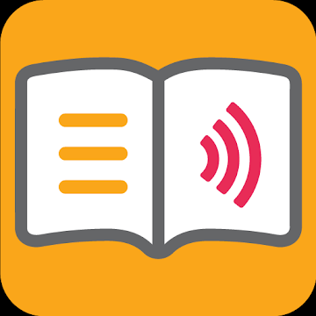

Picture of Dolphin EasyReader App

EasyReader is a FREE accessible reading app for readers with dyslexia, low vision or blindness. Browse & download from the World's largest collection of talking book and newspaper libraries. Open & read books from your device, email or the cloud. Or copy text from anywhere on your phone & hear EasyReader read it back to you. Experience perfectly synchronized text & audio. Or for text only titles, EasyReader can add a human sounding voice of your choice. Boost comfort or contrast - choose colours, text size and highlights to suit your visual needs.

Make your books' text as big as your eyes require. Unlike other mainstream reading apps, there's no restriction with EasyReader. Zoom in with a standard 2 finger pinch or make fine adjustments with the simple sliders. There's never any blurry text or fuzzy fonts, your books' words are always crystal clear and always easy on the eye.

Navigate your books or newspapers by skipping directly to specific pages or headings. Search your book for words or phrases. Add text bookmarks or record your own audio bookmarks and return to them with ease.

EasyReader connects directly to World's largest collection of accessible book libraries with 100,000s of titles and is fully compatible with VoiceOver and TalkBack.

Download the app in the iTunes App Store or Google Play Store.

JobSense

If you have sensory loss and are currently out of work, JobSense could help you access employment, education or training.

JobSense has been funded by the European Social Fund to help people, aged over 25, with a sensory loss to find employment. The project is delivered in partnership between Action on Hearing Loss Cymru, Centre of Sign, Sight and Sound (COS) and Elite Supported Employment Agency.

If you have sensory loss, JobSense can help you by:
• supporting you with job searching, filling in application forms and building a CV
• assisting with interview preparation
• helping you meet potential employers
• helping you access education, training or work experience.

For more information, or to register for the JobSense project, phone 029 2033 3034 (Next Generation Text service (NGT) available) or e-mail jobsense@hearingloss.org.uk

You can also get Employment Advice from RNIB at https://www.rnib.org.uk/information-everyday-living/work-and-employment or call the Helpline on 0303 123 9999.

Independent Age

Independent Age, the older people's charity, is offering free friendship services to help alleviate loneliness and social isolation across Cardiff. Their Friendship Service gives older people the chance to receive a regular phone call or visit from one of their volunteers. The service is free and is open to any older person of post retirement age who would benefit from having someone to chat to on a regular basis.

If you’d like to find out how you can get support or get involved as a volunteer, call them on: 0800 319 6789 or email gavin.stewart@independentage.org. Alternatively, you can visit their website www.independentage.org

Active community - National Lottery Community Fund project update

Activities

Most of the theatres and museums around Cardiff offer regular performances and events that are specifically aimed at or adapted for people with vision impairments. They often ask us to let our people with sight loss know about upcoming events. This is much easier and quicker to do via Facebook and email.

If you have an email address and you would like us to keep you up to date with news and information by email, please let us know the address and what information you would like so that we can pass this information on when we receive it. Also, if you use Facebook, follow the CIB Facebook page. Craig in the office is always happy to help anyone who would like to learn how to use e-mail or Facebook and we are hoping to set up some regular sessions at local libraries soon. Please get in touch if you do not currently use email or Facebook but would like to learn.

Lots of our service users of all ages, are now regularly using leisure centres across the city. The staff are helpful and friendly and will show you the best machines to use, how to operate them with little or no sight and provide you with a programme to help you achieve your own individual goals, whether that be to strengthen muscles, improve flexibility or simply get fitter.

The leisure centres are a great place to go along for some exercise and to meet people – regardless of the weather! It is around £21 per month to join and a guide can come in with you for free if this makes things easier for you. If you would like to have a look round any of them, please contact Jane in the office and we can organise an individual or group visit.

Now that we are back in British Summer time and the weather is getting finer, outdoor bowls has started again. If you have never tried it before, why not go along to the croquet pavilion in Llandaff Fields on a dry Sunday afternoon or Whitchurch Bowls Club on a Monday lunchtime and have a go. Refreshments are available at both, together with lovely company. If you don’t fancy going along on your own first time, give Jane a ring in the office and we can see if we can arrange a volunteer to accompany you.

We are hoping to organise some swimming lessons in one of the leisure centres and some golf lessons for visually impaired players in conjunction with the VI Golf Society over the summer. You don’t have to have done either before to give it a try, so let us know if you are interested and we will add your name to the list to be contacted once we have confirmed the arrangements.

VI Football

Cardiff City FC Foundation are holding visually impaired football sessions at Cardiff University Sports Training Village, Talybont, Cardiff CF14 3AT every Monday from 6pm – 7pm. All ages, (children and adults) and abilities are welcome.

For more information please contact Jane at the office on 02920 398900 or you can look at their website www.cardiffcityfcfoundation.org.uk

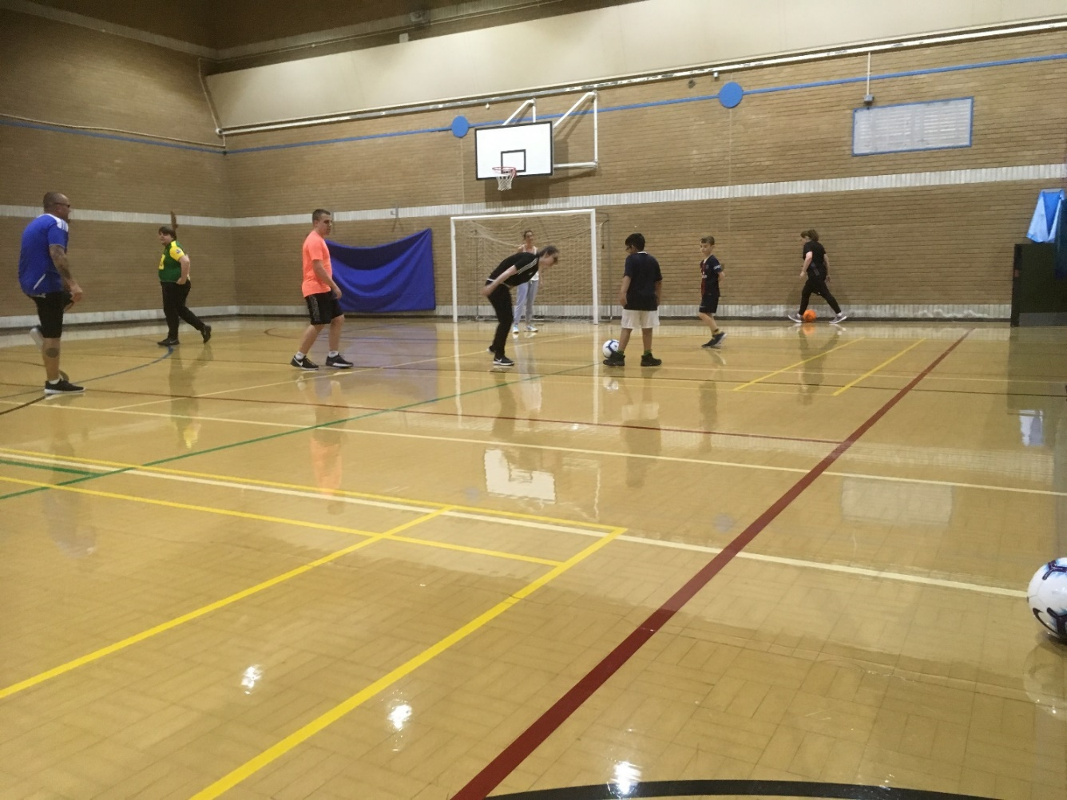

Picture: VI footballers in a sports hall

Arts and Crafts group

Our new arts and crafts group is held in our activity room at Jones Court on the last Tuesday of the month from 10am until 12noon.
Open to all budding artists or those who just fancy a little creative time with a coffee and a chat.

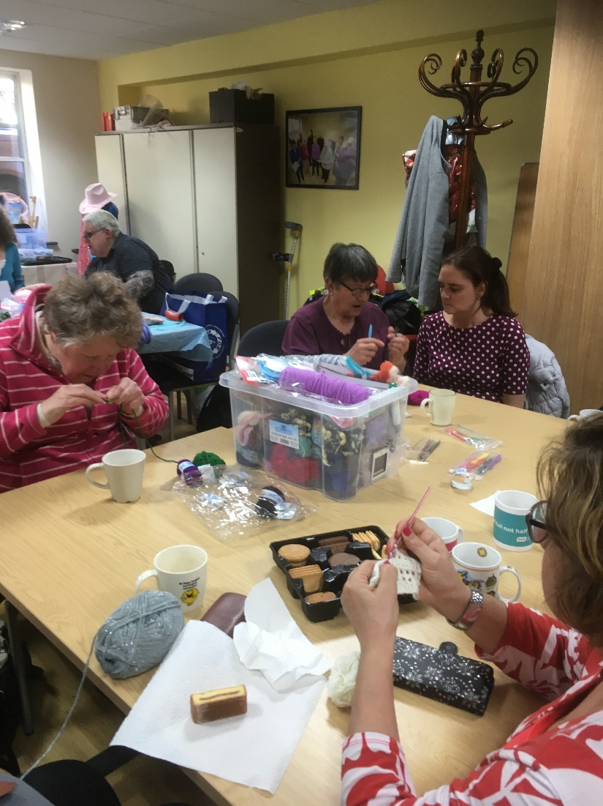
Picture: Members using craft materials

Adult Education Courses

Cardiff Community Learning offer a programme called DICE, which is a range of courses that are completely free for people with certain disabilities such as sensory impairment, mental health issues and acquired brain injuries, who do not feel ready to sign up for a mainstream course. They include computer courses, creative writing, craft and photography. They are very popular, so it is important to enrol promptly. Enrolment for September courses is usually in early July, though the date has not yet been announced. Start exploring this year’s brochure and keep an eye on the Adult Learning website or sign up for their Facebook page so that you are ready. Adult Learning also offer a wide range of courses for adults at a discounted rate for those on PIP or attendance allowance.

If you would like to enrol on any of these, ring Adult Learning Cardiff in Severn Road on 02920 872030 and let them know about the course you would like to enrol on and your access needs. Also, disabled learners can book an appointment for advice and guidance with enrolment and course information by ringing 02920 231652.

The Centre for Life Long Learning also has a wide range of discounted courses for adults. They can be contacted on 02920 870000 and again can help by providing materials in an accessible format or a notetaker.

Llanover Hall are celebrating their 50th birthday on June 15th and will have a full programme of free taster sessions and evening entertainment. Details to be announced nearer the time and you can find out more via (provide their contact details).

Feedback from our service users

We’ve had some great feedback from you. Thank you for taking the time to talk to our volunteer Julie about your experience. We really do appreciate it, as it demonstrates to others the impact our services have.

Here are some of our favourite quotes:

”CIB has played a major part in my life for the last 12 years since I developed Macular. Both Teresa and Michelle are both a major inspiration to me. They are absolute diamonds and are always there to help me if I need them. Through the Macular group I have made many new friends and learned from them and the speakers how I can adapt and cope with the condition. I also come to Yoga group which is very uplifting spiritually as well as physically. Thank you CIB for all your support and help.”

“Teresa has helped me in so many ways. I hadn't really imagined she could do so much for me. She arranged a Low Vision Assessment at home, which I didn't know existed and they were extremely helpful. They gave me magnifiers and some special TV glasses and I can now watch the TV, which is a miracle. Teresa also arranged a Hynt card for me, which means I can go for audio description Theatre performances with my daughter coming as my guide for free. Amazing! Thank you very much.”

“Teresa has been a fantastic help to me. I developed progressive sight loss two years ago due to a chronic condition. Teresa's help has acted as a gateway to a much more positive future for me. Just knowing there is help from CIB has got rid of the fear and depression that was surrounding me. You either stay in bed or decide to get on with it and now I'm being helped, I do the latter. Because of Teresa's advice, I got an appointment with the Eye Clinic to be certified by the Consultant Ophthalmologist as sight impaired and I’ll then be entitled to benefits such as PIP (Personal Independence Payment), which will be a great help as my finances are tight. I've got a symbol cane now and have also been referred to Cardiff Council for mobility training. Overall, I'm extremely pleased with the help and support I've received so far.”

“I can't fault Craig and Jeff for all the IT help they have given me. They really do go the extra mile and bend over backwards to get things done for me. I was having problems with my internet connection and Jeff came to my home and sorted it out for me. I'm so chuffed. Also, I came in for an open day and Michelle was extremely helpful in demonstrating a Talking Book machine, which will definitely enhance my leisure time. I also met a fellow visually impaired person, who really inspired me as he had overcome so many obstacles since being helped by CIB. Thanks for all your help.”

“Since meeting Jane at CIB, my life has totally changed. I am now going to the gym, something I thought I would never do. I feel happier and healthier than I have in years and I’ve made lots of new friends. I have also come to arts and crafts group. Thank you so much to Jane and CIB.”

Cardiff Institute for the Blind

Jones Court

Womanby Street

Cardiff

CF10 1BR

Telephone: 029 2039 8900

Email: CIBPostmaster@cibi.co.uk
Website: www.cibi.co.uk
Twitter: https://twitter.com/CardiffBlind
Facebook: www.facebook.com/CardiffInstitutefortheBlind

Data protection and contact from CIB

Many of you will be aware of the regulations on data protection, called the General Data Protection Regulations, giving people more control over their data and how it is used. CIB has always taken its responsibility of taking and using personal data very seriously. We have usually taken verbal consent to store and use information, but we now have to be able to evidence that we have consent, particularly for email and text communication.

So that we can stay in touch can you call us on 029 2039 8900, or email cibpostmaster@cibi.co.uk or return this form to let us know your preferences.

Please select what you'd like to hear from us about or just select ‘All’ if you want to receive information, advice and news on everything we do:

Services and products Yes/No
General news Yes/No
Campaigning and Volunteering Yes/No
Fundraising Yes/No
All Yes

Please indicate below if you want to hear from us by email or text:
Yes, I want to hear from you by email

Yes, I want to hear from you by text

Please indicate below if you don’t want to hear from us by post or phone:
No, I don’t want to hear from you by post

No, I don’t want to hear from you by phone

Name: ______________________________________________

Postcode: ________________ Telephone: __________________

