Vision News
The newsletter for people with sight loss in Swansea.
Working in partnership with Sight Life and VIWG.
No. 8, January 2020
Contact us: Sight Life, Swansea Vale Resource Centre, Ffordd Tregof, Swansea SA7 0AL 01792 776360. Email: anita.davies@sightlife.wales

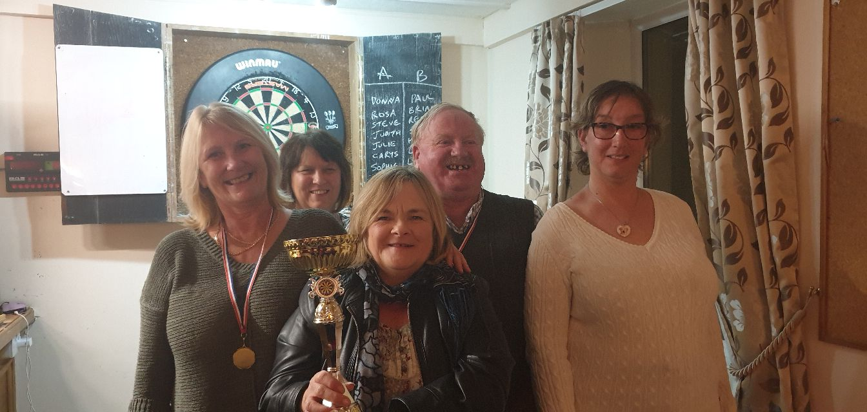

Photograph of members winning the Darts tournament; left to right Julie Mathews, Judith Lombardo, Rosa Thomas, Steven Pearson, Donna Livotti
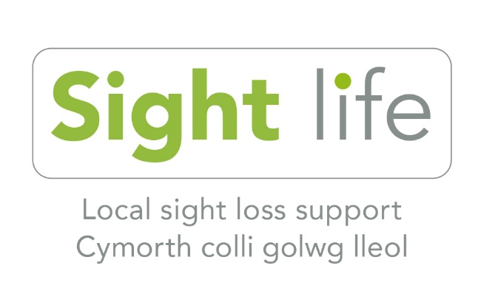

Registered Charity Numbers:
CIB 214131 VIWG 504736

Contents

Hello and Welcome 3
A Personal Story 4
News 6

Events and Activities 10

Trips 11

Peer Support Groups 12

Visually Impaired Sports Activities 14

Hobbies and Interests 15

County Steering Group 16

Community Coordinator 16

Useful Telephone Numbers 17

Hello and Welcome

This newsletter is for blind and partially sighted people living in the Swansea area. We hope this will give you some useful information and advice on the services we run.

Under the General Data Protection Regulation, we are required to request your consent to contact you.

We send this newsletter out in large print, audio and electronic formats. Please let us know at the office if you would like to change the format you receive our newsletter in.

Although we send out newsletters, we also contact members via the phone or email. This is because for many people it is the most preferred method of informing them of new services. If this is not the case with you, and you would prefer not to have phone calls or emails then please let us know when we contact you.

As many of you will know Cardiff Institue for the Blind (CIB) has changed its name to Sight Life. In the past, CIB was operating in the Swansea, Neath and Port Talbot areas under the umbrella of RNIB because if our contract with Swansea Council. This was not working for many reasons and after extensive consultation with service-users, partners and funders, we began using the name Sight Life this October. More information is available on our new website address; www.sight life.wales
A Personal Story

My name is Rosa and I have advanced stage Retinitis Pigmentosa, which is a progressive degenerative condition. I have been employed as an administrator for over 30 years using assisted technology.

During the last 2 years my sight has deteriorated rapidly and I lost confidence, which affected my independence and ability to socialise. My optician contacted the Sight Life office suggesting I would benefit from meeting with an instructor on Digital Inclusion initially.

I met with Anita to discuss Digital Inclusion and an overview of apps designed specifically to help the visually impaired. Anita determined my interests and opened my eyes to the diverse functions of apps that I might utilize to suit my needs and improve confidence. Anita was an enthusiastic and well-informed advocate who demonstrated functions on a level that I could follow, which inspired me to act and I look forward to learning more from the peer support group and share information.

I found the session inspiring and we spoke about other activities organised by the Sight Life. I received the Vision News magazine, which provided further information of the services available.
I had long since lost confidence to attend sporting activities like dance or take up a new interest and mix with strangers to strike up new friendships. However, I spoke to Charlotte the Community Coordinator and Judith and found them both empathetic, encouraging and obviously committed to ensuring people had the opportunity to try new activities and be given the chance to reconnect with or expand their interests in a safe and non-judgmental space with caring instructors and support groups.
Being accompanied by Charlotte has been a key element in me attending Yoga, Tai Chi and Zumba classes, which are not just fun but are improving my fitness and well-being. We constantly hear of the benefits of keeping fit and Sight Life are facilitating opportunities to attend tailored classes, which will help maintain good physical and mental health.

The monthly darts social evening, arranged by Sight Life and hosted by Glantawe Lions at the Travellers Wells was an opportunity to meet other members and hear first-hand what activities they enjoyed and where friendly banter was the order of the evening, as some of us leant the ‘art’ of hitting the dartboard.
Attending the Peer Support Group organised by Judith was a great opportunity to learn what is happening locally, to share information and advice and hear from interesting speakers. The Garw Valley coach trip was also great fun and history was brought alive through the running commentary of a local guide.

On reflection, my journey of sight loss was one of gradual disconnect from taking part and a decreasing comfort zone. However, I now have a more positive outlook as the proactive nature of Sight Life services being rolled out locally and the way Sight Life staff interacts with members shows a deep understanding of the obstacles facing me as a person. To date, this team has opened my eyes to new possibilities, provided a vehicle to make new friends and have fun, restored a sense of control and inspired me to raise the bar and challenge myself.

They have been a motivating force on many levels, stimulating and reassuring in equal measure and have enabled me to start to regain independence and socialise more easily, for which I am grateful.

News

Swansea Contract
Following further discussions with Swansea City Council about our contract, there will now be a sensory services commissioning review. As part of this, the authority will run a workshop early next year to gain the views of blind and partially sighted people. This will be an opportunity for you to give your views on the services provided by the authority, by us and by others and what services you feel would be of most benefit in the future. Further information will be sent closer to the time.

World Stroke Day
On the 29 October we attended World Stroke Day in Melyn, Neath. This was a great event to create awareness around how we can support people who have acquired their sight loss due to a stroke. We will continue to work in partnership with the Stroke Association to support people who have had a stroke and create awareness around the services available.

Living with Sight Loss Workshops
We are planning on running Living with Sight Loss workshops between January and April 2020. These workshops will give you an understanding of what services and support are available to you through six themes covering transport, shopping, money, leisure and entertainment, digital inclusion, and health and wellbeing.

A wide range of information will be available in the workshops, which are highly recommended for anyone newly diagnosed, recently experiencing sight loss or anyone who would like to know what is available to them. They are free to attend. Please contact the office to book your place on 01792 776360.
Darts Group
We are pleased to announce that our VI darts group, who played against the Travellers Wells Pub on 17 October , won the trophy and we have put a pictute of the winning team on the front page.

Zumba
Following a successful 6 week introductory course in VI Zumba, which all members enjoyed, we will continue to run the sessions in the New Year. If you would like to try something new, as a New Year’s resolution, why not come along and learn to dance and have some fun.

Here is a quote from one of our members who attended the introductory course: “Zumba classes have been really entertaining. The tutor Mustapha’s enthusiasm is infectious and he tailors dance moves to suit the group. Learning the dance steps is fun and moving to the music is a subtle exercise.”

Driving Experience
Would you like to experience driving a car at 50mph around a race track? This event is for Visually Impaired or Blind people to try driving. It’s on Tuesday 28 July at Llandow Race Circuit. If you are interested, please ring 016171544567 or go to www.speed ofsight.org/eventListing.php.

Eating Out
Eating out at restaurants with friends and family is an enjoyable and important experience for a lot of people. Here are some hints and tips.

Booking the table:
When booking, make sure you ask about lighting over the table and suitable seating e.g. near a toilet. Also, ask for a quieter area, so you can hear what your friends are saying. Ask if the venue has a large print menu.

At the restaurant:
Carry your symbol cane so that the restaurant is aware of your needs. Make sure you have your preferred app on your phone for either magnifying the text in a menu or for reading it out to you - for example, the ‘Seeing AI’ app.
Take a small task light, it’ll help you see the menu and your plate.

Remove clutter from the table if you can. Look at the menu online beforehand if this is available. If struggling with the menu, ask a member of staff for help. If you struggle with meat on the bone either ask them to cut this for you in the kitchen or choose fillet options.

Ask waiters to tell you where the glasses are on the table and ask them to pour your drinks if you would prefer.
If you order something light in colour, you could ask if they have darker plates they could put it on.
Take a coloured paper napkin with you and if the tablecloth is white, place it on the table in front of you before the waiter puts your plate down so that there is good contrast between the plate and the napkin.
Ask for wine in a tumbler with a sturdy wide base. It’s easier to grip, less easy to spill and you get a decent measure!
This information has been taken from the Macular Society November newsletter.

Women’s Peer Support
Women’s peer support is for women who would like to share their interests and experiences in an informal, non-judgemental and safe space. Peer support is very beneficial for well-being as it helps to create supportive two-way trusting relationships, which in turn helps to reduce feelings of isolation while helping each other to feel valued.

Your group can have a social, practical and/or emotional focus and can give you opportunities to develop your individual strengths, talents, skills and empathy. You will be encouraged to make decisions for and with your group, so you have some control over how the group is shaped. If you’d like to know more about starting a women’s group, please contact: Anita Davies on: 07824541982

Catch It, Bin It, Kill It
Below are three simple steps to help prevent Colds and Flu germs spreading.

Catch It: Germs spread easily. Carry a tissue and use it to catch your cough and sneeze.
Bin It: Germs can live for several hours on tissues. Dispose of your tissue as soon as possible.
Kill It: Hands can transfer germs to every surface you touch. Wash your hands with soap and water.

You may also want to ask your GP about the flu jab.
Events and Activities
Low Vision Group
The Low Vision Group is friendly, informative and fun.

We look at the importance of regular optician visits, benefits of a low vision test, and what free low vision aids are available.

We have low vision aids for people to try. These include a monocular, lamp, visim (electronic magnifier), hand magnifier and typoscope. You are very welcome to bring the things you find useful and share your experience with us.

We also look at the benefits of using different types of coloured paper and pens, as well as other things that people may find useful. We talk about the importance of good lighting and welcome questions which we do our best to answer.

Please come along. Who knows - sharing tips and experiences may well make a difference to your life or someone else’s.

Wednesday 19th February 10.30am-12.30pm
Wednesday 22nd April 10.30am-12.30pm
Venue: Singleton Hospital, Swansea.
Please meet Susan in main foyer area.
Booking is essential on 01792 776360.

Grow, Eat and Gossip Group
Would you like to join like-minded visually impaired people to learn how to grow fresh produce?
The Grow, Eat and Gossip Group will be growing vegetables on an allotment at the community gardens in the Sandfields, Swansea. We will be able to use the kiln to make pizza and a barbecue to cook and eat our produce.
If you are a gardener, we need your help. Or are you interested in learning more about growing fresh produce? If so, please get in touch on 01792 776360 or 07885209181. The next date will be Thursday 6th February from 10am to 12noon and then every other week on a Wednesday or Thursday.

VIWG Wellbeing Walk
Members of VIWG are arranging a Wellbeing and Sensory Walk, leaving from Civic Centre reception waiting area at 10.30am on Thursday 27th February, Thursday April 23rd and Thursday 25th June.

Trips
Bristol Zoo
Date: Saturday 25 April 2020
Venue: Bristol
Cost: £25
Coach pick up 9am Wellington Street; 9.25am Neath Railway Station.
Payment is due by 20 March.

Everybody is talking about Jamie
Date: Thursday 21 May 2020
Venue: Cardiff Millennium
Cost: £35
Coach pick up 11am Wellington Street; 11.25 Neath Railway Station.
Payment is due by 24 January.

Peer Support Groups
Join one of our friendly social and support groups. Build your confidence by bringing friends or family. Enjoy a cup of tea or coffee, make new friends and listen to a guest speaker.

Gorseinon Group at Gorseinon Institute
Wednesday, 5th February, 10am-12 noon
Wednesday, 4th March, 10am-12 noon
Wednesday, 1st April, 10am-12 noon

Mumbles Group at the Methodist Church
Monday, 20th January, 11am-1pm
Monday, 17th February, 11am-1pm
Monday, 16th March, 11am-1pm
Monday, 20th April, 11am-1pm

City Centre Group at St Mary’s Church
Monday, 13th January, 10 am-12 noon
Monday, 10th February, 10am -12 noon
Monday, 9th March, 10 am-12 noon
Monday, 13th April, 10 am-12 noon

Pontarddulais Group at Bont Elim Church
Thursday, 16th January 10.30am-12.30pm
Thursday, 20th February 10.30am-12.30pm
Thursday, 19th March 10.30am-12.30pm
Thursday, 16th April 10.30am-12.30pm

Support Group for Phone and Tablets
Peer support groups and one to one sessions are available to help with the use of mobile phones and Tablets. The groups will cover themes such as:

How to use voice over;
Looking at which mobile phones are more suitable for people with sight loss;
The pro and cons of using technology when you have sight loss;
The peer support groups are aimed at sharing information and ideas.

One to one sessions are available for those who need support to learn things such as:
How to turn the phone on and off;
How to make a call;
How to store numbers;
How to use voice over;
How to shop online or listen to audio books.
If you are interested, please contact the office on 01792 776360.

The Swansea & Gower Talking Magazine records items of Swansea news from the Evening Post each month, and other information of interest to those with sight loss. Local history books have also been recorded. It is produced on Memory
Sticks and CDs each month and posted free. Please contact Mr and Mrs Les and Lynne Want 39 Huntingdon Way, Sketty, SA2 9AN, 01792299985.

Visually Impaired Sport Activities

Darts Night
Try something new – Glantawe Lions are holding a monthly Darts Night on the third Thursday from 7pm-9pm at the Travellers Well Pub, Carmarthen Road, Swansea. A free finger buffet and raffle will be provided. This activity is open to all ages and levels of sight loss.

Want to meet new people and have fun?
Come along to one of our groups which support people to continue with interests or to enjoy a new hobby.
Roll and Stroll – Every Tuesday 10am-12noon, meeting at the Café, Civic Centre, Swansea. Walking group.
Swimming – Lane swimming at Penlan Leisure Centre.
Bikeability - Tandem Cycling – at Dunvant Rugby Club. Contact Mike Cherry on 07584044284
Bowls – Tuesday 12 noon-2pm Beaufort Indoor Bowls, Landore. Ring Julie Thomas, Secretary of West Glamorgan VI Bowls club, for details on 07823771471.

Hobbies and Interests

Knitting Social Group at St Mary’s Church
Share tips on making knitted items
Thursday, 9th January, 11am -1pm
Thursday, 13th February, 11am -1pm
Thursday, 12th March, 11am -1pm
Thursday, 9th April, 11am -1pm

Reading Group at Swansea Central Library
Share books and stories
Wednesday, 15th January, 11am-12pm
Wednesday, 19th February, 11am-12pm
Wednesday, 18th March, 11am-12pm
Wednesday, 15th April, 11am-12pm

Arts and Crafts
Join the Glynn Vivian’s learning team to explore the exhibitions, try different materials and techniques in this creative monthly workshop, specifically tailored for those with a visual impairment. Third Tuesday of each month from 1.00pm-3.00pm. For further information please contact Charlotte Phillips on 01792 776360 Charlotte.Phillips@rnib.org.uk to book your place or for more information.

Ten Pin Bowling
We have set up a Ten Pin Bowling Group which takes place on the first Friday of each month 2pm-3pm at Parc Tawe. Side rails are raised, lighting is improved, and you don’t need bowling shoes. Booking is essential. If you are interested, please contact the office on 01792 776360.

Yoga Classes
Yoga classes will be run from 1.30pm-2.30pm every Monday at the Urban Zen Yoga Movement, 2 Little Glam Street, Swansea. If you are interested, please contact Emma 07741254468.

County Steering Group Meetings run by Vision Impaired West Glamorgan
at Civic Centre, Swansea

The County Steering Group is made up of people with sight loss who represent the views of blind and partially sighted people in the Swansea area. The group campaigns locally to improve services, whether this is around transport, access to the City Centre and shops or any other barriers people face in day to day life. Group members sit on a variety of forums relating to disability, health and local authority services. The group is friendly and is always looking for new members. Come along and find out more on the last Wednesday on the month from 11am-1pm.

Community Coordinator

We are in the third year of our National Lottery Community Fund project to help people participate in sport and leisure activities. This project funds our Community Coordinator, Charlotte Phillips. Charlotte’s role is to support our members who want to take part in various sport and leisure activities within their local community.

Another area of Charlotte’s role is to encourage people with sight loss and give information and advice on how to organise their own activities. Having sight loss can sometimes make it more difficult to access services. Similarly, some service providers can be unsure about how to react to someone with sight loss who wants to use their service.

The Community Coordinator is here to help build understanding, and to show ways in which both parties can support one another.
If you live in the Swansea area and want to access some local community, sports or leisure groups but aren’t feeling very confident. Then why not give us a call on 01792 776360 and see what we can do to help?‬

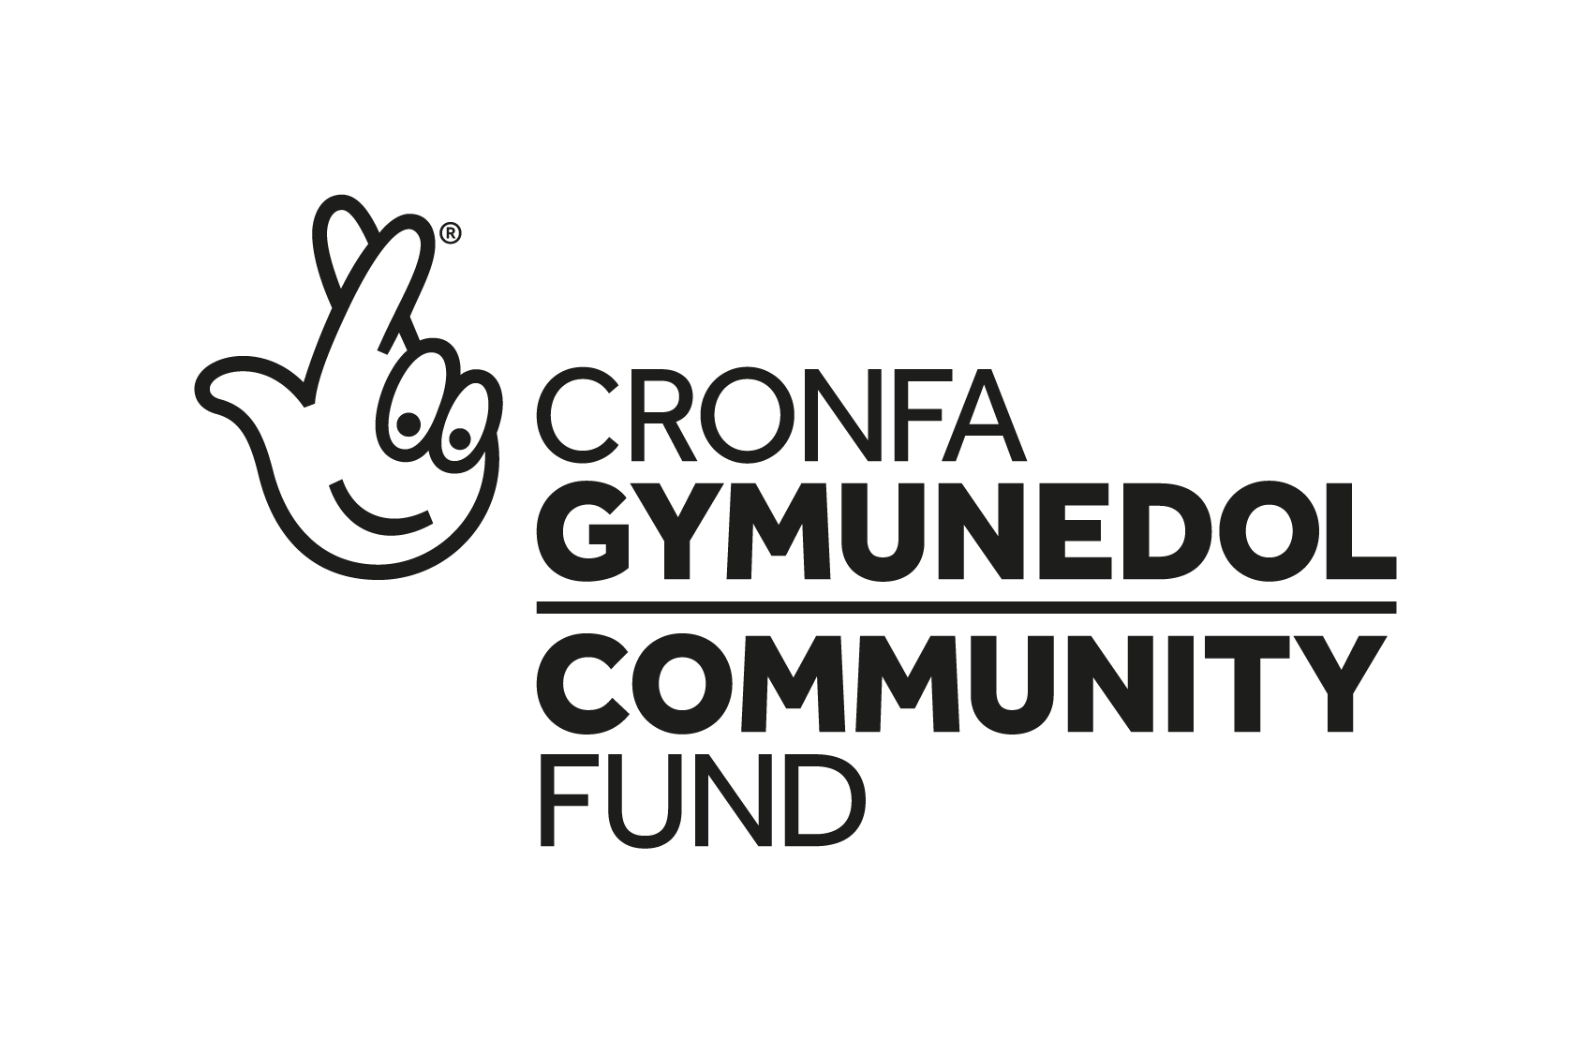
Our thanks go to the National Lottery Community Fund for their support. This project was recently highly commended at the Welsh Charity Awards.

‬ ‬‬‬‬‬‬‬‬‬‬‬‬‬‬‬‬‬‬‬‬‬‬‬‬‬‬

Useful Telephone Numbers
Age Cymru 01792 648866
Assisted Travel 0333 005 0501 Care & Repair 01792 798599
Community Transport St Johns Day Service 01792 456593
Deaf Blind UK 0800 132320
Foodshed food delivery (covers Swansea area) 01656 722506
Macular Society Swansea Support Group 01792 401450
Morriston Hospital 01792 702222
Oakhouse, Foods 01792 709232
Sight Life 01792 776360
RNIB Helpline 0303 123 9999
Seable Holidays 02033 756947
Sensory Services Team 01792 315969
Singleton Hospital 01792 205666
Sue Neale ECLO Swansea 01792 200390
Swansea & Gower Talking Magazine 01792 202679
Swansea Civic Centre 01792 636000
Swansea Council for Voluntary Services 01792 544000
Traveleyes
01138 346094
We provide other services to support individuals such as:

Braille
These workshops are to assist people who would like to learn Braille. Booking is essential. Please ring the office 01792 776360.

Telebefriending – a regular weekly, fortnightly or monthly call from one of our volunteers.

Annual Welfare Call (Contact Line) – a volunteer will ring each member at least once a year.

Volunteering: Sight Life has many volunteering opportunities. Please contact the office for further information on 01792 776360.

If you would like to change the format you receive our newsletter in please let us know at the office. We provide large print, audio, email, braille.

I look forward to hearing from you.
Anita Davies, Locality Development Manager

This newsletter has been printed by Wales Council of the Blind.

