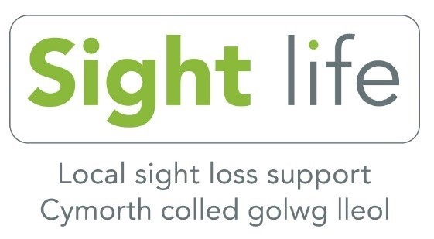

Community Coordinator Job description

Position Details
Job Title: Community Coordinator

Job Level: S1

Location: Cardiff

Type of Contract: Fixed term 1 year contract (01 April 2020 – 31 March 2021)

Salary: £11,137 per annum

Hours: 21 per week (evening and weekend working may be required)

Reports to: Locality Development Manager

Purpose of job:
To help deliver a Big Lottery Fund People & Places project that aims to ensure:

- Blind and partially sighted people will be better able to engage with their local communities and participate more in activities, sports and leisure interests.
- More local activities, sports and leisure interests will be accessible and meet the needs of blind and partially sighted people.
- Blind and partially sighted people will have the skills and confidence to be better able to organise and arrange activities for themselves and their peers.
- Blind and partially sighted people will feel less isolated and lead more healthy, active and fulfilling lives.

Specific responsibilities and duties:

1. To work with providers of leisure, sport and interest activities to encourage them to engage blind and partially sighted people and ensure their offer/services are accessible.

2. To work with providers of leisure, sport and interest activities to run accessible introductory opportunities, open days, taster sessions, or pilot sessions.

3. To inform blind and partially sighted people of accessible opportunities, encouraging them to participate by themselves or with the support of project staff or volunteers.

4. To produce and deliver training so that blind and partially sighted people have the skills, tools and confidence to organise activities for themselves and other blind and partially sighted people.

5. To recruit, induct, develop and manage volunteers in delivering the project. Volunteers will have a number of roles such as admin support, activity and leisure buddy and social activities driver.

6. To monitor and record progress and prepare written reports as required.

7. To undertake any other duties commensurate with the role.

Person specification:

Please note that all criteria are essential unless otherwise stated.

1. Knowledge

1.1. Knowledge of issues and difficulties experienced by people with disabilities.

1.2. Knowledge of working/liaising with statutory and voluntary organisations.

1.3. An understanding of visual impairment and its impact upon those living with sight loss is desirable.

1.4. An understanding of the Equalities Act and the Social Services and Well-being (Wales) Act 2014 is desirable.

1.5. An ability to communicate in Welsh is desirable.

2. Skills

2.1. Ability to communicate effectively, both verbally and in writing, adapting style to suit the audience, in order to communicate with blind and partially sighted people and to influence external organisations.

2.2. Ability to take direction and manage time effectively.

2.3. Ability to take responsibility for own actions, make decisions without referring to others and use initiative.

2.4. Ability to quickly learn and use new information, such as when explaining how the Equalities Act and the Social Services and Well-being (Wales) Act 2014 apply to public and voluntary organisations.

2.5. Ability to provide line manager with clear, concise written updates and oral presentations as and when required.

2.6. Ability to deal appropriately with sensitive issues and confidential information.

2.7. Evidence of a flexible approach to meet the developmental needs of the post.

3. Special Conditions

3.1. Appointment is subject to an enhanced DBS check.

3.2. Willingness to travel throughout South Wales.

4. Equal Opportunities
Ability to understand and demonstrate commitment to our Equal Opportunities Policy and to ensure all activities are consistent with the Equal Opportunities Policy. This includes all staff activities and their interface with the general public.

5. Behaviours

We operate a behaviours based appraisal system and staff at this level are expected to evidence the following:

Deliver results
- Shows commitment to continuous personal learning and development which supports the delivery of outstanding service.

Engage customers
- Prepared to go the extra mile to exceed customer expectations.

Engage others
- Builds and sustains strong support relationships with colleagues and customers and others which engenders trust and respect and contributes to team and organisation’s profile and reputation.

Set direction
- Demonstrates awareness of financial considerations.
- Identifies opportunities for innovation and creativity which contribute to team’s goals and continued success.
- Cooperates and is open to possibilities of change, responds positively to change and considers ways to implement and adapt to change.

Lead and inspire
- Shows willingness to take responsibility for own action.
- Remains calm and focused under pressure.
- Displays resilience and takes a rational approach.

Personal impact
- Communicates clearly, concisely, accurately and appropriately to the audience.

