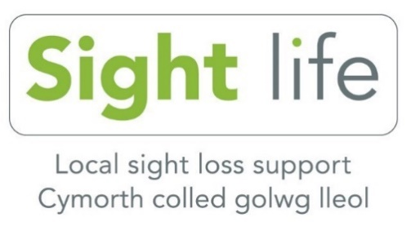
National Lottery Community Fund
People and Places Consultation

The Coronavirus pandemic has changed life for everyone and as the Country starts to emerge out of lockdown for some this is welcome news but for others it is a time of great anxiety.

We appreciate that many of our members have lost confidence in going about their normal daily lives since the start of the pandemic and we would like to try to identify some key areas that we can provide support to our members over the next few years.

We have been very fortunate to have had Lottery funding which has enabled us to support many blind and partially sighted people take part in local community activities they may not have tried before. However, this funding will come to an end next year and we intend to apply to National Lottery for another grant to support many more of our members.

To help us to shape our application and provide some evidence of people’s requirements we would be grateful if you could answer the following questions:

On a scale of 1 to 5 (1 being low 5 being high) please circle how you would rate the following:

Confidence
How confident were you going out and about before Covid-19?
1 2 3 4 5
How confident do you feel about going out now?
1 2 3 4 5

Would you like to explain any difficulties linked to Covid-19?

Shopping
How confident were you getting shopping before Covid-19?
1 2 3 4 5
How confident do you feel getting shopping now?
1 2 3 4 5
Please can you give any reasons for your answer?
_________________________________________________________

Have you experienced difficulties with social distancing? If so, how could these be overcome?

Transport
How confident were you using public transport before Covid-19?
1 2 3 4 5
How confident do you feel using public transport now?
1 2 3 4 5

Any reasons behind your answer?

_________________________________________________________

Are you able to go out and about independently? Can you explain any barriers you face using public transport?

Social Life
How socially connected were you before Covid-19?
1 2 3 4 5
How socially connected are you now?
1 2 3 4 5
Any reasons behind your answer?

_________________________________________________________

What are your barriers to social connection?

Technology/Communication

How did you communicate with people before Covid-19?
- Landline telephone
- Mobile - Smart phone - calls only
- Mobile - Smart phone - all calls/texts/other communication apps
- Calls only on a non-smart mobile phone
- Calls and texts on a non-smart mobile phone
- I Pad or Tablet device or other computer
- None of the above

Would you like to be able to use technology more as a means of communication in the future?
- Yes
- No
- Not sure

What training would you be interested in?
- Mobile phone (smartphone)
- I Pad or Tablet device
- Computer training basics e.g. email, internet searching.
- Other (please specify) _____________________________

Did you attend a Sight Life club or group before Covid-19?
- Yes
- No

Do you attend a Sight Life telephone group now?
- Yes
- No

How would you like to attend groups in the future?
- Face to face
- Telephone
- Online (Zoom/teleconferencing)
- Combination

Can you tell us if there are any barriers preventing you from moving on with your life following the Covid-19 outbreak?
- Changes to public spaces/routes
- Social distancing
- Transport
- Independent travel
- Lack of confidence
- Fear of falling
- Fear of crossing roads
- Financial worries
- Other (Please specify) _____________________________________________________

_____________________________________________________

What activities / interests would you like to be doing a year from now?
- Face to face groups
- Telephone groups
- Independent travel
- Independent shopping
- Volunteering
- Engaged with Social media/internet

What special interest groups would you like Sight Life to run?

Any additional feedback or comments you would like to add?

Thank you for taking the time to complete this survey. Could you please return it in the envelope provided, you do NOT need to put a stamp on it.

