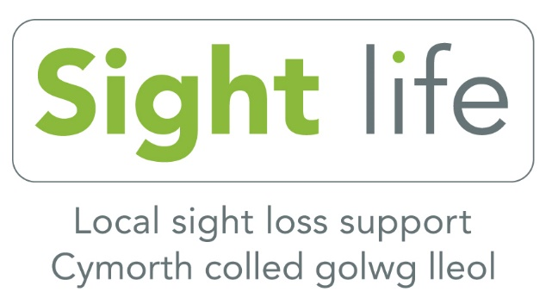
Sight Life (Formerly RNIB in Swansea)
Swansea Vale Resource Centre
Ffordd Tregof
Swansea
SA7 0AL
Tel: 01792 776360

Newsletter November 2020
Dear Members
I hope you are well especially as we now move into the winter period.
This year has been one that no one could have imagined on 1st January 2020. It has been a challenge for all of us in many ways from the loss of close ones to loss of confidence and independence as well as lack of physical contact with the outside world.
We have focussed on helping our members have some level of normality through providing services via the telephone such as our group calls and workshops. Members have benefited from our volunteers and staff providing them with weekly one to one support.
We have worked with several organisations to provide support with shopping and essential services. This partnership working has been amazing and many of our members have benefited from this collaborative working.
I would like to give a massive thank you to my staff, volunteers and our partners who have worked so tirelessly to help and support our members throughout the lockdown period. We have supported and helped just over 1000 blind and partially sighted people in addition to individuals who have been newly diagnosed with a condition. We have supported family members with some of the challenges they have encountered through supporting their loved ones.
We were able to visit in October those identified with essential need. We hope to continue visiting providing restrictions allow us to. It gives me great pride to know that I have such an amazing team. who have really pulled together at a difficult time for everyone?
Unfortunately, we do not know when the time will come where we can meet again but I am excited with the programme we have coming up. These services will be running from 2nd November 2020. The services are run via telephone conferencing calls. For those who are not able to dial in themselves we are able to dial them in through this system. Please contact the office, my mobile or email me for more information.
Services via telephone conferencing.
Mondays
10am to 11am - City Centre group 1
11.30am to 12.30pm – Laughter yoga
1.30pm to 2.30pm – City centre group 2
3.00pm to 4.00pm – Pontarddulais group
Tuesday
10am to 11am - Mumbles and Gorseinon Group
1st and 3rd Tuesday of each month
11.30am to 12.30pm – Technology support group
4th Tuesday of each month 11.30am to 12.30pm - Quiz group 2
1.30pm to 2.30pm – Make the Change workshops
1.00pm to 4.00pm – Men’s group
Wednesday
10am to 11am – Chair exercise class
11.30am to 12.30pm – Women group
1.30pm to 2.30pm – Wellbeing group
3.00pm to 4.00pm – Chair yoga group
Thursday
10am to 11am – Make the Change group
11.30am to 12.30pm – Knitting group
2nd Thursday of each month 1.30pm to 2.30pm – Quiz group 1
3rd or 4th Thursday of each Month 1.30pm to 2.30pm
County Steering Group

Christmas activities
Come along with your drink and something to eat for festive fun and laughter as you connect with us on the phone.
Pantomime A Partridge in a Pear Tree
11th December 1.30 to 3pm
The pantomime has been written by one of our members Caroline Williams. The parts are played by our very own members and volunteers who are very excited about bringing song, laughter and “its behind you, oh no it isn’t”. To your very own home.
Christmas sing along
17th December 1.30 to 2.30pm
A traditional get together of familiar Christmas songs and carols while you sip your drink and eat your snacks, sit back and enjoy or take part in our sing along.
Members Christmas Party
Bring your own drink and food to the phone and join in with our members for an afternoon of laughter and fun.
Friday 18th December 1.30 to 3.30pm
This will consist of a quiz.
Poem by Richard Lawson one of our members and volunteer.
Professional entertainer Nicky Smiles comedian
Chair Line dancing to end.
We do hope you can join us for the activities above. Please contact the office on 01792776360, mobile 07824541982, email anita.davies@sightlife.wales.
I want to take this opportunity to wish happiness and joy over the festive period and remember we are here to help.
Kind regards
Anita Davies
Locality Development Manager
Sight Life

