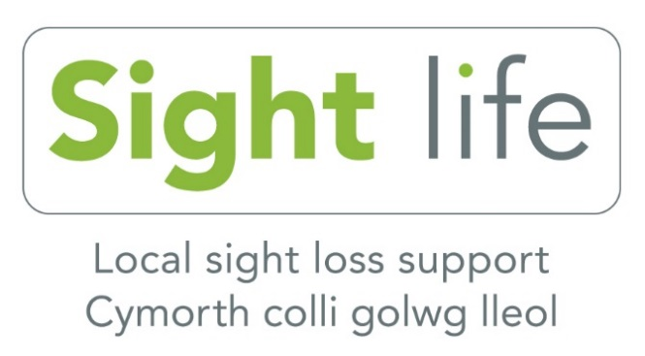

Sight Life Newsletter (Cardiff)
Summer 2020

I am writing this introduction in my new kitchen, aka my new office, (which fortunately was finished the day before lockdown), in my new role as Interim Director of Operations which I started 01 May 2020.

Firstly, I would like to send you our very best wishes and hope that everyone is keeping safe and well during these very challenging and uncertain times. This is the first newsletter we’ve been able to send out since the start of the Coronavirus pandemic. I felt it was important to communicate with all our members as we appreciate not everyone is able to keep up to date with the latest news and events via technology or social media.

Our world has certainly changed. On 12 March 2020 the World Health Organisation declared the global outbreak of coronavirus (COVID-19) a pandemic. No-one could have predicted the massive impact the virus was going to have on all our lives. Following government guidance and for the safety and wellbeing of all concerned we closed our Resource Centre and offices and stopped all face to face contact on 17 March 2020.

Since then, our staff and volunteers have been working from home and contacting members by telephone for ‘keeping in touch’ calls and more regular tele-befriending calls. We have also introduced many telephone support and interest groups such as chair yoga, music appreciation and quizzes; a full list is at the end of this newsletter. We have been circulating weekly emails and updating our social media and website with lots of useful information.

It is quite a task to send a printed newsletter, particularly at this time, so I would encourage you to contact us from time to time to find out what’s going on so you can get involved. You can also keep up to date via our website and social media. Also, please get in touch if you have changed your details or if you have a new email address. Email is our preferred method of contact as it is more cost effective and a speedier means of communicating. But if you’re not on email, don’t worry - we still want to keep in touch with you!

I understand that some of our members are keen to visit the Resource Centre and many of you are wondering when some of our groups will resume. We are working towards re-opening for a limited service as soon as we possibly can, safely, following government guidance with all necessary risk assessments in place. Don’t forget the team are available via telephone for general queries and advice, so please don’t hesitate to call us on 02920 398900.

At the end of this newsletter you will find a consultation paper with questions relating to the Coronavirus pandemic and how it has affected you. Your responses will help us shape our new application for future funding from the National Lottery, so, I would be extremely grateful if you could complete the questionnaire.

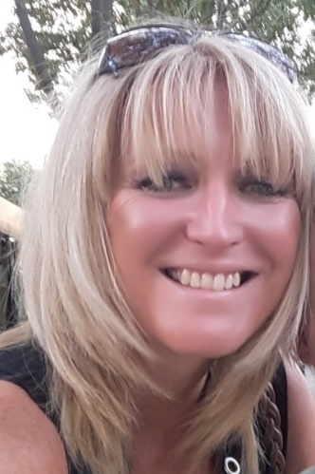
I will keep you updated with the latest developments but in the meantime, please stay safe, follow government
guidelines and we will look forward to seeing
you, hopefully, in the near future.

Best wishes

Michelle Jones
Interim Director Sight Life

Contents
1
Farewell Kieran, welcome Val 3
Update from Ruth Rhydderch, Eye Clinic Liaison Officer (ECLO) 4
Important changes to accessing Accident and Emergency Unit: 5
TV Licencing changes 6
South Wales Talking Newspaper and Magazine 7
Real Life: My funny eyes by John Sanders, Chair of Sight Life Board of Trustees 7
Free Amazon Fire Tablets 9
Eye care at home 9
Active community - National Lottery Community Fund project update 9
Sight Life Telephone Groups 10
RNIB Telephone Groups 11
Connect Cymru Telephone Groups 11
Feedback from our service users 12
Looking after your eyes 13
Product of the month: Socially Distance Lanyard 15
15
National Lottery Survey 15
Data protection and contact from Sight life 16

Farewell Kieran, welcome Val

We sadly said goodbye to Kieran Harris, Director of Operations in May after eight years with Sight Life. Kieran was passionate about ensuring people with sight loss lived independent and fulfilled lives and I am sure he has taken that passion to his new role as Chief Executive Officer with Carers Trust South East Wales. We all wish Kieran the very best in his new role and for the future.

Valerie (Val) joined Sight Life in June as part-time Community Co-ordinator, a role she will share with Jane McCann. Many of you will already know Val as she has been Jane’s PA for some time now. Since she started, Val has been organising many of our telephone social groups which have become very popular. Contact Val or Jane if you might be interested in joining in on 029 2039 8900.

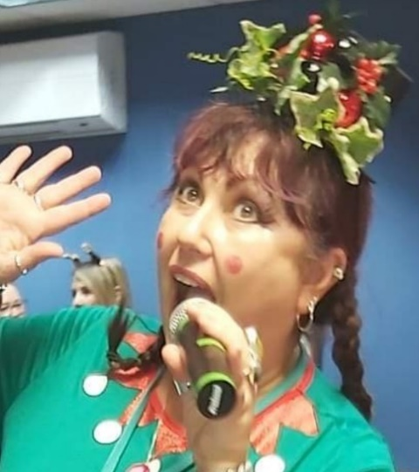
Picture: Val Baynton

Update from Ruth Rhydderch, Eye Clinic Liaison Officer (ECLO)

The ECLO service continues to operate 9am - 5pm Monday to Friday at University Hospital Wales (UHW) Cardiff. Although the last few months have seen lots of change, Ruth is still available to provide information and support to patients and their families/carers. The other thing that remains unchanged is the importance of attending your appointments for monitoring and treatment.

Appointments have altered significantly since March. Initially during the lockdown period, all but emergency appointments were postponed. However, from the very beginning consultants have reviewed all patients due an appointment and have either offered a telephone consultation or postponed their appointment for a time period that was deemed to be safe both from an eye and COVID point of view.

As time has passed, more and more clinics have begun to operate in a “new normal” way. This means far fewer patients are being seen during a clinic session to allow for social distancing in the waiting area and for areas to be cleaned thoroughly between patients.

Appointments for urgent and sight threatening conditions are the priority. Some services have been moved out of UHW to the Spire hospital in Pentwyn, including the AMD (age related macular degeneration) service. Before entering the clinic, patients are screened with health questions and a temperature check. All health care professionals you meet will be wearing appropriate protective equipment (PPE).

If you are worried about attending an appointment, it is really important that you discuss this with someone as missing treatment and monitoring can have serious consequences for your vision. The first port of call is either to call the ECLO, Ruth, or the secretary of your consultant. They can answer your questions, offer reassurance and see what the options are regarding your appointment. Ruth can be contacted on 029 2074 6860.

Important changes to accessing Accident and Emergency Unit: CAV 24/7 – Phone First, Stay Safe, Right Place, First Time

The way you can access urgent health care is changing for Cardiff and Vale University Health board (CAV). From 05 August 2020 you will have to phone first if you think you need to attend the Emergency Unit and it is not life threatening.

CAV 24/7 is a new and innovative approach to how patients access urgent care. Patients who want to access the CAV Emergency Unit will have to phone ahead on 0300 10 20 247 before attending the hospital, and if appropriate will be given an appointment slot saving them precious time and NHS resources.

This new approach is a response to COVID-19 and to ensure services remain safe whilst practising social distancing. It means that the Emergency Unit will not become overcrowded while patients wait safely in their own home for an appointment. You can read their frequently asked questions page to find out more http://www.cardiffandvaleuhb.wales.nhs.uk/cav-247-faq

TV Licencing changes

We have received many calls over the last few months regarding the TV licence. The following information should clarify the position for you.

Can I get a free TV licence?
Having sight loss does not automatically entitle you to a free TV licence. However, if you are registered blind (severely sight impaired), you can get a 50 per cent reduction (called a blind concession) on the cost of your TV Licence. Your licence will also cover anyone who lives with you, but the licence must be in your name. Unfortunately, you cannot claim this 50 per cent reduction if you are registered partially sighted (sight impaired).

Important changes for people 75 or over from August 2020
After August 2020 anyone over 75 and not claiming pension credit will have to pay the full licence fee. However, if you are registered blind (severely sight impaired), you can apply for the previously mentioned 50 per cent reduction.

Do I need to do anything now?
If you had a free TV Licence up to 31 July 2020, you don’t need to do anything now to stay licensed. During August and September, they will be writing to you to explain what you need to do to set up your next licence. You’ll have plenty of time to do that. Meanwhile, don’t worry – you’re covered.

Full information about how to claim a reduced TV Licence and the changes regarding free licences can be found on the official TV Licensing website. If you would like further information, contact TV Licensing: telephone 0300 790 6130 or www.tvlicensing.co.uk

South Wales Talking Newspaper and Magazine

The South Wales Talking Newspaper and Magazine’s team of dedicated volunteers has been busy behind the scenes during lockdown archiving their 50 years of material, setting up a new website and getting ready for restarting with social distancing measures in place. As soon as the recording and copying studio can be accessed safely, those already receiving the talking newspaper and magazine will start receiving them again, although this is likely to be every fortnight rather than every week.

Anyone who does not receive it but is interested in finding out more, please visit the new website www.swtma.com or get in touch with Sight Life on 02920 398900 to be added to the list.

As well as including many interesting articles about Cardiff and sight loss, the magazine is a useful way of finding out news from Sight Life in between our quarterly newsletters.

Real Life: My funny eyes by John Sanders, Chair of Sight Life Board of Trustees

“Can you tell me when the next bus is due? I can’t see the electronic display.” I can’t always read the display either, but this Monday morning the light was just right for my funny eyes. So, I was happy to tell the woman at the bus-stop that a number 57 was due in two minutes. In fact, it drove around the corner as we were speaking and she bustled on board. Sadly, that robbed me of the chance to strike up a conversation about neither of us being able to see very well.

How many of us are vision impaired was very much on my mind that January morning (before Covid-19 struck and my attitude to catching buses changed). I was on my way to the Sight Life office in Jones Court, a stone’s throw from Cardiff Castle. I’d just taken over as chair of trustees and this would be my first time trying to make sure we got through the agenda and everyone felt they’d had their say.

I’ve been a Sight Life trustee on and off for 20 years and involved in other charities for even longer, so I knew what to expect. We had to sign off the budget for the year ahead, check that everything was running smoothly and that, as far as we and our very dedicated staff could tell, there were no nasty surprises lurking on the horizon. Fortunately, all seemed well.

We’ve already helped more than 3,000 people in the last nine months, putting us comfortably ahead of our target for the year. “Helping” can come in many different forms. An obvious one is Ruth, our ECLO in Cardiff’s Heath Hospital (see article on page 4), who supports hundreds of people every year when they get the devastating news that their sight is deteriorating and there’s probably no medical fix.

Helping also includes the social activities we organise, because having less or no vision often leads to loneliness, isolation and even depression. So, our Zumba class and darts team in Swansea are vital to what we do. As, of course are the drama and photography groups in Cardiff. (I have to mention those because I’m a member of both and I’ll never hear the end of it if I leave them out!)

Hopefully, all these activities, and possibly new ones, will resume once it’s safe to meet again and continue as long as there is demand for them. With lots of charities fighting for not very much money though that’s never certain. So, if Sight Life has helped you, make sure you tell others about it. The more positive publicity we get, the more chance we have of being around to help people for another 150 years.

Finally, although the trustees’ meeting was over, my experience of being vision impaired wasn’t. On my way to catch the bus home, I popped into M&S to buy some milk and potatoes (chairing a charity is neither a paid role nor a glamorous one). At the check-out I had to ask the cashier how much I owed. She pointed to the electronic display. It was too small, and I couldn’t read it.

Free Amazon Fire Tablets

RNIB is offering Amazon Fire Tablets free to those who currently receive its large or giant print books who have access to the internet. They have been contacting people by phone to let them know about this offer, but many people have been worried that it is a scam.

If you would like to find out more, please contact RNIB on 0303 123 9999.

Eye care at home

Eyecare at home will be resuming domiciliary eye care services as normal on 17August 2020. If you need an eye test or a low vision assessment and are unable to leave the house, contact Karen on 0333 335 0068 to arrange an appointment.

Active community - National Lottery Community Fund project update

Since lockdown began back in March, we have obviously been unable to continue our face to face community work. However, we have been busy contacting members and setting up telephone groups which include special interest groups with guest speakers, quizzes, music appreciation and coffee time to name but a few. Below is the complete list:

Sight Life Telephone Groups
(Weekly unless stated otherwise)

Mondays
1.00pm-2.00pm Book Club - Chat about your lockdown reads. (First Monday of the month)
2:00pm-3:15pm – Strength and Balance exercises with Gareth from Elderfit – seated and standing exercises.
3:30pm – Afternoon chat with Val – usually a specific topic each week such as “New arrangements in Castle Street”, “Arrangements in the town centre for social distancing”.
Tuesdays
10:00am fortnightly – computer room catch up
11:00am-12:00noon – coffee morning
Wednesdays
11:00am-12:00noon – Social chat
3:30pm – Wellbeing chat – discuss relaxation and stress busting tips in a friendly, supportive and informal group
Thursdays
2:00pm-3:15pm – Strength and Balance exercises with Gareth from Elderfit – seated exercises
Fridays
11:00am fortnightly – Music appreciation
11:00am fortnightly– Morning quiz
2:00pm fortnightly – Afternoon quiz (repeat of the morning session on the same day)
Contact Val Baynton or Jane McCann for joining details.
Val: 07754 071868, Valerie.baynton@sightlife.wales or
Jane: 07864 964833. Jane.mccann@sightlife.wales

RNIB Telephone Groups

You may also be interested in one of the RNIB telephone groups listed below:

Tech Talk and Support – An opportunity for the community to have their technology questions and queries answered by their peers. Useful and informative advice given in a language we can all understand!
Food and Nutrition – An opportunity to share culinary expertise, hints and tips with the community. Learn new recipes and share your own ideas.
The Great Big South West Quiz – fun for all budding eggheads. Join friends from across the South West in our weekly quiz.
Mission Ambition – See where your dreams can take you! Use the support of the community to help realise your ambitions and dreams – no matter how big or small. Join us for regular advice, guidance, support and encouragement from friends across the South West.
Fitness and Exercise – An opportunity to listen to representatives from a variety of different sporting endeavours. Become inspired to take up a new sport or exercise.
Blind Snaps – Discover your passion for photography! Take part in photographing a new theme each week and learn everything there is about photography. For beginners and experts, Blind Snaps brings photographers from across the South West together.

Contact George Hinton or Bernice Cocking for more information
Email: George.Hinton@rnib.org.uk mobile: 07751 369079 or
Bernice.cocking@rnib.org.uk

Connect Cymru Telephone Groups

RNIB Cymru Connect also holds a range of telephone groups including: Cardiff young people’s group, braille group, women with vision (ethnic minority young women), South Wales welsh speakers’ group and golf group. All groups last for one hour.
Please contact community facilitators Eleanor Rothwell or Carol McKinlay if you would like to join any of these groups
Eleanor: 0770 282 1915, email Eleanor.rothwell@rnib.org.uk
Carol: 0786 496 8859 email Carol.McKinlay@rnib.org.uk

Feedback from our service users

“I so enjoy the group calls. All I am doing at the moment is going for a short walk around the block. It is lovely to feel involved with others from the outside world.”

“I am so fortunate to have Sight Life. I have met some amazing people. Although my cataracts are a nuisance, I am just grateful for having had the opportunity to mix with such wonderful people.”

"Such a useful and interesting discussion, big thanks also to Sight and Sound Technology for organising the event. I also wanted to say a personal thanks for passing on the information a few weeks' ago on Tesco's now taking on blind and VI people for their priority deliveries, an absolute life saver for me and I now have my weekly Tesco's delivery, which is brilliant. I had real problems going into supermarkets with all this going on, but now I don't need to worry about not being able to practice social distancing in the queue or in the shop and can get the things I need delivered.”

“All of your emails are always very helpful, thank you so much for all you and your team are doing, it really is much appreciated. "

“Please do keep me updated with info about music and Elderfit. It's great that so much is being arranged for us by Sight Life. Thank you so much.”

“I just want to thank you for the enormous amount of work you have put into keeping us informed of such a wide range of issues and services. I know this will have been invaluable to many of us VIPs (Vision Impaired People). Thank you.”

"I am so glad you called me today. I'm really happy you've offered me so many different things! I would love to join the telephone groups; it will stop me being on my own and thinking about all the awful things going on in the world with Coronavirus at the moment.”

“I really love the Sight Life website, it’s so easy to use, it’s wonderful. Sight Life really has an amazing schedule of events, it looks like there is something for everyone! I’m was really impressed by it and all that you do for visually impaired people.”

Looking after your eyes

Having a regular eye examination (eye test) with your optometrist (optician) is the best way to make sure that your eyes are healthy. Some sight-threatening conditions have no symptoms and could cause you to lose sight before you notice a difference. An eye examination can pick up these conditions making sure that you get any sight saving treatment you need.

Contact your local optometrist to book an appointment. You can search for an optician near you on NHS Direct Wales website or call us on 029 2039 8900 and we can source one for you.

Research suggests that the following points will make sure your eyes are healthy and your risk of developing an eye condition is as small as possible.

1. Regular eye tests
Everyone should have their eyes examined at least once every two years - even if there is no change in your vision. An eye examination can often pick up the first signs of an eye condition before you notice any changes in your vision. This can lead to you getting vital treatment at the right time, which could save your sight.

2. Stop smoking
Did you know smoking can double the risk of developing age-related macular degeneration, the UK's leading cause of sight loss? In fact, the link is as strong as the link between smoking and lung cancer. Speak to your GP about stopping smoking.

3. Eat healthily and watch your weight
Eating a diet low in saturated fats but rich in green leafy vegetables such as spinach and broccoli may help delay the progression of cataracts and AMD. Oranges, kiwis, nuts, seeds and oily fish may also help prevent and slow down some eye conditions. Taking supplements is not a substitute for a healthy diet. It is important to maintain a healthy weight. Obesity can increase the risk of developing diabetes, which in turn can cause sight loss.

4. Keep your eyes covered in the sun
UVA and UVB rays in sunlight can harm your eyes and may increase the risk of cataracts and AMD. Wearing sunglasses, glasses or contact lenses with built in UV filter will protect your eyes. Only buy sunglasses that have a CE mark or carry British Standard BS EN ISO 12312-1.

A full range of eyeshields and sunglasses is available to buy in the eyeshields and sunglasses section of the RNIB shop click here https://shop.rnib.org.uk/mobility/eyeshields-and-sunglasses.html

5. Safety first
DIY causes thousands of eye related injuries each year. Always wear safety goggles (European Standard BS EN 166) to protect your eyes from flying debris and fine particles. Sport (especially racquet-based sports) also causes lots of eye related injuries each year. Investing in a good pair of protective sports goggles will help prevent serious damage to your eyes.

Product of the month: Socially Distance Lanyard

These lanyards have been produced by the Partially Sighted Society for use when out and about to make other people aware that you are visually impaired and are unable to socially distance.

Call us on 029 2039 8900 if you would like to purchase one for £2.00.

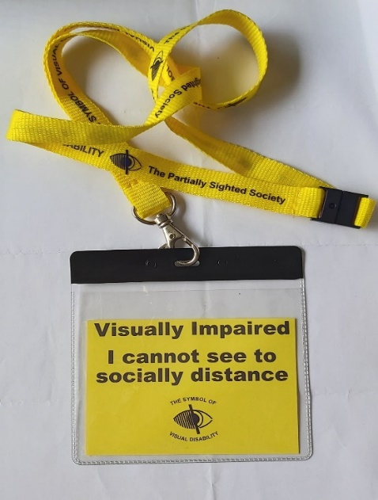

National Lottery Survey

The enclosed questionnaire can be completed in one of the following ways:

- Complete it and return it via post in the envelope enclosed
- Call us on 029 2039 8900 and complete it over the telephone, we can call you back to save your phone bill!
- Complete it and return it via email
- Complete the survey online here: https://form.jotform.com/202173550135041

We look forward to receiving your responses.
Thankyou.

Data protection and contact from Sight life
Many of you will be aware of the regulations on data protection, called the General Data Protection Regulations (GDPR), giving people more control over their data and how it is used. Sight Life has always taken its responsibility of collecting and using personal data very seriously.
Please let us know if you would only like to receive certain types of information from us or if you would like us to stop sending you all forms of communication. You can do this by calling us on 029 2039 8900 or emailing ask@sightlife.wales. You can also update your communication preferences, asking to receive this newsletter via email rather than in large print or Braille as an example.
Please also let us know if you have joined the Fundraising Preference Service and selected not to receive fundraising messages or information from us.

Sight Life
Jones Court
Womanby Street
Cardiff
CF10 1BR
Telephone: 029 2039 8900

Gwefan/website: www.sightlife.wales
Twitter: @SightLifeWales1
Facebook: www.facebook.com/SightLife.Wales
Instagram: sightlifewales2020
YouTube: https://www.youtube.com/channel/UCmsO4dmcCKlt-ouqAzEIssA/featured?disable_polymer=1

Registered Charity Number: 214131 (England & Wales)
Company number: 00149982

