Newsletter
January 2023

Swansea and Neath Port Talbot

Welcome to the January 2023 newsletter of events and activities in the Swansea and Neath Port Talbot areas. There is a busy timetable for the coming months, and we hope there is something of interest to all our members and we look forward to seeing you.

As well as our usual local group meetings and activities such as Wellbeing Walks, Gardening and Allotment sessions and sports events, there are some new ones that you might like to know about, including new Tea and Chat sessions in Neath and Port Talbot as well as in Sketty. There is also a programme of technology themed events, pottery classes, and more VisionZone extravaganzas. Look out too for the Seeing it Differently Triple Challenge!

The services we provide are available across all Sight Life areas to all our members, regardless of where you live.

We ask members to try and pre book when attending any of the activities and events so we know how many to expect and in case arrangements change at short notice we can let you know.

Sight Life WhatsApp Groups
Would you like to be kept up to date with the latest activities and events, as well as having the opportunity to keep in touch with and ask questions of other members? The groups cover activities in the Swansea, Neath, Port Talbot and Bridgend areas, they are a great way to keep abreast of all new developments and be up to date with details of activities you are interested in.
You will need a mobile phone with WhatsApp installed on it; if you need help with this, please let us know and we will support you to do this. We will require your consent to be added to the groups so please get in touch with Anita on 07824 541982 if you wish to join them.

Seeing It Differently Triple Challenge
Would you like to do something a bit different? Join our Triple Challenge where you pick three activities you have never tried before, or you have been told you can’t do, or perhaps you believe you can’t do but would love to do. These could be anything from trying a new activity to breaking a habit. The idea is to do each challenge three times. Some of our members might chose to do some of the activities below, or you can pick your own. To help us raise money for Sight Life individuals are asked to raise the minimum of £50 per challenge. Contact Anita on 07824 541982 for more information.

Wellbeing Walks
Wellbeing Walks are held twice each month on a Monday and Friday. Each month there is a short walk and a longer one if you fancy stretching your legs a bit more. There is always something to eat, drink and socialise about at the end or at the half-way point! The walks are different each month and normally start around 10.00am. Details can be had from the Swansea office, or a good way to keep informed is via the WhatsApp Group, see above.

Contact and Advice Line and Keep in Touch Service
Our Contact Line offers advice and support and can signpost you to relevant partner organisations. In addition to our Contact Line, we can offer a more regular befriending call with our volunteers. If you feel you would benefit from this, please call the office 01792 77630.

Help with Technology
Sight Life can offer you support in the setup and use of your phone, tablet/iPad, computer, TV or smart speaker (such as Amazon Echo) and we can also provide support to help you get more out of those devices. We will also help diagnose and fix problems with this technology should this be needed. Support can be provided over the phone, by a home visit or a meeting at a location convenient for you.
To arrange support please contact Keir on the office number (01792 776360), or on his mobile 07548 802295.

VisionZone Is Back!
Run by Optelec Limited and involving a number of support organisations, this exhibition was very successful the last time it was run in Pontarddulais and Neath. It will give you an idea of what equipment is available to help with reading and provide you with information about local services to support you. This is the place to be! Dates and venues are:

23rd March 2023 10am to 2pm
VisionZone Neath
Neath Community Centre, 10-12 Orchard Street, Neath SA11 1DU

22nd June 2023 10am to 2pm
VisionZone Swansea (in conjunction with Sight Life Wales)
Bont Elim Community Church, Alltiago Road, Pontarddulais SA4 8HU

29th September 2023 10m to 3pm
VisionZone Swansea Central
YMCA, 1 The Kingsway, Swansea, SA1 5JQ

Programme of Activities
The Swansea office is not currently hosting telephone conference calls but see page 18 for activities on either Zoom or telephone conference calls hosted by our Cardiff office; please contact them on 029 2039 8900 to find out details.

The following activities, events and groups run face-to-face in Swansea, Neath and Port Talbot. There are also some in Bridgend.

Neath Port Talbot Face-to-face Groups
Do you live in the Neath Port Talbot area? If so, we would like to hear from you. We have a programme of new and exciting activities described below starting in January 2023. Please call the office on 01792 776360 to show your interest.
Tea and Chat, Hints and Tips
Tea and Chat Groups are starting in January in Neath and in Port Talbot, and they are a good opportunity to meet other Sight Life members in your area. Some weeks there will be a theme for information and discussion to help improve your confidence around and outside your home with daily tasks.
Meetings are on the same day in Port Talbot (morning) and Neath (afternoon), and the dates are:

Wednesday 25th January, then
Monday 30th January, and then
every Monday in February: 6th, 13th, 20th and 27th, and
every Monday in March: 6th, 13th, 20th and 27th.
Port Talbot Tea and Chat meetings are 10am to 12noon at Port Talbot Library, Aberafan Shopping Centre.

Neath Tea and Chat meetings are 1pm to 3pm at Neath Community Centre, Orchard Street, Neath.

Accessible Technology in Neath Port Talbot
Four sessions covering topics to help get to grips with and use technology to support everyday living; these sessions are all held at the Gwyn Hall, Orchard Street Neath, 1pm to 3pm. Details and dates are below:

- Monday 13th February
Troubleshooting and spring cleaning your smart phone, iPad/tablet and computer– how to keep things in good shape, stay safe from cyber risks and avoid having to spend money on replacements.
- Monday 27th February
Getting the most out of the WhatsApp messaging app – using the app effectively for one-to-one and group messages and chats; settings to help you manage your chats; using Siri or Google to read, send and reply; using voice messages and dictated messages; deleting messages; privacy and security.
- Monday 13th March
Digital Art – have you always wanted to be creative with pencil or brush? Use technology to get creative, learning to draw and paint on an iPad/tablet; come and learn the first simple steps with a trained artist and get doodling and sketching.
- Monday 27th March
Books and reading – there is a wide range of free and paid-for audiobooks and e-books out there; learn what’s on offer, what you need to get reading and how much or little will it cost you.
Come along to Tea and Chat and book a session, or phone the office or Keir on 07548 802295.

Swansea Face-to-face Groups
Many of the long-standing groups and activities continue into 2023 but look out for the new Tea and Chat group in Sketty, the chance to learn to make pottery, get swimming in the Penlan pool and some technology events too. Groups and activities are listed by day of the week. Contact the Swansea office if you need more information on 01792 776360.

Monday Activities

Mumbles Group
Time: 1.30pm – 3pm
Where: Mumbles Methodist Church, Mumbles Road, Mumbles SA3 4EA.
Dates: the second Monday of each month (13th February, 13th March, and so on, but due to Easter check with the office for the April date)

Wellbeing Long Walk
Starting point and routes will change each month, but the walks usually start at 10am and for an ‘out and back’ route will be about 30 minutes to an hour each way.
These long walks take place on the 1st Monday of the month (6th February, 6th March, 3rd April and so on)
Please check for walk details with the office on 01792 776360.

Tuesday Activities

Gardening at the Sight Life allotment
Time: 10am to 12 noon
Where: Vetch Fields, Sandfields, Swansea
Dates: every Tuesday (see also Thursday)
Come along and be prepared to drink tea and eat cake, but also to give your green fingers some light exercise and grow some amazing veg.

Wednesday Activities

Gorseinon Group
Time: 10am to 12pm
Where: Gorseinon Institute, Lime Street, Gorseinon SA4 4EE.
Dates: the first Wednesday of the month (1st February, 1st March, 5th April on so on)

New!! Sketty Group
Time: 1pm – 3pm
Where: Conference Room, Hazel Court, Maes y Gollen, Sketty SA2 8BP
Dates: on the third Wednesday of each month (15th February, 15th March, 19th April and so on)

BikeAbility
Time: 12noon to 1pm
Where: Dunvant Rugby Club, Broadacre, Killay SA2 7RU
Dates: every Wednesday
Get back in the saddle or try it for the first time, BikeAbility has a large range of adaptable cycles to enable people of all ages and abilities to access cycling. Cost £6 per session, guides are provided for those who require one. These sessions are popular and so you will need to pre book.

Thursday Activities

Pontarddulais Group
Time: 10.30am - 12.30pm
Where: Bont Elim, Alltiago Road, Pontarddulais SA4 8HU
Dates: the third Thursday of each month (16th February, 16th March, 20th April and so on)

Gardening at the Sight Life allotment
Time: 10am to 12pm
Where: Vetch Fields, Sandfields, Swansea.
Dates: every Thursday (see also Tuesday)
Another chance to get digging (not a lot), sowing, planting and harvesting some lovely veg from our raised bed allotment.

Swansea Central, Tea and Chat, Hints and Tips
Time: 10am to 12noon
Where: Glynn Vivian Art Gallery, Alexandra Road, Swansea SA1 5DZ
Dates: every Thursday

Art Group
Time: 1pm to 3pm,
Where: Room 1, Glynn Vivian Art Gallery, Alexandra Road, Swansea SA1 5DZ
Dates: fortnightly (2nd February, 16th February, 9th March, 23rd March)
In partnership with Glynn Vivian Art Gallery, this creative welcoming group use different materials and techniques to respond to their exhibitions and displays programme, co-producing the project with their learning team. The sessions provide a perfect way to get accustomed to visiting museums and galleries again.

Glynn Vivian are also offering us described tours of the Gallery from 1pm to 2pm on 2nd February and 2nd March.

Darts Night – in partnership with the Lions
Time: 7.00pm
Where: Travellers Well pub, 554 Carmarthen Road, Swansea SA5 8LA
Dates: the third Thursday each month (16th February, 16th March, 20th April and so on)

Friday Activities

Ten-pin Bowling
Time: 12noon
Where: Tenpin Swansea, Parc Tawe, The Strand, Swansea SA1 2AX.
Dates: first Friday of each month (3rd February, 3rd March, and so on, but due to Easter check with the office for the April date)
Please contact the Swansea office to book.

Wellbeing Short Walk
Starting point and routes will change each month, but the walks usually start mid to late morning, last about 30 minutes and end somewhere nice for lunch.
The walks take place on the 3rd Friday of the month (20th January, 17th February, 17th March, 21st April and so on).
Please check for walk details with the office on 01792 776360.

Board Games
Time: 12 noon to 2pm
Where: Social Dice Board Game Café, 43 Wind Street, Swansea SA1 1EF
Dates: 4th Friday of each month (27th January, 24th February, 24th March, 28th April and so on)
With over 400 board games to choose from, there will be one that takes your fancy, and with a tasty food menu to choose from too. Please let us know if you would like to come along.

New!! Swimming
This will start in February at Penlan Leisure Centre. Day, dates and time to be confirmed. Penlan pool is accessible and has a ramped access to the pool. We need to know who is interested so please get in touch with the office on 01792 776360.

New!! Pottery Classes
We are pleased to announce this new activity at the Community Centre at Upper Killay.
Not just plates & bowls, you could do a pencil pot, jewellery dish, hanging mobile, paw and hand prints or a two-dimensional face. The first day is for the hands-on getting to grips with clay and shaping your piece (hand shaping, not on a wheel). The piece will then be fired for you and made ready to decorate and glaze on the second day.
Sessions are £15 per person and include everything you need. Wednesday March 1st and 8th from 1pm to 3pm

If you are interested, please contact the office on 01792 776360 to book a place.

Technology in Swansea
Sessions covering topics to help get to grips with technology to support everyday living; these sessions are split between Hazel Court Sketty and the Glynn Vivian Art Gallery, with one session in Pontarddulais. Dates, times and venues are:

- Wednesday 8th February 1pm to 3pm Hazel Court Sketty
Troubleshooting and spring cleaning your smart phone, iPad/tablet and computer– how to keep things in good shape, stay safe from cyber risks and avoid having to spend money on replacements.
- Wednesday 22nd February 10am to 12.30pm at the Glynn Vivian Gallery
Digital Art – have you always wanted to be creative with pencil or brush? Use technology to get creative, learning to draw and paint on an iPad/tablet; come and learn the first simple steps with a trained artist and get doodling and sketching.
- Wednesday 8th March 1pm to 3pm Hazel Court Sketty
Getting the most out of the WhatsApp messaging app – using the app effectively for one-to-one and group messages and chats; settings to help you manage your chats; using Siri or Google to read, send and reply; using voice messages and dictated messages; deleting messages; privacy and security.
- Wednesday 15th March 10am to 12.30pm at the Glynn Vivian Gallery
Books and reading – there is a wide range of free and paid-for audiobooks and e-books out there; so what’s on offer, what do I need to get reading and how much or little will it cost me?
- Monday 20th March, 10am to 12.30pm at Bont Elim Community Church Pontarddulais
Digital Art – have you always wanted to be creative with pencil or brush? Use technology to get creative, learning to draw and paint on an iPad/tablet; come and learn the first simple steps with a trained artist and get doodling and sketching.
If you’d like to attend any session please phone the office or Keir on 07548 802295 to book.

Other sport, recreation and leisure activities
Activities run by other organisations are described below with dates, venues and contact numbers. But don’t forget that all are welcome to attend, no matter where you live.

Blind Baseball
Come try Blind Baseball! 1pm to 3 pm at Singleton Park, Swansea. Dates are:
February 11, February 25
March 11, March 25
April 8, April 29
May 27
June 3, June 17
July 8, July 22

RBI Wales Baseball Softball is bringing baseball and softball to people of all ages in Wales. It’s a fun afternoon, and you’ll learn how to play the amazing game of Blind Baseball.
To find out more, contact Holly at info@rbiwales.com.

Goalball
Goalball is a paralympic sport for visually impaired individuals. These sessions are run by South Wales Goalball club and are open to all ages and to individuals with any level of visual-impairment. The object of the game is to score a goal by bowling a sound ball (with bells in it) along the floor of the indoor court so that it crosses the goal line of the opposing team of 3 visually-impaired players. The first session of goalball is free of charge. If you get the goalball bug and come back to further sessions there is a small charge of £3 per adult (£2 for under 16s).
Sessions are on Saturday from 1:30pm to 3:30pm at Ysgol Bae Baglan, Seaway Parade, Port Talbot SA12 7BL.
Contact Steve Jones 07743 947605 or Anita on 07824 541982 for further information and to check for dates.

Dance sessions
Learn Latino, Ballroom and Latin styles of dance. These classes will run throughout the Bridgend, Swansea, Neath and Port Talbot areas. It is a great opportunity to meet other members and get active. These sessions are running over a term of 6 weeks. There is a charge for the term. Sight Life works in partnership with Impetus Dance, a not-for-profit social enterprise, to provide these classes. Contact Anita on 07824 541982 to find out more details.

Dance To Health
Dance to Health is working in partnership with Sight Life to offer classes throughout the area of Swansea, Neath and Port Talbot. The weekly sessions have become very popular with members, they can be done seated or standing, and cater for all abilities, focussing on strength and fitness to exercise the body and help with reducing falls. Contact Anita on 07824 541982 for more details.

Sailing June 2023
Sailing will be returning to Wales for June 2023. This is your chance to have a go at sailing with VISA GB (Visually Impaired Sailing Association of GB). Sight Life will be working in partnership with VISA GB to run a sailing trip from Milford Haven. There will be opportunities to do either a week-long or a three-day sailing trip.
In our previous newsletter we reported on the success of last year’s trip. One Sight Life member said:
“This week of sailing has made such a difference. I feel I have grown in my confidence and so much more”.
There are videos of participants’ interviews on the Sight Life Facebook page.
We will also be looking at local opportunities for partnerships to do some taster session for those who have never experienced sailing and want to see what it is all about. Contact the Swansea office if you want to know more on 01792 776360
Walk and Run Events
These are every Saturday from 1pm to 2pm at the running track behind Bridgend recreation centre in Angel Street. This has become a popular event for all ages. Each person has a sighted guide to walk or run with them around the track. The guides are all trained and are part of the ‘Just to Run’, running group. Being able to have physical exercise in a safe area, builds confidence to enable improved fitness as well as improved balance.
Attendees commented on how easy they found it to walk around the track and were pleasantly surprised with how many laps they did. One attendee said: “The great thing about the track is that the environment is flat and safe so we felt we could walk with ease with the guides beside us, telling us where and when we were approaching a bend or on a straight and how far around the track we were”. If you are interested in coming along Anita has more details.

VI and blind football for children and adults
Are you interested in playing football? If so, please get in touch as we are re-starting football in Swansea for those under and over 18.

Blind and VI Archery
Neath Archery Club and Gower Archery Club have equipment suitable for anyone with sight loss to do archery.
If you are interested, please contact Anita on 07824 541982, or please ring the Swansea office on 01792 776360.

Horse Riding
If you are interested, please contact the office on 01792 776360 to discuss further.

Surfing
Karma Seas is a local not-for-profit social enterprise that aims to make surfing accessible, providing a safe and inclusive environment where children and adults feel welcome, have fun and learn at their own pace. Karma Seas provide surfing sessions that can be booked directly with them. Contact Julia on 07919 133855 for more information.

If we haven’t mentioned an activity that you do or are keen to do, please let us know – others may also be interested.

Public Transport Users
Local transport provider First Bus Cymru has several ‘Extra Help to Travel’ cards, including one for visual impairment. Available on their website, the cards can be downloaded, cut out and shown to the driver if you would like extra help on your bus journey. They can be downloaded from:
https://www.firstbus.co.uk/uploads/node_images/Extra-Help-To-Travel-Cards-a19.pdf

The example below shows some of the cards that are available.

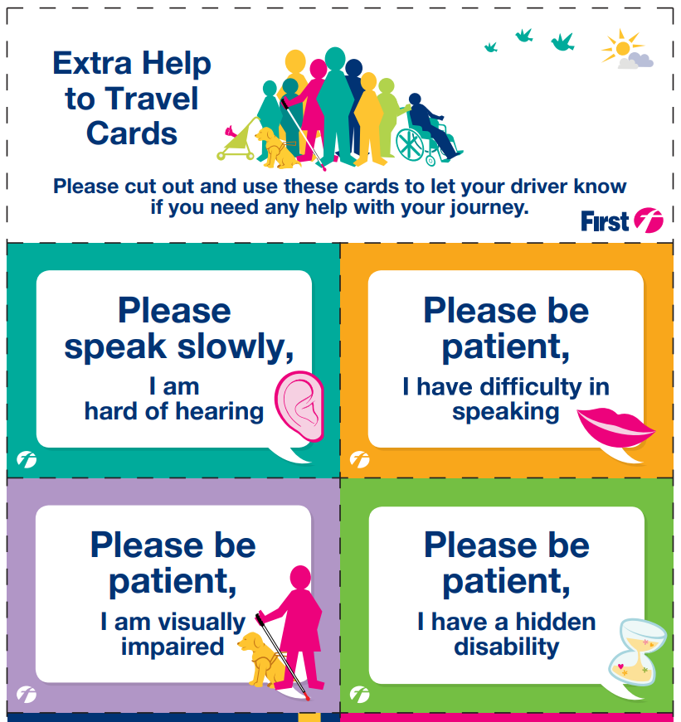

Vision Impaired West Glamorgan (VIWG) County Steering Group
This meets on the 4th Thursday of every other month at the Civic Centre. The first meeting of 2023 will be on 26th January from 2pm to 3.30pm
Contact Anita for further information on 01792 776360 or mobile 07824 541982.

Future Services
We have re-started the day trips and holiday groups. Please contact the Swansea office for further information.

Increasing accessibility
Are you frustrated, annoyed, and fed up that there is a lack of transport, safe places to cross a road or that you generally feel unsafe when you go out due to lack of awareness of your needs due to your sight loss? We want to hear your voice, your stories, examples and ideas of how the environment you live in could be improved and needs to be improved so that people with sight loss can have a better, safer quality of life.

Sight Life Telephone Groups
Due to low numbers, we are no longer running telephone conference calls from the Swansea office. However, the Cardiff office is running telephone groups and, as ever, these are open to all Sight Life members.

For further information on the activities below contact the Cardiff office on 029 2039 8900.

Elderfit
Sessions will be every Thursday at 11am. Seated-only exercises which are excellent for flexibility and strength. Members really enjoy exercising together, even though it is on the phone there is still a strong social connection, with group discussions being lively, funny, and informative. The group is also online with Zoom.

A Monday session is running at 10.30am, telephone only.

There is a payment to Gareth at Elderfit for the sessions but if it is your first time attending you can have a taster session for free.

Quiz
Our fun quiz starts on Friday 20th January 11am and repeated 2pm, then continues fortnightly.

These are available on the telephone, and includes cryptic clues, kazoo name that tune and a pot-luck general knowledge round. A chance to test your knowledge and work as a team. There is usually a lot of laughter during the quiz and friendly rivalry!

Data protection and contact from Sight Life
Many of you will be aware of the regulations on data protection, called the General Data Protection Regulations (GDPR), giving people more control over their data and how it is used. Sight Life has always taken its responsibility of collecting and using personal data very seriously.
Please let us know if you would only like to receive certain types of information from us or if you would like us to stop sending you all forms of communication. You can do this by calling us on 029 2039 8900 or emailing ask@sightlife.wales. You can also update your communication preferences, asking to receive this newsletter via email rather than in large print or Braille as an example.
Please also let us know if you have joined the Fundraising Preference Service and selected not to receive fundraising messages or information from us.

Sight Life
Jones Court
Womanby Street
Cardiff CF10 1BR
Telephone: 029 2039 8900

Gwefan/website: www.sightlife.wales
Twitter: @SightLifeWales
Facebook: www.facebook.com/SightLife.Wales
Instagram: SightLife.Wales
YouTube: https://www.youtube.com/channel/UCmsO4dmcCKlt-ouqAzEIssA/featured?disable_polymer=1

Registered Charity Number: 214131 (England & Wales)
Company number: 00149982

