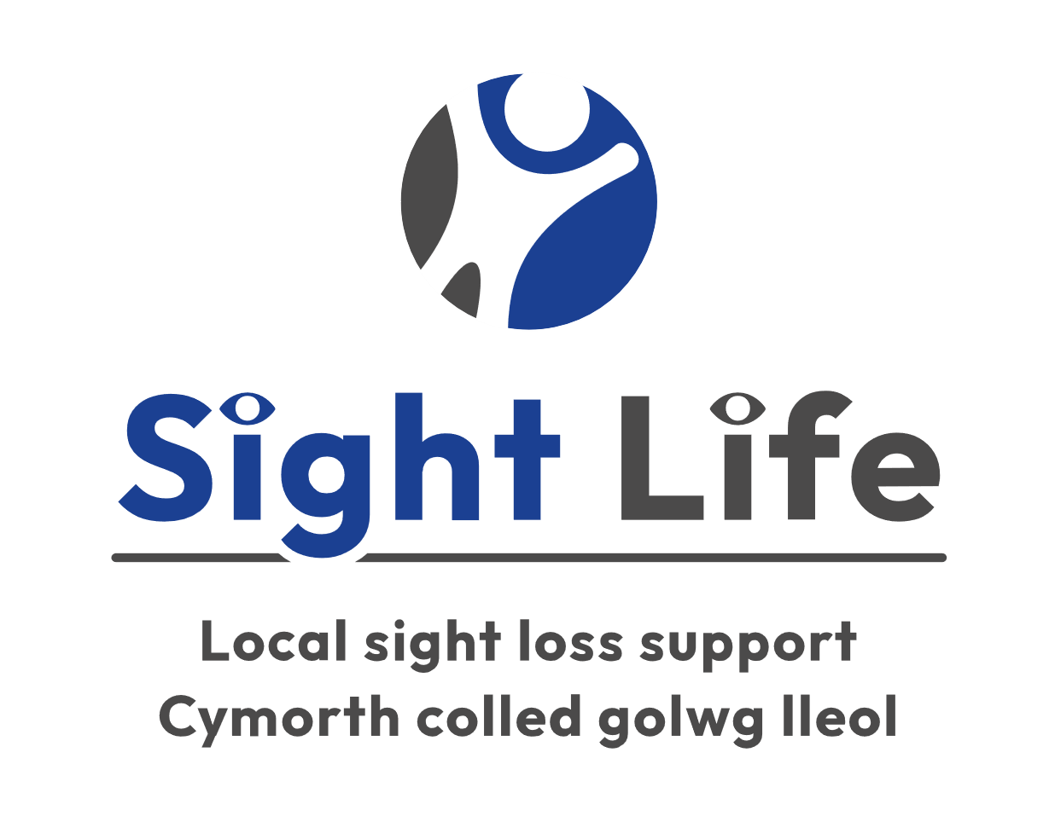
Sight Life Safeguarding Adults Policy
Contents
1. Introduction 2
2. Principles of Adult Safeguarding 3
3. Making Safeguarding Personal 4
4. Who is an adult at risk? 4
5. What is abuse? 4
6. What is an “adult safeguarding enquiry”? 6
7. Historic Abuse 7
8. Whistleblowing 7
9. Role and Responsibilities 7
10. Practical Considerations 8
11. Confidentiality 9
12. Supporting staff 9
13. Charity Regulators: England, and Wales only 10
14. Policy review and version control 11

Introduction
This policy aims to explain what adult abuse is and how we can recognise it; demonstrate how Sight Life will safeguard against the abuse of vulnerable adults and provide a range of procedures to guide staff and volunteers in the management of safeguarding matters.
Safeguarding adults from harm is a core duty of Sight Life. The nature of the services we provide means it is likely that staff and volunteers will have contact with adults at risk of abuse or neglect. This policy provides guidance for staff and volunteers to ensure the principles of safeguarding adults are embedded in all aspects of Sight Life’s work.
Sight Life is committed to the aims of adult safeguarding which are to:
- Prevent harm and reduce the risk of abuse or neglect to vulnerable adults with care and support needs.
- Stop abuse or neglect wherever possible.
- Safeguard adults in a way that supports them in making choices and having control over their lives.
- Promote an approach that concentrates on improving life for the adults concerned.
- Raise public awareness so that communities, alongside professionals, play their part in preventing abuse.
- Identify and respond to abuse and neglect.
- Provide information and support in accessible ways to help people understand the different types of abuse, how to stay safe and what to do to raise a concern about the safety or well-being of an adult.
- Address what has caused the abuse or neglect.
To achieve these aims, we will:
- Ensure all staff and volunteers have access to, and are familiar with, this policy and procedures and their responsibilities.
- Ensure concerns or allegations of abuse are always taken seriously.
- Ensure the Mental Capacity Act 2005 is used to inform any decision making on behalf of adults at risk who are unable to make decisions for themselves.
- Ensure all staff and volunteers receive training in relation to safeguarding adults at a level relevant to their role.
- Ensure our beneficiaries and where relevant their relatives have access to information about how to report concerns or allegations of abuse.

Principles of Adult Safeguarding
Empowerment | Adults are encouraged to make their own decisions and are provided with support and information.  ‘I am consulted about the outcomes I want from the safeguarding process and these directly inform what happens.’
Prevent | Strategies are developed to prevent abuse and neglect that promotes resilience and self-determination.  ‘I am provided with easily understood information about what abuse is, how to recognise the signs and what I can do to seek help.’
Proportionality | A proportionate and least intrusive response is made balanced with the level of risk.  ‘I am confident that the professionals will work in my interest and only get involved as much as needed.’
Protection | Adults are offered ways to protect themselves, and there is a coordinated response to adult safeguarding.  ‘I am provided with help and support to report abuse. I am supported to take part in the safeguarding process to the extent to which I want and to which I am able.’
Partnership | Local solutions through services working together within their communities.  ‘I am confident that the information will be appropriately shared in a way that takes into account its personal and sensitive nature. I am confident that agencies will work together to find the most effective responses for my own situation.’
Accountable | Accountability and transparency in delivering a safeguarding response.  ‘I am clear about the roles and responsibilities of all those involved in the solution to the problem.’

Making Safeguarding Personal
Adult safeguarding work should be person-led and outcome-focused. It should engage the person in a conversation about how best to respond to their situation in a way that enhances their involvement, choice, and control, as well as improving their quality of life, wellbeing, and safety.
At Sight Life, we will meet the aims of Making Safeguarding Personal by:
- Keeping the person at the heart of the process.
- Striving to understand the outcomes they want to achieve from the safeguarding work and supporting them to achieve these outcomes.

Who is an adult at risk?
The Safeguarding Adults policy applies to people who are aged 18 years or more, and:
- Have need for care and support (whether these are currently being met); and
- Are experiencing, or are at risk of, abuse or neglect; and
- Because of those needs, are unable to protect themselves against the abuse or neglect or the risk of it.

This includes adults with physical, sensory, and mental impairments and learning disabilities, whether present from birth or due to advancing age, illness, or injury. Also included are people with a mental illness, dementia or other memory impairments, and people who misuse substances or alcohol (where this has led to impaired physical, cognitive, or mental health).

What is abuse?
Abuse can take many forms and the circumstances of the individual should always be considered. It may consist of a single act or repeated acts. The following are examples of issues that would be considered as abuse or neglect:

Physical abuse | Includes hitting, slapping, pushing, kicking, misuse of medication, unlawful or inappropriate restraint, or inappropriate physical sanctions.
Domestic Abuse | Is an incident or pattern of incidents of controlling, coercive or threatening behaviour, violence, or abuse by someone who is or has been an intimate partner or family member. Domestic violence and abuse may include psychological, physical, sexual, financial, emotional abuse; as well as so called ‘honour’ based violence, forced marriage and female genital mutilation. The Domestic Abuse Act 2021 applies.
Sexual Abuse | Includes rape and sexual assault or sexual acts to which the adult at risk has not consented or could not consent to or was pressured into consenting.
Psychological Abuse | Includes emotional abuse, threats of harm or abandonment, deprivation of contact, humiliation, blaming, controlling, intimidation, coercion, harassment, verbal abuse, cyber bullying, isolation or unreasonable and unjustified withdrawal from services or supportive networks.
Financial Abuse | Includes theft, fraud, exploitation, pressure in connection with wills, property or inheritance or financial transactions, or the misuse or misappropriation of property, possessions, or benefits.
Modern Slavery | Includes human trafficking, forced labour and domestic servitude. Traffickers and slave masters use whatever means at their disposal to coerce, deceive, and force individuals into a life of abuse, servitude, and inhuman treatment.
Neglect and Acts of Omission | Includes ignoring medical or physical care needs, failure to provide access to appropriate health, social care or educational services, the withholding of the necessities of life, such as medication, adequate nutrition, and heating.
Discriminatory Abuse | Includes abuse based on a person’s race, sex, gender, disability, faith, sexual orientation, or age; other forms of harassment, slurs or similar treatment or hate crime.
Organisational Abuse | Includes neglect and poor practice within an institution or specific care setting such as a hospital or care home, for example, or in relation to care provided in one’s own home. This may range from one-off incidents to on-going ill-treatment. It can be through neglect or poor professional practice because of the structure, policies, processes, and practices within an organisation.
Self-neglect | Covers a wide range of behaviours, such as neglecting to care for one’s personal hygiene, health or surroundings and includes behaviours such as hoarding. A safeguarding response in relation to self-neglect may be appropriate where a person is declining assistance in relation to their care and support needs, and the impact of their decision, has or is likely to have a substantial impact on their overall individual wellbeing.
Radicalisation | Radicalisation is comparable to other forms of exploitation, such as grooming and Child Sexual Exploitation. Prevent is part of the Government's counterterrorism strategy CONTEST and aims to provide support and re-direction to vulnerable individuals at risk of being groomed into terrorist activity before any crimes are committed. Vulnerable individuals are groomed directly or through social media to be persuaded of the legitimacy of a radical’s cause to inspire new recruits and have extreme views embedded.

What is an “adult safeguarding enquiry”?
Where a local authority in England or Wales believes an adult at risk is experiencing or at risk of experiencing abuse or neglect, it must make enquiries (this is not necessarily an investigation), or cause others to do so. This is a duty under The Social Services and Well-being (Wales) Act 2014

An enquiry should establish whether any action needs to be taken to prevent or stop abuse or neglect, and if so, by whom.
The objectives of an adult safeguarding enquiry are to:
- Establish facts.
- Ascertain the adult’s views and wishes.
- Assess and address their need for protection and support, in accordance with the wishes of the adult.
- Make decisions as to what follow-up action should be taken.
- Enable the adult to achieve resolution and recovery.

Historic Abuse
Abuse that took place when a person was under 18 years old is not an adult safeguarding issue but, dependant on the concern, could be a child safeguarding issue, irrespective of how old that person is now.
In certain cases, the relevant Children’s Social Care department may need to be informed, if for example, the person who caused harm, is considered as a continued risk to other children.
Adults who disclose historical childhood abuse can be advised that this is a crime and that they can still report this to the Police, if they want to do this.

Whistleblowing
To fulfil its commitment to safeguarding, Sight Life has a Whistleblowing Policy, and a culture that enables issues about safeguarding and promoting welfare to be addressed in a facilitated way.

Role and Responsibilities
These roles and responsibilities are relevant to Sight Life’s Safeguarding Policy and procedures.
Trustees | Trustees take reasonable steps to protect all those connected with Sight Life from harm. Sight Life’s Safeguarding Adults Policy and procedures are approved by the board. The board delegates the day-to-day work for safeguarding within Sight Life to the chief executive but are ultimately responsible. Trustees are accountable to the Charity Commission.
Chief Executive | The chief executive of Sight Life will ensure that safeguarding underpins all decisions made by the organisation. The chief executive is accountable to the board for safeguarding matters and must report on safeguarding concerns as a standing item at every board meeting.
All other staff and volunteers | All staff and volunteers must be vigilant to potential safeguarding concerns and will raise these with the chief executive in the first instance, even if they are unsure whether the concern meets the safeguarding concern threshold:  - A policy of, “If in doubt, raise it anyway,” applies at all times.  In the event of the chief executive’s absence, safeguarding concerns must be raised with the operations manager.

Practical Considerations
Sight Life will develop effective working relationships with all other agencies involved in safeguarding vulnerable adults and ensure that all managers have received relevant training on safeguarding vulnerable adults and that all staff are briefed on what is required.
Sight Life’s selection and recruitment policy for staff and volunteers includes checks on suitability, including Disclosure and Barring Service (DBS) checks, in accordance with current legislation. Induction training for staff and volunteers will cover safeguarding issues to ensure understanding of all types of abuse as described above. Sight Life will ensure that all members of staff and volunteers know how to respond appropriately to an adult who alleges abuse and is aware of the procedure to be followed.
Sight Life acknowledges the need for effective and appropriate communication between all members of staff and other agencies in relation to safeguarding vulnerable adults, to:
- Promote the wellbeing, security, and safety of vulnerable people consistent with their rights, capacity and personal responsibility, and prevent abuse occurring wherever possible.
- Ensure that the process of reporting, investigation, and subsequent action, is as effective as possible in achieving good outcomes for vulnerable people.
- Ensure that the processes of investigation, assessment and prevention of abuse do not constitute an abusive or harmful series of events for the vulnerable person.
- Ensure that the promotion of safeguarding adult work is integral to the development and delivery of our services.
If anyone has concern for a vulnerable adult, they must report their concerns to the chief executive, or to the operations manager in his/her absence. The chief executive (or operations manager) is responsible for:
- Alerting the Local Authority Social Care team of any instances of concern relating to an adult’s welfare, possible abuse, or neglect.
- Cardiff Council Adult Safeguarding team may be contacted as follows:
- Adult social care team: 029 2053 6490
- Outside of office hours: Emergency Duty Team on 029 2078 8570
- Swansea Council’s Safeguarding Adults Team
- 01792 636854
- Email: adult.safeguarding@swansea.gov.uk
- Neath Port Talbot’s Adult’s and Children’s Single Point of Contact Team (SPOC) team may be contacted as follows:
- Office hours: 01639 686802
- Outside of office hours: Emergency Duty Team on 01639 895455
- Rhondda Cynon Taff: The Cwm Taf Multi-Agency Safeguarding Hub (MASH)
- Office hours: 01443 425 003
- Emergency out of hours number: 01443 743 665
- Ensuring that detailed and accurate written records of concerns about an adult are kept even if there is no need to make an immediate referral.
- Acting as a focal point for staff concerns and liaising with other agencies and professionals.

Confidentiality
We recognise that all matters relating to safeguarding vulnerable adults are confidential. The designated person will not disclose confidential information to volunteers except on a strict need-to-know basis.
However, all staff and volunteers will be aware that they have a professional responsibility to share information with other agencies to safeguard vulnerable adults. Staff and volunteers must be aware that they cannot promise a member or any other informant to keep secrets which might compromise the members/adult’s safety or wellbeing or that of another.

Supporting staff
We recognise that staff or volunteers working at Sight Life who have become involved with an adult who has suffered harm or appears to be likely to suffer harm may find the situation stressful and upsetting. We will support staff and volunteers by providing an opportunity to talk through their anxieties and to seek further support. Sight Life understands that staff should have access to advice on the boundaries of appropriate behaviour.
All staff and volunteers should take care not to place themselves in a vulnerable position with an adult who has expressed a concern or reported abuse of any kind. It is always advisable for interviews or work with the individuals concerned to be conducted with another member of staff present.
Sight Life recognises that vulnerable adults cannot be expected to raise concerns in an environment where staff and volunteers fail to do so. All staff should be aware of their duty to raise concerns about the attitude or actions of colleagues.

Charity Regulators: England, and Wales only
The Charity Commission requires charities to report serious incidents. If a serious incident takes place within Sight Life, it is important that there is prompt, full and frank disclosure to the Commission. Sight Life will report what happened and, importantly, let the Commission know how Sight Life is dealing with it, even if Sight Life has also reported it to the police, LA, or another regulator.
A serious incident is an adverse event, whether actual or alleged, which results in, or risks, significant:
- Harm to Sight Life’s beneficiaries, staff, volunteers, or others who encounter Sight Life through its work, or
- Harm to Sight Life’s work or reputation.
For the purposes of reporting a serious incident to The Charity Commission, “significant” means significant in the context of the charity, taking account of its staff, operations, finances and/or reputation.
Sight Life must report an actual or alleged incident promptly. This means as soon as is reasonably possible after it happens, or immediately after Sight Life becomes aware of it.
The responsibility for reporting serious safeguarding incidents rests with the charity’s Trustees. However, this is delegated to the Chief Executive and will be agreed with Trustees before any incident is reported to The Charity Commission.

Policy review and version control
The policy will be reviewed bi-annually by the chief executive and approved by the board of trustees. It will also be reviewed in response to changes in relevant legislation, contractual arrangements, good practice or in response to an identified failing in its effectiveness. All staff and people working within the charity will be made aware of the policy.

Version | Date | Author | Review Date | Changes | Status
1.0 | 13/06/22 | Michelle Jones Operations Manager | 13/06/24 | Document created | Approved by Trustees

