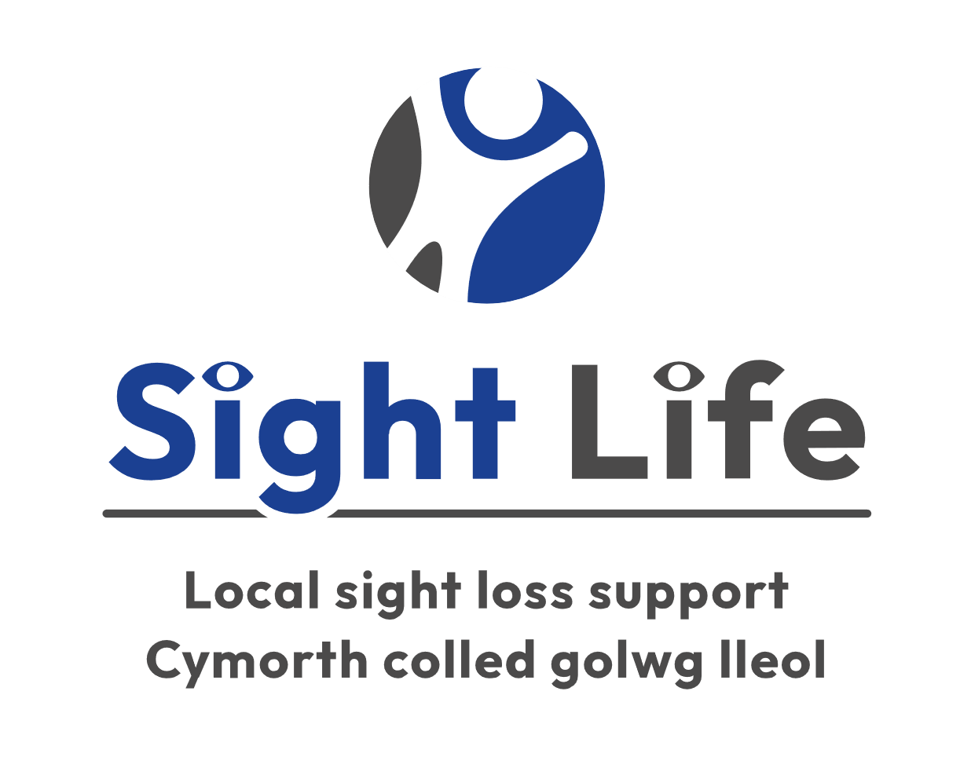

Job Description & Person Specification

Job Title: Fundraising Manager

Job Level: Senior Staff Member for Sight Life.

Location: Cardiff Head Office

Type of Contract: Permanent

Salary: Up to £38,000

Hours of work: Full time 36hours/week (flexibility required)

Reports to: Chief Executive Officer

Purpose of Job:

This role is at the heart of our strategy to:
- secure major new funding
- achieve greater sustainability
- expand Sight Life’s services.
You will lead on developing and implementing strategies to generate new income streams to improve Sight Life’s financial stability and fund service expansion. You will support your colleagues to meet annual income targets, in particular by writing bids to trusts and other funding bodies. You will also organise fundraising events and programmes.

Impact:
Identify and find suitable income streams and projects for single and multi-year funding to deliver Sight Life’s plans.
Personal stewardship of donor funds by undertaking, either personally or through staff and colleagues, appropriate action to fulfil the requirements of financial support made by grant making trusts.
Building and maintaining good working relationships with trustees, administrators, and correspondents of Sight Life’s donors and major prospects is maintained and developed and donors are updated on the progress of grants.

Financial Responsibility:
Total fundraised income target of £200k +

Decision Making Responsibility:
You will have a high level of autonomy and be responsible for managing your own portfolio of income streams.
You will apply independent judgement which will be guided by policies and precedents.
You will operate within parameters agreed with the CEO (Chief Executive Officer) and with some latitude to act.

Main Accountabilities:
- Income generation
  - Working with the CEO and senior staff, draft and implement a strategy to achieve agreed annual income targets by raising funds from trusts, foundations, statutory bodies, awards, tenders, corporate, individual giving, major donors, and legacies.
  - Take the lead to identify and research new funding and partnership opportunities and identify and progress corporate opportunities.
  - Lead on drafting grant applications and partnership proposals to secure and renew funding and in-kind support.
  - Assess prospects for success and prioritise your work accordingly.
  - Collaborate with the CEO and the Finance Officer to pull together budgets for applications.
  - Explore options for tapping into new or under-developed income streams and sources for in-kind donations.
  - Ensure Sight Life thanks all donors, liaising with service users and other stakeholders/beneficiaries as required.
  - Nurture key stakeholder relationships and develop and manage a portfolio of funders and supporters.

- Grant funding: applications
  - Co-ordinate, research and write funding bids, presenting a professional pitch for funding proposals.
  - Keep Sight Life's CEO and the Board of Trustees informed of new initiatives and explore and initiate new and innovative projects.
  - Work with the CEO to prepare and implement the organisation's funding strategy and identify a range of funding sources.
  - Take responsibility for making major funding applications and the management and budgets of new projects.
  - Keep abreast of changes, trends, and regulations within the charity sector and across fundraising ensuring compliance with the Code of Fundraising Practice.

- Grant funding: monitoring and reporting
  - Ensure managers are aware of relevant grant deliverables, timelines, budgets, and grant conditions.
  - Draft concise and captivating reports for funders which fulfil all the donor requirements and demonstrate relevant impact, outcomes, and value for money where appropriate.
  - Organise regular check-ins with the CEO to ensure Sight Life is on track with activities, deliverables and on budget.
  - Complete all administrative tasks associated with the post, including maintaining grant records, monitoring processes and regular reporting against fundraising outcomes and indicators.
  - Ensure that the file management systems, both digital and physical, and grant monitoring table are accurate and up to date with all communications and key grant details.
  - In conjunction with the CEO liaise with and provide reports to funders as required.
  - Represent Sight Life at external meetings and events as required, acting as an ambassador for the organisation and engaging with all stakeholders.

- Management responsibilities
  - Take overall responsibility for the management and development of Sight Life's income generation strategy.
  - Support general fundraising, social media, and marketing.
  - Carry out your duties in compliance with the General Data Protection Regulations (GDPR), the Data Protection Act and the Freedom of Information Act.
  - Work in accordance with Sight Life's policies, procedures and working practice agreements.
  - Operate within an Equal Opportunities Framework and promote equality issues in all aspects of work.

General
The following points are common to all job descriptions:

- Undertake any other duties appropriate to the post.
- Adhere to Sight Life policies and procedures.

Person Specification
Please note all criteria are essential unless otherwise stated.

- Specialist Knowledge, Skills, and Experience
  - An understanding of charities and the voluntary sector and the role we play in helping people disadvantaged in society.
  - Experience and success in the research, preparation, and delivery of proposals for both existing trust donors and prospects.
  - Knowledge of how computer databases manage information to support fundraising, marketing, or sales activity.
  - Ability to use Microsoft Office e.g. Word to produce letters and other documents.
  - Ability to make simple calculations, understand financial information and produce financial proposals.

Desirable
  - Experience of working directly with external customers in either fundraising and/or marketing.
  - Experience of being a representative of an organisation at functions and/or social events.
  - Experience/evidence of fundraising success in the disability sector.

- People management/team working skills.
  - Experience of building relationships with funders/external customers quickly and establishing professional relationships with others, based on trust and understanding.

- Planning and Organisational skills
  - Ability to be proactive, self-starting, enthusiastic and committed.
  - Ability to work on your own initiative and deliver objectives.
  - Ability to work to strict deadlines with little supervision.

- Problem-solving and creative skills
  - Ability to identify fundraising opportunities for trusts and foundations from within Sight Life’s projects and services.
  - Ability to develop attractive funding proposals using photographs, quotes and case studies where appropriate.
  - Ability to present information on Sight Life’s projects and services to meet funder’s requirements.

- Communication skills
  - Experience of communicating effectively both verbally and in writing to produce funding proposals and reports, deal with routine correspondence and communicate with external customers over the telephone and face to face.
  - Ability to identify sources of information and gather data, especially by working with Sight Life colleagues.
  - Ability to represent the charity in a clear, emotive, and factual way.

Other attributes - essential
- Strong team player willing to support colleagues as required.
- Committed to working within our agreed value framework.
- The right to reside and work permanently in the UK.

Equal Opportunities
Ability to understand and demonstrate commitment to Sight Life’s Equal Opportunities Policy and to ensure all activities are consistent with the Equal Opportunities Policy. This includes all staff activities and their dealings with the public.

Special Conditions
- You must be prepared to travel and attend meetings and training as required which may involve occasional overnight stays.
- An Enhanced Disclosure and Barring Service Check is required for this role.
- The Job Description is subject to change as Sight Life develops in the years ahead.

Application process
If you would like to apply for this role please forward a 2 page CV and 2 page covering letter evidencing how you meet the essential criteria in the person specification and return it to: Nicola.llewellyn@sightlife.wales

Closing date for applications: 15 April 2024 (1pm)
Interview dates: TBC

You will find more information on Sight Life’s website. If you have specific questions, please contact us by emailing michelle.jones@sightlife.wales for an informal discussion.

The closing date for all applications is 15 April 2024, although we may close earlier if enough suitable candidates come forward. Initial interviews are planned to take place from 22 April 2024. We particularly welcome applications from people with disabilities.

End of document

