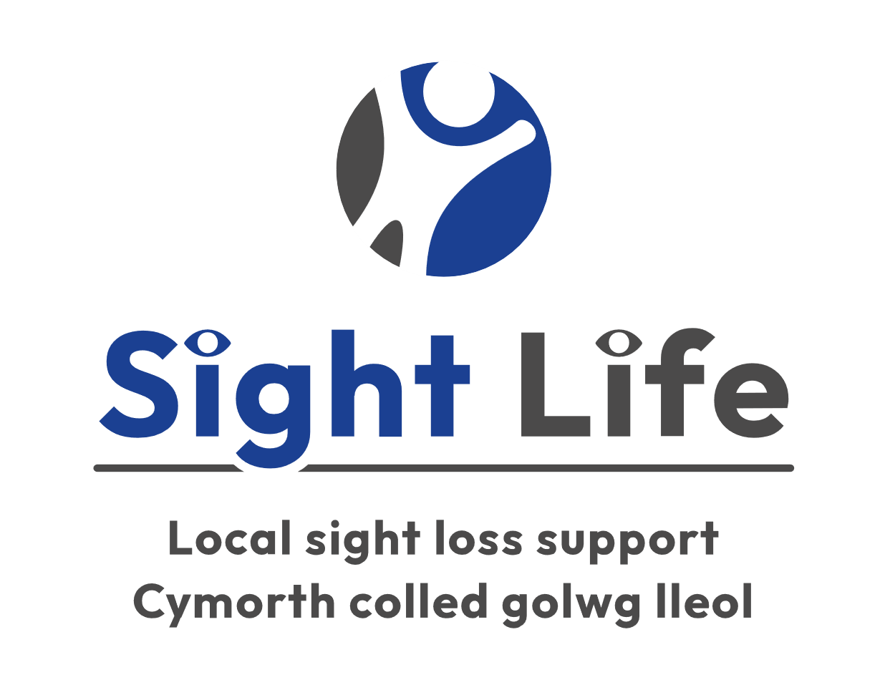

Job Description

Marketing & Communications Assistant

Purpose and Aims of the role
Sight Life provides a range of services to blind and partially sighted people across much of South Wales. We are now looking for a full time Marketing & Communications Assistant to support with implementing our marketing strategy.

General Information
Job Title: Assistant Marketing Officer

Location: Office Based at Jones Court Cardiff with potential for some homeworking as required.

Renumeration: £9,600.00 / year

Hours: Two days per week.

Duration: Commencing April/May 2024. This is a fixed term post. Funding has been secured from for this post for 11 months.

Responsible for: Please see the “What will I be doing outline below”.

Reports to: Fundraising Manager/CEO

What will I be doing?
- Promoting Sight Life’s work under the Shared Prosperity Fund
- Making amendments to the website through WordPress
- Preparing, writing, and scheduling social media posts
- Designing assets on Canva
- Writing copy for the quarterly newsletter and website
- Writing fundraising communications and marketing material
- Using and updating third-party fundraising platforms used to collect donations
- Helping to provide a brief for videos for the website and social media
- Assisting on fundraising campaigns and Christmas campaigns
- Helping to prepare Sight Life’s Impact Reports
- Supporting with the SEO for the website, including google AdWords and Facebook ads.
- Fundraising research tasks
- Representing Sight Life at external meetings and events as required, acting as an ambassador for the organisation and engaging with stakeholders.
- Producing short videos on tablets/mobile phones

What skills can I bring to this role?
- Ability to work on own initiative.
- Good communication and writing skills, with some prior experience in a Communications role or course and the ability to write copy for different audiences.
- Experience using WordPress, Hootsuite and Canva are desired.

What qualities do I need?
- Be enthusiastic, flexible and committed to the cause.
- A fast learner
- Reliability and a commitment to treat all information in a confidential manner.
- Ability to communicate in Welsh language.

When will I be needed?
- The role will be for 2 days per week for 11 months.

Location
- Jones Court, Womanby Street, with some homeworking required.

What support will I be given?
- Induction
- Training
- Supervision and support from your manager

Additional Information
To apply, please send a 2-page CV and covering letter to Nicola.Llewellyn@sightlife.wales

Contact Details
For more information please contact Michelle Jones on 02920 398900

